Jeffery Ulmer, Director
Gary Zajac, Managing Director
Holly Nguyen, Associate Director
Elaine Arsenault, Docket Editor



Message from the Director
As the Fall of 2025 begins, we at the Criminal Justice Research Center are eager to begin another academic year. We have two exciting new faculty affiliates, Miranda Galvin and Riley Tucker, both new assistant professors in criminology. We also have a strong lineup of speakers for our series this fall. And as usual, our staff and faculty affiliates are hard at work on a wide variety of research projects and funding proposals that should yield important social scientific knowledge as well as criminal justice policy guidance.
We congratulate Joy Vincent-Killian, the Outreach Coordinator for us and the Department of Sociology and Criminology, on her retirement this summer. Her contributions will greatly be missed. Given her retirement and the complexity of planning the fall Career Expo with the Department of Sociology and Criminology, we will not hold this event in 2025. We will reassess and reorganize for next fall, and hope to see a Career Expo in fall of 2026.
Finally, we are very happy that the College of the Liberal Arts has continued to support the CJRC generously. This support will allow the CJRC to continue to be a resource for faculty and students.

Jeffery Ulmer
CJRC Director

The Docket September 2025
The Criminal Justice Research Center is housed within the College of the Liberal Arts

Criminal Justice Research Center Welcomes New Associate Director

The CJRC is very excited to welcome Holly Nguyen as associate director of the CJRC. Holly Nguyen is an associate professor of sociology, criminology, and public policy. She earned her doctoral degree in 2015 from the University of Maryland, College Park. Her research focuses on labor markets and crime, disparities in the criminal legal system, decision-making processes, and illicit drug markets. Nguyen’s work has been published in leading academic journals, including the American Sociological Review, Criminology, and the Journal of Quantitative Criminology. Her research has received funding from prestigious organizations such as the National Institutes of Health, the National Science Foundation, and the Social Sciences and Humanities Research Council. In 2024, Nguyen was named Penn State’s College of the Liberal Arts Endowed Fellow. She also received the American Society of Criminology’s Ruth Shonle Cavan Young Scholar Award in 2020.



ANNOUNCEMENTS

Criminal Justice Research Center Welcomes New Faculty Affiliates
Miranda Galvin has just returned to Penn State as an assistant professor of criminology, after spending several years on the faculty at Townson University. She was a CJRC Post Doctoral Scholar from 2019 to 2022, working with the Pennsylvania Commission on Sentencing on a variety of studies. She earned her doctoral degree in criminology and criminal justice from the University of Maryland. Her current work centers on prosecution, sentencing, and criminal justice policy. She has received grants from Arnold Ventures and the National Institute of Justice and looks forward to continuing her research in Pennsylvania.
Riley Tucker is an assistant professor of criminology at Penn State. His research uses computational methods such as machine learning, natural language processing, and web scraping to better understand cities and the spaces within them. He is particularly passionate about using these methods to test and develop interdisciplinary theories that explain why some urban places experience more crime than others. Prior to joining Penn State, he was a Post Doctoral Fellow at the University of Chicago's Mansueto Institute for Innovation and Data Science Institute. He earned his doctoral degree in criminology and justice policy at Northeastern University and his work has been published in venues such as Journal of Quantitative Criminology, Journal of Research in Crime & Delinquency, and Scientific Data.

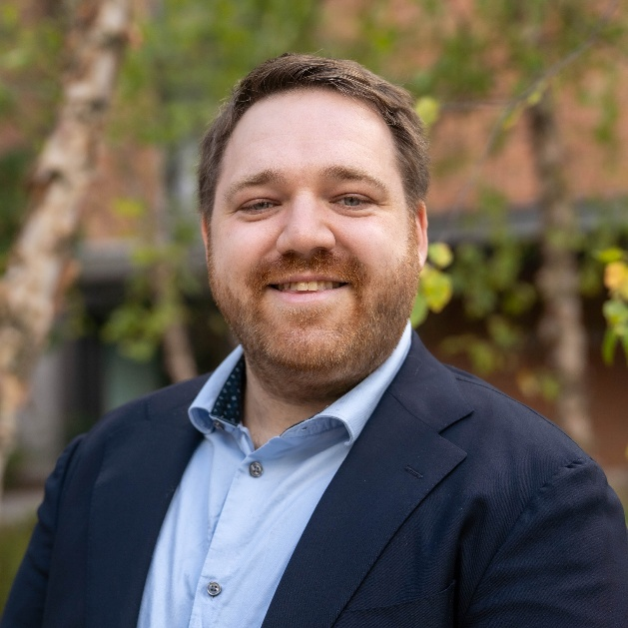
Miranda Galvin Riley Tucker

Criminal Justice Research Center Departures

Joy Vincent-Killian, CJRC outreach and enrichment coordinator, retired in July. We wish Joy all the best and thank her for all that she has done for the department and CJRC over the past three years. Joy has done an incredible job serving the department and CJRC in her position. She wore many hats in the department and CJRC and did an excellent job with alumni relations, internship and scholarships, establishing connections with dozens of criminal justice agencies in support of internships and career placement, and in making the Criminal Justice Career Expo a gem for us and the College of the Liberal Arts. Joy retires after twenty-five years of service to Penn State. Many thanks to Joy for her service and congratulations to her on retirement!

The CJRC bids a fond farewell to Glenn Sterner, who until August had been the CJRC-Abington faculty lead and associate professor of criminal justice at Penn State Abington. Glenn has taken a position as associate professor of criminal justice in the College of Social Work at the University of Kentucky. Glenn first joined the CJRC in 2015 as a Post-Doctoral Scholar, after having completed his doctoral degree in Rural Sociology at Penn State. In 2018, Glenn moved on to Penn State Abington to become an assistant professor of criminal justice, receiving tenure in 2024. As regular readers of The Docket know, during his three years as Post-Doctoral Scholar with the CJRC, Glenn developed an impressive research agenda focused largely on the opioid crisis and on policy and programming around that. He was named Post-Doctoral Scholar of the year in 2018 by the Penn State Postdoctoral Society. Upon moving to Abington, Glenn wanted to build upon this portfolio and with support from the College of the Liberal Arts and the CJRC established the Abington office of the CJRC. During his seven years at Abington and his three as Post-Doctoral Scholar with the CJRC, Glenn developed a research portfolio that encompassed over twenty funded projects (half of them as PI) for a total of over $5 million in funding, resulting in over two dozen articles, book chapters and special reports. Glenn’s projects have focused heavily on improving the understanding of opioid and related addictions issues on various communities in Pennsylvania. His work has been supported extensively by various agencies within Pennsylvania state government, for projects such as the ongoing PA Assessment of Interactive Gaming and the evaluation of the impacts of the 2022 opioid settlement funding in Pennsylvania. Glenn’s work at Abington has also supported several staff members over the years and many undergraduate and graduate students across multiple campuses. The Abington office has also served as a mentor to faculty at other Commonwealth Campuses in the development of their own research agendas. Glenn’s career to date serves as a prime example of the potential to develop a research portfolio begun through a Post-Doctoral Scholar position into a successful career of scholarship that has a high impact on both the practitioner and scholarly communities. We are confident that Glenn will continue this work at Kentucky, in part through collaboration with Penn State. We are grateful for his long record of contribution to the CJRC over the past decade and wish him all the best going forward.

Emerson Waite, PA Commission on Sentencing Graduate Student at the CJRC recently passed his dissertation defense and currently works as the research and data manager for the Pennsylvania Prison Society.

Jeffery Ulmer, CJRC Director, Named Distinguished Professor
Congratulations to Jeffery Ulmer, CJRC Director, who was named Distinguished Professor of Sociology and Criminology! This university award recognizes distinction and excellence in research, teaching, and service. Read the Penn State Today article.

CJRC Postdoctoral Scholar Receives Award

Nicolette Bardele, Criminal Justice Research Center Postdoctoral Scholar, presented at the Seventeenth Annual Postdoctoral Research Symposium at Penn State. The event included research presentations from postdoctoral scholars across a range of disciplines at Penn State. Nicolette gave a lightning talk, on “How Community Context Shapes Community Supervision.” For this talk Nicolette received the Judges’ Award for Best Short Talk in the Social Sciences and Humanities. Congratulations Nicolette!

Criminal Justice Research Center Graduate Student Research Awards

The CJRC is pleased to announce the following graduate students as the recipients of the CJRC Graduate Student Research Awards.
Carlos M. Gonzales, At Risk of a Good Time? Risk, Pleasure, and LGBTQ+ Drug Use in Nightlife
Siyang Ni, Development of Self-Control and Delinquency in Youth: A Longitudinal Test of Self-Control Theory
Congratulations to Carlos and Siyang!

Fall 2025 Criminology Speaker Series

We were excited to kick off the 2025 Criminal Justice Research Center’s Speaker Series on September 18 with Emma Fridel, assistant professor of criminology at Florida State University. The lecture title was “Evaluating the Impact and Implementation of Risk Protection Orders in Florida, 2018-2023.”

Upcoming Speakers This Semester

Bob Apel, Rutgers University–Newark, Thursday, October 30, 2025, 2:00 p.m.

Miranda Galvin and Riley Tucker, Penn State, Thursday, December 4, 2025, 2:00 p.m.

All talks are held in 202 Welch Building. Please arrive early for in-person seating.

Register to attend via Zoom.

CORRECTIONS AND RE-ENTRY

Seed Grant Award: Community Supervision: Experiences and Challenges in Rural Pennsylvania

Pamela Wilcox, professor of sociology and criminology and CJRC Faculty Affiliate, will focus on probation/parole service provision and client experiences in Rural Pennsylvania. The Pennsylvania Commission on Sentencing will fund this work.

Seed Grant Award: Peer Tutoring at SCI Muncy: Implications for Tutors’ Self-Perceptions, Experience of Imprisonment, and Behavioral and Educational Outcomes
Esther Prins, professor of education and CJRC Faculty Affiliate, and Collaborating Investigator, Marcela Movit, research professor (ISAL) and CJRC Faculty Affiliate, will conduct a pilot study on peer tutoring program in other correctional settings.

COURTS AND SENTENCING

Seed Grant Award: Organizational Dimensions of Prosecutorial Discretion
Nicholas Goldrosen, (Pennsylvania Commission on Sentencing Postdoctoral Scholar-CJRC) and Noah Painter-Davis, deputy director for research and technology at the Pennsylvania Commission on Sentencing and CJRC Faculty Affiliate, aim to study how chief prosecutors set policies and practices about, manage, and track the exercise of prosecutorial discretion.

TREATMENT AND REHABILITATION

Seed Grant Award: Supporting Moms in Recovery: A Longitudinal Evaluation of an Integrated Mother-Child Substance Use Treatment Program

Kristina Brant assistant professor of rural sociology and CJRC Faculty Affiliate, and Abenaa Jones, assistant professor of human development and family studies and CJRC Faculty Affiliate, will examine the impacts of criminal legal and child welfare involvement on mothers’ substance use and parenting outcomes and to evaluate components of an integrated mother-child treatment program.

PUBLIC SAFETY AND CRIME PREVENTION

Seed Grant Award: A Statistical and Network Analysis of Terrorist and Street Gang Choices to Claim Responsibility for Violent Behavior

Diane Felmlee, Distinguished Professor of Sociology and Demography and CJRC Faculty Affiliate, and Collaborators, Scott Gartner, affiliate of Penn State School of International Affairs and Andrea Corradi assistant professor of criminal justice and criminology at Georgia Southern University, will examine the degree to which a group’s choice to claim credit is a function of its network ties to other groups.

Seed Grant Award: Investigating Contributors to Voluntary and Involuntary Illegal or Unregulated Gambling in the United States

Gillian Russell, assistant research professor at CJRC-Abington, and Co-Investigators, Glenn Sterner, associate professor of criminal justice in the College of Social Work at the University of Kentucky and CJRC - Abington - Faculty Lead, Alumni, and Sujeong Park, assistant professor of health policy and addiction studies and CJRC Faculty Affiliate, will develop a comprehensive method of assessing illegal and unregulated gambling, determine whether illegal or unregulated gambling is voluntary or involuntary, and identify contributors to both forms of illegal gambling.

Criminal Justice Research Center

Penn State
402 Welch Building
University Park, PA 16802

cjrc.la.psu.edu

September 2025

This publication is available in alternative media on request. Penn State is an equal opportunity employer and is committed to providing employment opportunities to all qualified applicants without regard to race, color, religion, age, sex, sexual orientation, gender identity, national origin, disability or protected veteran status. Our events and programs are open to all students regardless of sex, gender, sexual orientation, race, or any other protected class. The College of the Liberal Arts is committed to building a community of belonging for all. UBR CLA 25-517

