**PENN STATE**

*Criminal Justice Research Center*

Jeffery Ulmer, Director

Gary Zajac, Managing Director

Megan Kurlychek, Associate Director

Elaine Arsenault, Docket Editor

*Message from the Director*

As the Fall of 2023 begins, we at the

Criminal Justice Research Center are excited

and eager to begin another academic year. We have many exciting things happening this fall. First, we put together a vibrant speaker series with the Department of Sociology and Criminology, with four speakers this fall. The fall slate of speakers features two Ph.D. alumni of the Penn State Criminology Program: Chris Schreck and Amy Anderson. Second, we were very pleased with the Career Expo with the Department of Sociology and Criminology on September 21.  This Career Expo was even bigger and better than last year’s successful event. Third, our staff and faculty affiliates are hard at work on a wide variety of research projects and funding proposals that should yield important social scientific knowledge as well as criminal justice policy guidance. Finally, we are very happy that in a time of budget constraints, the College of the Liberal Arts has continued to support the CJRC at the same level as the previous year. This support will allow the CJRC to continue to be a resource for faculty and the criminal justice policy community. We wish everyone a happy, healthy, and productive academic year!

*Jeffery Ulmer*

*CJRC Director*

The Docket October 2023

**The Criminal Justice Research Center is housed within the College of the Liberal Arts**

***ANNOUNCEMENTS***

Criminal Justice Research Center Welcomes New Personnel

Chris Lehman started in August at the CJRC as a Research Technologist. Chris graduated from Penn State with a Bachelor of Arts degree in Psychology. His undergraduate career was focused on research pertaining to group discussions of religion and non-religion using interview data that was collected through the Penn State Altoona Undergraduate Research Laboratory. Chris earned his master’s degree in experimental psychology from Saint Joseph’s University where he conducted survey research focused on the effects of entitled advertising on psychological entitlement. Chris continues to collaborate with the Undergraduate Research Lab and is also a frequent guest lecturer on the sociology of non-religion at Penn State Altoona.

## Headshot of Christopher Lehman

Criminal Justice Research Center Welcomes New Graduate Student

Ashley E. Rodriguez started in August as a Graduate Student at the CJRC. Ashley is a Ph.D. student in Criminology at Penn State University. Her research interests include judicial decision-making, pretrial and sentencing case processing, pretrial risk assessments, and disparities in the criminal-legal system. Ashley received her B.S. in Criminology, Law and Society from George Mason University. While at GMU, she worked as a research assistant at the Early Justice Strategies Lab examining bail reform strategies, racial disparities at various points of the criminal-legal system, judicial decision-making in a pretrial context, and graduated supervision strategies. Additionally, GMU’s Office of Student Scholarship, Creative Activities and Research (OSCAR) funded her vignette study on risk assessment use and risk communication in pretrial decision-making from the perspective of courtroom decision-makers. In addition, she participated in a National Science Foundation-funded Research Experience for Undergraduates (REU) at the University of South Carolina. During this project, she studied disparities in virtual bond hearings during the COVID-19 pandemic.



Criminal Justice Research Center Departure

Michael LaForest was a Post-Doctoral Scholar in the Criminal Justice Research Center. In this role, he worked closely with the Bureau of Planning, Research & Statistics at the Pennsylvania Department of Corrections, which funded this position. Mike was the inaugural Post Doctoral Scholar in this position, spending nearly three years with us and PADOC. During his time as post doc with CJRC/PADOC, Mike conducted a very productive portfolio of research on PADOC treatment programs and on policies and practices regarding parole and other PADOC operations. Mike also continued with his own independent research agenda that he was establishing prior to his arrival to the CJRC in 2020. His publications while at CJRC can be found on our website. During his time here, Mike set the standard for the Post Doctoral Scholar position with PADOC and was an exemplary colleague for all of us here at CJRC and for our agency partners in PADOC. Mike left us this spring to take a position as Assistant Professor in the Department of Economics in the United States Air Force Academy in Colorado Springs. We are pleased that Mike is continuing to collaborate with the CJRC and PADOC on the research agenda that he established while in his post doc. We wish him the best of luck at the Academy and look forward to continuing a partnership with him.

Criminology Speaker Series- Fall 2023

The Criminal Justice Research Center and Department of Sociology and Criminology are happy to announce that the following speakers will present during the Fall Speaker Series in 406 Oswald Tower and via Zoom:

Friday, November 3 at 12:00pm to 1:00pm

Jason Brooks, Penn State

“What Happens When We Die? Death Investigation Beyond Hollywood”

[Register Here to join via Zoom](https://events.la.psu.edu/event/css_jason-brooks)

 Friday, December 8 at 12:00pm to 1:00pm

Amy Anderson, University of Nebraska Omaha

“Politics, Religion, Education and Views of Capital Punishment”

[Register Here to join via Zoom](https://events.la.psu.edu/event/css_amy-anderson)

***OUTREACH AND ENRICHMENT ACTIVITIES***

# Criminal Justice, Policy, and Intelligence Career Expo

The annual Criminal Justice Career Expo, held on September 21 at the Alumni Hall of the HUB-Robeson Center, proved to be a resounding success, drawing nearly 500 attendees and featuring 60 tables representing various federal and state agencies. This event provided an invaluable opportunity for students to explore career prospects, network with industry professionals, and gather essential information about potential career paths in an array of fields.

Organized by the Criminal Justice Research Center (CJRC) and the Department of Sociology and Criminology, the Expo featured a range of participants, including federal and state agencies, more than 20 law enforcement agencies, county courts, public defenders, district attorneys, and county human resources representatives from across the state. This representation guaranteed that students attending the Expo had the chance to explore numerous career options and engage with professionals from various sectors within criminal justice.

The event ran from 11:00 am to 3:00 pm, providing students with a convenient four-hour window during the two lunch windows on a Thursday to engage with agency representatives, ask questions, and learn more about careers and employment. The Department of Sociology and Criminology professors recognized the value of hands-on experience and networking opportunities and decided to incorporate the Expo into their curriculum, replacing their traditional classroom lectures. This move underscored the event's significance in providing practical, real-world insights to students pursuing careers in their field of choice. Students discovered roles in corrections, domestic relations, accounting investigations, postal investigations, probation, forensics, and all aspects of law enforcement and courts.

A total of 60 agencies participated in the Expo, among the notable agencies present were NCIS, NGIC, DIA, HSI, IRS-Criminal Investigations, Pennsylvania Office of State Inspector General, U. S. Department of Health and Human Services OIG, Amtrak Police, U.S. Customs and Border Protection and the FBI. The Pennsylvania State Police were joined by the New York State Police and the Maryland State Police.  The legal sector was well represented, with representatives from Pennsylvania State Attorney General and Blair, Montgomery, Somerset, Clinton, Crawford, Cumberland, Dauphin, and Lehigh Counties. Agencies stated upon their departure that they were pleased with the long lines of well-dressed and prepared students and looked forward to returning next September.

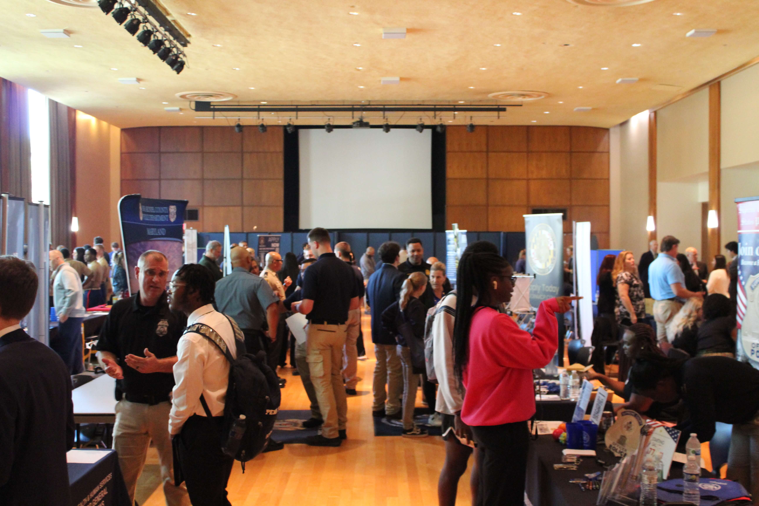

Student Spotlight Profiles

Recently, many of the CJRC’s undergraduate research assistant alumni offered positive feedback and insight on what it is like to be a research assistant on CJRC research projects. Read their feedback [here](https://cjrc.la.psu.edu/outreach-enrichment/). To get involved with undergraduate research at the CJRC please reach out to Joy Vincent-Killian, Outreach and Enrichment Coordinator for CJRC and Sociology/Criminology at jkv1@psu.edu.

***TREATMENT AND REHABILITATION***

Developing Early Warning Systems for Emerging Epidemics of Illicit Substances: A Data-Driven Modeling Approach

The objective of this four-year study is to develop a data-driven analytical framework of the Early Warning System (EWS) for the illicit substance use crisis to help policymakers and stakeholders identify high-risk areas of emerging drug threats, understand the underlying driving factors, and develop effective response strategies. The substance use crisis has not only become increasingly fatal but also presents constantly shifting patterns and variations in the drug market, uses, and impact (e.g., overdoses), leaving policymakers and communities grappling to respond effectively and mitigate the resulting harms. To tackle this societal challenge across the criminal justice, healthcare, prevention, and public health policy sectors, our study seeks to take a holistic, collaborative, and system-focused approach to advance the fundamental knowledge of illicit drug supply in communities, leading to effective multi-pronged responses to mitigate the emerging drug threats from both the supply and demand sides. This study will facilitate the education of future academics and researchers in tackling complex societal challenges with advanced analytical tools, and training to enhance analytical capacity for work professionals in the field.

This project develops a novel EWS framework with transformative learning and optimization methodologies for identifying and responding to emerging illicit substance threats and enhancing the use of observational data from descriptive to predictive and prescriptive analyses. In particular, this project will (1) develop a novel geospatially-aware predictive model to detect emerging threats of illicit drugs and identify high-risk communities by exploiting inherent geospatial connections in the data, (2) learn causal pathways through efficient algorithms to uncover the driving factors of the emerging threats among communities, (3) optimize dynamic intervention strategies that can adapt to emerging data from shifting epidemics, and (4) develop a decision support tool as a proof-of-concept of the proposed EWS framework. The predictive modeling and decision-analytic framework are generalizable to EWS in other application areas. The multidisciplinary team will partner with national and regional drug control programs to demonstrate the practical impact of the proposed data-driven EWS framework.

The National Science Foundation awarded $670,000 for this project. The project team consists of Co-PIs Qiushi Chen, Glenn Sterner (CJRC - Abington - Faculty Lead at Penn State Abington), and Paul Griffin.

***COURTS AND SENTENCING***

Pennsylvania Commission on SentencingRecent Publication

Staff at the Pennsylvania Commission on Sentencing (PCS) recently published an article focused on the impact of COVID-19 on sentencing practices and outcomes in the American Journal of Criminal Justice ([https://doi.org/10.1007/s12103-023-09730-y](https://nam10.safelinks.protection.outlook.com/?url=https%3A%2F%2Fdoi.org%2F10.1007%2Fs12103-023-09730-y&data=05%7C01%7Cepa5015%40psu.edu%7C1f352913fe5d4465b6d408dbab0db08c%7C7cf48d453ddb4389a9c1c115526eb52e%7C0%7C0%7C638291847503639981%7CUnknown%7CTWFpbGZsb3d8eyJWIjoiMC4wLjAwMDAiLCJQIjoiV2luMzIiLCJBTiI6Ik1haWwiLCJXVCI6Mn0%3D%7C3000%7C%7C%7C&sdata=FDdymDdOQkE3g35tDtFfZfT9fSH2eUnqhBZ6k7lx5Zs%3D&reserved=0)). The article provides the first empirically based examination of the impacts of the pandemic on criminal sentencing practices, and any associated racial disparities, by comparing outcomes and trends before and after the onset of the pandemic. The paper employs two theoretical frameworks (focal concerns and the liberation hypothesis) to motivate competing expectations regarding sentencing behavior and disparities. The paper was coauthored by Jordan Zvonkovich (PCS employee and PSU graduate student), Matthew Kleiman (Senior Deputy Director of PCS), Rhys Hester (visiting scholar at PCS through the partnership between PCS and PSU/CJRC), and C. Clare Strange (former post-doctoral scholar at PSU and the CJRC).

Opportunity for Research Collaboration with Pennsylvania Commission on Sentencing

The Pennsylvania Commission on Sentencing welcomes opportunities to support faculty, graduate student, or undergraduate research on issues and topics that would help inform and advance the mission of the Commission.  The Commission has previously provided data, direct consulting opportunities, and funding to support research endeavors or evaluations. Please contact Matt Kleiman, Senior Deputy Director, at [mxk1283@psu.edu](mailto:mxk1283@psu.edu) if you have interest in advancing a specific project or in collaborating with the Commission on Sentencing.

CJRC Director Jeffery Ulmer Publishes in Journal of Crime and Justice and Social Problems

CJRC Director Jeffery Ulmer and Jason Silver (Assistant Professor of Criminal Justice, Rutgers University) recently published an article in Journal of Crime and Justice titled, “Moral Intuitions, Punishment Ideology, and Judicial Sentencing.” This study is based on a survey of Pennsylvania judges on their moral views, criminal justice attitudes, and sentencing preferences, supported by the Pennsylvania Commission on Sentencing.

Read the article here: <https://doi.org/10.1080/0735648X.2023.2248085>

Jeffery Ulmer and Jordan Zvonkovich also published an article titled “Segregation and Group Threat:  Specifying Hispanic-White Punishment Disparity” in Social Problems. Jordan is a Criminology Ph.D. candidate and is a full-time member of the research staff of the Pennsylvania Commission on Sentencing.

 Read the article here:  <https://doi.org/10.1093/socpro/spad032>

Associate Director of the CJRC, Present at Penn Criminology Colloquium Series

Megan Kurlychek, Associate Director of the CJRC, was invited to present as part of the Penn Criminology Colloquium Series. She presented on September 27 on “Dismissal and Discretion: A forgotten piece in the criminal justice puzzle and its role in racial disparities.”

NIJ W.E.B. Du Bois Fellowship

Clare Strange, PhD, former CJRC postdoc and current Assistant Research Professor in the Drexel University Department of Criminology and Justice Studies, was awarded a [five-year, $730,000 grant](https://nam10.safelinks.protection.outlook.com/?url=https%3A%2F%2Fnij.ojp.gov%2Ffunding%2Fawards%2F15pnij-23-gg-01365-nijb&data=05%7C01%7Cepa5015%40psu.edu%7Ccb1c520efe674aded59008dbc5ec2af7%7C7cf48d453ddb4389a9c1c115526eb52e%7C0%7C0%7C638321390344054851%7CUnknown%7CTWFpbGZsb3d8eyJWIjoiMC4wLjAwMDAiLCJQIjoiV2luMzIiLCJBTiI6Ik1haWwiLCJXVCI6Mn0%3D%7C3000%7C%7C%7C&sdata=Ss1cv6eU92AJ2mjMIye%2Brab9ybbBcTfDZmcP5veiejA%3D&reserved=0) from the National Institute of Justice (NIJ) under the [W.E.B. Du Bois Fellowship for Research on Reducing Racial and Ethnic Disparities in the Justice System](https://nam10.safelinks.protection.outlook.com/?url=https%3A%2F%2Fnij.ojp.gov%2Ffunding%2Ffellowships%2Fweb-du-bois-program%23awardees&data=05%7C01%7Cepa5015%40psu.edu%7Ccb1c520efe674aded59008dbc5ec2af7%7C7cf48d453ddb4389a9c1c115526eb52e%7C0%7C0%7C638321390344054851%7CUnknown%7CTWFpbGZsb3d8eyJWIjoiMC4wLjAwMDAiLCJQIjoiV2luMzIiLCJBTiI6Ik1haWwiLCJXVCI6Mn0%3D%7C3000%7C%7C%7C&sdata=GAMHvmyfttoU%2BgbZ2LdJgDLEKygIvNvzlX3Lq3VnUg4%3D&reserved=0). Dr. Strange (principal investigator), alongside colleagues from Penn State (Jeff Ulmer, PhD and Jordan Zvonkovich, MS, co-investigators), Drexel (Jordan Hyatt, JD, PhD, co-investigator), and Clemson university (Rhys Hester, JD, PhD, consultant) will use project funds to conduct a statewide mixed-methods evaluation of Pennsylvania’s newly adopted 8th edition sentencing guidelines and their impacts on racial and ethnic disparities in sentencing outcomes.

***PUBLIC SAFETY AND CRIME PREVENTION***

## CJRC Faculty Affiliate, Eric Baumer, Publishes in Criminology & Public Policy

CJRC Faculty Affiliate, Eric Baumer, recently published the following article “Federal–local Partnerships on Immigration Law Enforcement: Are the Policies Effective in Reducing Violent Victimization?” in Criminology & Public Policy, with colleague Min Xie (UMD at College Park).

Read the article [here](https://onlinelibrary.wiley.com/doi/epdf/10.1111/1745-9133.12619).

Read the SSRI article [here](https://ssri.psu.edu/news/federal-local-immigration-enforcement-policies-designed-reduce-crime-found-raise-victimization).

The Criminal Justice Research Center supported part of this work through a 2022 seed grant award for the “Leveraging Prominent National Surveys to Assess the Efficacy of County and City Crime Control Efforts” project.

## PA Assessment of Interactive Gaming (Online Gaming) Project at CJRC- Abington

Through Pennsylvania Act 42 of 2017 legalized gambling was greatly expanded. This expansion included interactive gaming, otherwise referred to as online gambling, which provided gambling opportunities across the state, opening up opportunities to gamble where previously there were none. Through this legislation, it was mandated that every year an annual assessment be conducted to assess the impacts of online gambling availability on Pennsylvania residents.

Through the PA Assessment of Interactive Gaming (Online Gaming) Project the PA Department of Drugs and Alcohol Programs (DDAP) originally awarded Penn State Abington to conduct the assessment from 2020 until 2023. The project was renewed with funding July 1, 2023- June 30, 2026 ($1,659,786.00). The project teams consists of Principal Investigator: Glenn Sterner, PhD (CJRC - Abington - Faculty Lead at Penn State Abington), Co-Investigators: Gillian Russell, MSc (Assistant Research Professor, Penn State Abington, CJRC), and Seoki Lee, PhD (Professor of Hospitality Management.

In order to examine the impacts of legalized online gambling in the state of Pennsylvania, each year a telephone survey is conducted to survey adults (18+) residing in Pennsylvania. This survey is designed to determine the population prevalence of online gambling in Pennsylvania each year to follow trends in online gambling, including participation in various online gambling formats. Factors associated with the decision to gamble online are also assessed (including demographics, beliefs, and motivations), in addition to problems with gambling.

Publication:

Russell, G. E. H., Sterner, G. E., Kaye, M. P., & Ahlgren, M. B. (2023). Online gambling in Pennsylvania. *International Gambling Studies,* 1-18. https://doi.org/10.1080/14459795.2023.2242903

Criminal Justice Research Center

The Pennsylvania State University

211 Oswald Tower

University Park, PA 16802

814-867-3292

<https://cjrc.la.psu.edu>

October 2023