**PENN STATE**

*Criminal Justice Research Center*

Jeffery Ulmer, Director

Gary Zajac, Managing Director

Megan Kurlychek, Associate Director

Elaine Arsenault, Docket Editor

*Message from the Director*

This has been another productive fall

with many student and faculty

achievements to celebrate, and new

people to welcome! Our activities this fall furthered our goals of fostering research excellence, outreach and involvement with criminal justice agencies, and outreach with students. We welcome two new postdocs, and have started our search for a third. We are excited to have Dr. Laura Beckman and Rhys Hester as Visiting Scholars with PCS. We enjoyed four informative and impactful speaker series events this fall, and look forward to more in the spring. Our Career Expo was a big success, and we engaged many students in research opportunities with Criminology and Sociology faculty this fall. Our fall seed grant competition yielded a record number of proposals. We detail the ones we funded below, and we encourage all research affiliates to continue submitting their research ideas for future seed grant competitions. We have continued to be a part of the Penn State C3N initiative in fostering several exciting and impactful projects by faculty at Commonwealth Campuses. We wish everyone happy and relaxing holidays, and we look forward to beginning a new year!

*Jeffery Ulmer*

*CJRC Director*

The Docket December 2022

**The Criminal Justice Research Center is housed within the College of the Liberal Arts**

Penn State Criminal Justice Research Center Seed Funding Programs Announcement and Submission Forms – Spring 2023

The Criminal Justice Research Center has for many years offered an annual seed funding program intended to assist PSU faculty (including Commonwealth Campuses) to pursue external funding by (1) buying out an investigator’s time, (2) supporting project-specific research meetings or workshops, (3) providing research personnel support (CJRC, Graduate, and Undergraduate wages and salaries), (4) collecting pilot data, and (5) other research-related activities in the areas of criminal justice and criminology. We strongly encourage interdisciplinary research and collaboration between units within Penn State.

**The regular CJRC seed funding program has traditionally offered support of up to $7,500. Thanks to support to the CJRC from the Penn State Social Science Research Institute, we are able to offer an Enhanced Seed Grant program with awards of up to $20,000.  Please note that this funding line is separate from the regular CJRC seed grant program, which is still being offered under a separate announcement.  Proposals are due January 31.**

Access the application [here](https://cjrc.la.psu.edu/faculty-resources/center-seed-funding/).

We encourage you to apply for either of these, which are open to faculty across the university. Please contact the CJRC Managing Director Gary Zajac at [gxz3@psu.edu](mailto:gxz3@psu.edu) with any questions.

***ANNOUNCEMENTS***

Post Doctoral Research Scholar Positions Available

The CJRC announces the availability of two Post Doctoral Research Scholar positions. The first position will become available in the spring of 2023 and involves collaboration with Professor Jeremy Staff on research related to adolescent substance abuse. Please follow the link below to apply for this position:

<https://psu.wd1.myworkdayjobs.com/PSU_Academic/job/Penn-State-University-Park/Postdoctoral-Scholar--Criminal-Justice-Research-Center_REQ_0000038331-1>

The second position will become available in the summer of 2023 and involves collaboration with the Pennsylvania Department of Corrections on corrections related research. Please follow the link below to apply for this position:

<https://psu.wd1.myworkdayjobs.com/PSU_Academic/job/Penn-State-University-Park/Postdoctoral-Scholar--Criminal-Justice-Research-Center---PA-Department-of-Corrections_REQ_0000038458>

Please note that candidates should not submit their materials directly to anyone at the CJRC, but must apply through the above links, which provide a full description of the positions and complete instructions on how to apply. We look forward to reviewing your applications!

Criminal Justice Research Center Welcomes New Visiting and Postdoctoral Scholars

**Dr. Laura Beckman** is a Visiting Scholar for the Pennsylvania Commission on Sentencing and the Criminal Justice Research Center. She is an Associate Professor in the Department of Criminal Justice at Shippensburg University. Her work focuses on assessing racial and ethnic disparity in courts, sentencing, and juvenile justice. Recent projects include a comprehensive examination of cumulative disadvantage in the federal court processing of immigration cases, a study on the impact of racial and ethnic segregation on sentencing in state courts, and an evaluation of disproportionate minority contact in Arizona’s juvenile justice system. Dr. Beckman received her Ph.D. in Criminology and Criminal Justice from Arizona State University. Prior to obtaining her Ph.D., Dr. Beckman worked in Pennsylvania as a Behavioral Specialist Consultant and Multisystemic Therapist and received a certificate in national service as an AmeriCorps volunteer.

**Dr. Dorothy Du** is a postdoctoral scholar for PA Commission on Sentencing in conjunction with the Criminal Justice Research Center at Penn State University. Dr. Du’s primary research interests focus on the intersection between brain science and judicial decision making, such as incorporating neuroscience into sentencing guidelines and decisions, enhancing evidence-based practice in juvenile justice, and addressing neuro-ethical concerns regarding judicial sentencing. Her second line of research involves the application of criminology theory and quantitative methods for causal inference, with a focus on moderation, mediation, and experimental design. Dr. Du earned her Ph.D. in Criminology, Law and Society at the University of Florida in 2021, where her dissertation explored the main and interactional effect of neuro-evidence on juror’s perceptions and decision-making processes. Dorothy is an Alum of University of Pennsylvania holding a M.S. in Criminology (2015) and Social, Cognitive, and Affective Neuroscience Certificate (2016). She also obtained her B.A. in Psychology and Sociology (2014) from the University of Texas at Austin. Prior to the current position, Dr. Du worked as a Visiting Assistant Professor (2020-2021) at Guilford College in North Carolina.

**Dr. C.P. Thomas** is a postdoctoral scholar for the Criminal Justice Research Center, working closely with the Pennsylvania Commission on Sentencing to explore racial and ethnic disparities in the criminal legal system. Dr. Thomas received a Ph.D. in Criminal Justice and Demography from the CUNY Graduate Center/John Jay College of Criminal Justice, where their dissertation focused on the racialized consequences of pretrial detention on local labor markets. While at CUNY, Dr. Thomas was a Demography Fellow at the CUNY Institute for Demographic Research, in addition to working with the Yale Law School Justice Collaboratory. Dr. Thomas also attended Deep Springs College and received a BA from Columbia College of Columbia University and an MSc from the London School of Economics. Dr. Thomas’ research is largely focused on how contact with the criminal legal system shapes racial inequality across the US over time, using computational social science techniques to explore these relationships. Their research has appeared in Race and Justice, Journal of Criminal Justice, Punishment and Society, Social Science Research, and other peer-reviewed journals. Dr. Thomas is honored to have received research awards from the New York Academy of Sciences, the American Society of Criminology Division on People of Color & Crime, the American Society of Criminology Division on Critical Criminology & Social Justice, the Society for the Study of Social Problems Crime & Juvenile Delinquency Division, the Southwestern Sociological Association, the Mid-South Sociological Association, and the Academy of Criminal Justice Sciences Critical Criminal Justice Division.



*Dr. Laura Beckman, Dr. Dorothy Du, Dr. C.P. Thomas*

Spring Criminology Forum Speakers

The Criminology Forum for the Spring semester will kick off in February with a non-academic job market panel featuring Theodore (Ted) Greenfelder, Research & Data Analysis Unit at Pennsylvania Commission on Sentencing, and Julia Laskorunsky, Research Scholar at the Robina Institute, followed in March and April by talks from CRJC/PCS Visiting Scholar Dr. Laura Beckman, Dr. Christopher Dum of Kent State and Dr. Aaron Chalfin from the University of Pennsylvania.  Exact dates and talk titles to follow!

Julia Dillavou, CJRC Graduate Student, Recipient of Graduate Scholar Award

Julia Dillavou, CJRC Graduate Student, was the 2022 recipient of Graduate Scholar Award from the Division on Women and Crime. This award recognizes the outstanding contributions of graduate students to the field of women and crime, both in their published work and their service to the Division on Women and Crime. Congrats Julia!

# Yiwen Zhang, CJRC Graduate Student, Selected as Winner of the 2022 Benjamin Steiner Excellence in Corrections Student Paper Competition

Yiwen Zhang, CJRC Graduate Student, was selected as the 2022 winner of the American Society of Criminology Benjamin Steiner Excellence in Corrections Student Paper Competition for her thesis, “Did the Prison Industrial Complex Deliver on Its Promise? Prison Proliferation and Employment in Rural America.” Congrats Yiwen!

Annual American Society of Criminology Meeting Conference Presentations

The following is a list of the presentations given by the Criminal Justice Research Center researchers at the Annual American Society of Criminology Meeting in Atlanta, Georgia in November.

### Inequality and the Death Penalty, Jeffery Ulmer, CJRC Director

### Wrong Place, Long Time: Contextual Effects in the Imposition of Consecutive Punishment Miranda Galvin, PA Commission on Sentencing Postdoctoral Scholar at the CJRC Alumni, Jeffery Ulmer, CJRC Director, Emerson Waite, PA Commission on Sentencing Graduate Student at the CJRC

### Probation Duration: How Much Is Too Much, Megan Kurlychek, CJRC Associate Director, Clare Strange, PA Commission on Sentencing Postdoctoral Scholar at the CJRC Alumni, Matthew Kleiman Pennsylvania Commission on Sentencing

### Mothers Inside and Out? Pseudo-Families and Motherhood in a Women’s Prison, Julia Dillavou, CJRC Graduate Student

### Adding a Spatial Component to Contextual Sentencing Research, Emerson Waite, PA Commission on Sentencing Graduate Student at the CJRC

### Exploring the Concept of Onset Within the Context of Prison Misconduct, Yiwen Zhang, CJRC Graduate Student

### Outcomes Associated with Policies Meant to Restrict Access to Illicit Drugs in Prisons, Richard Hahn, University of Maryland, and Yiwen Zhang, CJRC Graduate Student

Criminal Justice Career Expo

The Criminal Justice Career Expo took place on October 4th in the HUB-Robeson Center’s Heritage Hall. Nearly 40 agencies and vendors meet with 321 students. Vendors who arrived early to set up found a line of eager students attend. Over half of the students were from criminology with many of their professors coming to see the packed room.

CJRC and the Department of Sociology and Criminology hosted the event, which was organized by Joy Vincent Killian, Outreach and Enrichment Coordinator for the CJRC and Department of Sociology and Criminology. Walking into Heritage Hall, the view was of Federal, State, and local uniformed law enforcement, lawyers from county courts, and county human resources throughout the state. Long lines formed at NCIS (Naval Criminal Investigative Service), DEA, and FBI with at times 10 to 18 students deep. Recruiters spoke to professionally dressed students for four hours, some without a break. Sixty percent of the Penn Staters were juniors and seniors looking for spring/summer internships or ready for employment after May graduation.

Ocean City, Maryland Police Department signed up 30 students for the upcoming testing weekend for their summer law enforcement internship. Professor Caren Bloom, who released students early from class to attend, spoke highly of their program saying, “after a summer in Ocean City, the interns see everything, and I mean everything.” The Arlington, Virginia police department was directing students, stopping at their table, to go through the Ocean City program because the officers had been interns themselves. They knew that the successful hires in their departments had completed the OC summer internship.

CJRC Director Jeff Ulmer spoke with vendors and agencies throughout the hall. He featured CJRC’s research and collaboration with law enforcement and courts.

Representatives from several county criminal justice agencies commented on the interest at their tables and the well-prepared and professional attire, noting that this was “very rare, and very impressive!” Some counties had as many as four tables with recruiters from multiple agencies. The National Ground Intelligence Center and United States Postal Inspector obtained the intern applications they were seeking and commented on what an excellent event it was. CJRC Assistant Director Dr. Megan Kurlycheck met with vendors and students confirming the importance of offering a specific career fair for criminal justice, law enforcement, courts, and public policy employers. Dr. Howie Smith encouraged attendance by providing extra credit to his students and faculty members Dr. Lucinda Yevchak, Dr. Martha Sherman, and Dr. Corina Graif promoted the expo in their classes and visited agencies in person.

Penn State units and Colleges comprised 10 co-sponsors and joined agencies at the expo. Some Federal agencies asked specifically if students from forensics or IT would be in attendance. These requests helped convinced Penn State departments to invest staff time to attend and to promote the expo on their electronic billboards and featured in e-newsletters. These new partnerships were essential to the growth of the expo from 2019 and the successful promotion to reach new audiences.

The strong collaboration across Penn State coupled with our champion faculty was evident in our high attendance of 321 students, 63% College of the Liberal Arts, 19% Eberly College of Science, and 5% College of Information Science and Technology. Forensic Science Program Director Dr. Jason Brooks was a champion faculty member who heavily promoted the expo in Eberly College of Science. Criminology comprised 52% of students, followed by 18% of Liberal Arts majors and 13% forensics students.

As the afternoon wrapped up, employers told CJRC staff this was by far the best career fair they had registered for in three years. The recruiters stated that our expo had many candidates in their specific field and produced many applications for their positions. All agencies and vendors said they were looking forward to fall 2023 and would be encouraging friends and colleagues in criminal justice to participate.

***OUTREACH AND ENRICHMENT ACTIVITIES***

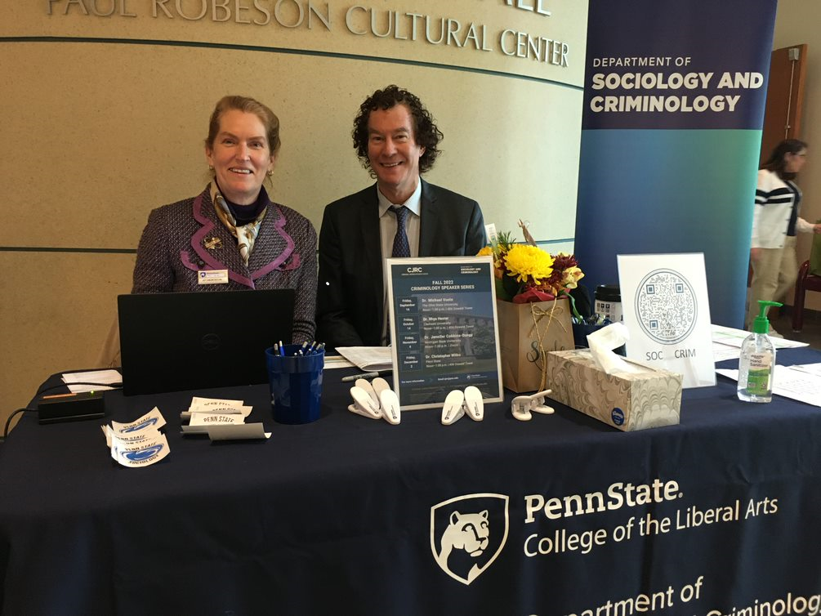

*Joy and Richard Killian*

***CAMPUS CONNECTIONS***

***CAMPUS CONNECTIONS***

Glenn Sterner, C3N Faculty Affiliate at Penn State Abington, Receives Rural Health Hero of the Year Award

Glenn Sterner, C3N Faculty Affiliate at Penn State Abington, received the 2022 Rural Health Hero of the Year Award. “The award recognizes an outstanding leader who demonstrates a personal and professional commitment to the rural health needs of their community, works with relevant organizations to develop or expand a program that addresses an identified need, and goes above and beyond the call of duty. Sterner was lauded for his leadership and coordination between organizations across the state. In addition to being a champion and advocate for rural communities, his work on substance use, human trafficking, and various health conditions have had meaningful impacts on rural residents of Pennsylvania.” Congrats Glenn!

Read more about Glenn’s contributions [here](https://www.psu.edu/news/health-and-human-development/story/pennsylvania-office-rural-health-honors-rural-health-champions/).

Glenn Sterner, C3N Faculty Affiliate Publishes in *The Milbank Quarterly*

# A new article was recently published in *The Milbank Quarterly*, titled “Conceptualizing and Measuring Abatement from the Opioid Epidemic: A Case Study from Pennsylvania.” The Penn State University authors Danielle Rhubart, Qiushi Chen, Glenn Sterner, C3N Faculty Affiliate at Penn State Abington, Robert Newton, Bethany Shaw, Dennis Scanlon. Finally, Glenn spoke about the paper in a recent [news article](https://www.cnn.com/2022/12/12/health/rural-opioid-settlement-funds-khn-partner).

Read the article [here](https://onlinelibrary.wiley.com/doi/10.1111/1468-0009.12589).

***TREATMENT AND REHABILITATION***

# Glenn Sterner, C3N Faculty Affiliate, Publishes in *Journal of Psychoactive Drugs*

A new article was recently published in the *Journal of Psychoactive Drugs*, titled “Social Networks, Stigma, and Hepatitis C Care Among Women Who Inject Drugs: Findings from A Community Recruited Sample” The authors include Abenaa Jones, CJRC UP Faculty Affiliate, Kristin Schneider, John Hopkins University, Oluwaseun Falade-Nwulia, John Hopkins University, Glenn Sterner, C3N Faculty Affiliate at Penn State Abington, Karin Tobin, John Hopkins University, and Carl Latkin, John Hopkins University.

Read the article [here](https://www.tandfonline.com/doi/full/10.1080/02791072.2022.2129886).

## Enhanced Seed Grant Award: Probation Officers’ Attributions of Clients and Inequity in the Justice System

Dr. Holly Nguyen, Associate Professor of Sociology, Criminology, and School of Public Policy and University Park CJRC Faculty Affiliate, Dr. Zach Rowan, Assistant Professor in the School of Criminology at Simon Fraser University, and Dr. Evan McCuish, Associate Professor in the School of Criminology at Simon Fraser University, will conduct a pilot study of whether, and in what way, probation officers’ pre-sentence reports (PSRs) generate disparities in sentencing outcomes. The investigators will analyze a random sample of PSRs completed on a subsample of participants from the Incarcerated Serious and Violent Young Offender Study (ISVYOS), an ongoing longitudinal study conducted in British Columbia that aims to identify risk factors in incarcerated youth informative of adult outcomes such as reoffending.

***COURTS AND SENTENCING***

## Seed Grant Award: Bail Decision-Making in a Rural Jail: Does Bail Reflect Risk or Extra-Legal Factors?

Dr. Thomas Loughran, Professor of Sociology, Criminology, and School of Public Policy and University Park CJRC Faculty Affiliate, Bryanna Fox, Associate Professor in the  Department of Criminology at University of South Florida, and Emerson Waite, PA Commission on Sentencing Graduate Student**,**in partnership with the American Civil Liberties Union (ACLU), the University of South Florida’s Center for Justice Research & Policy (CJRP), and a rural Florida jail, will evaluate the factors contributing to pretrial decisions—whether an individual is released on their recognizance, is denied bail, or receives monetary— and whether these decisions are associated with legal factors, extra-legal factors, and/or objective risk level. The second part of the proposed project involves interviewing justice involved individuals to gain perspective on why they are unable to make bail and how that affects them mentally and behaviorally, their perceptions of the justice system, and the implications of these decisions on their future. Finally, the investigators will also interview judges making these decisions in rural Florida, to assess their consideration of factors (e.g., legal, extra-legal, risk) in alignment with the four elements of focal concerns theory.

Criminal Justice Research Center Graduate Student Alumni Hired at Pennsylvania Commission on Sentencing

## The Research & Data Analysis Unit welcomes Theodore (Ted) Greenfelder and Jordan Zvonkovich as Research Data Analysts.

## Ted and Jordan previously worked at the CJRC as Graduate Student Assistants. Congrats Ted and Jordan!

Senior Deputy Director of the Pennsylvania Commission on Sentencing Presents at the International Conference of Sentencing Commissions at the Supreme Court of Korea

Matthew Kleiman, Senior Deputy Director of the Pennsylvania Commission on Sentencing, presented (*Data as the Lifeblood of Sentencing Commissions)* in November at the International Conference of Sentencing Commissions at the Supreme Court of Korea. The conference was hosted to celebrate the 15th anniversary of the development of sentencing guidelines in Korea.

PA Commission on Sentencing Graduate Student wins Pennsylvania Commission on Sentencing Thesis Award

“Adding a Spatial Component to Contextual Sentencing Research” by Emerson Waite earned the Criminology Master’s Thesis Award for 2021-2022.  This novel research examines how criminal sentencing, specifically the use of incarceration within a county. is influenced by community factors and social processes in neighboring counties. This study expands upon prior sentencing that looked only at social context of the focal county without regard to broader social context.  The most interesting finding was that the political context of nearby counties did impact sentencing within a focal county in such a way that increases in conservatism in surrounding counties decreased the use of incarceration in the focal county. These findings were notable because without accounting for the political context of neighboring counties the political context of the focal county had no effect.

CJRC Director Publishes in *Justice Quarterly*

CJRC Director, Dr. Jeffery Ulmer, recently published three articles in *Justice Quarterly* with colleagues.

[Back to Basics: A Critical Examination of the Focal Concerns Framework from The Perspective of Judges](https://www.tandfonline.com/doi/full/10.1080/07418825.2022.2132274), with Dr. Eric Silver, CJRC Faculty Affiliate, and Dr. Lily Hanrath.

[Racialized Victim Gender Differences in Capital Decision Making in Pennsylvania](https://www.tandfonline.com/doi/full/10.1080/07418825.2021.1965187), with Dr. Lily Hanrath, and CJRC Managing Director, Dr. Gary Zajac.

[Expanding Our Understanding of Focal Concerns: Alternative Sentences, Race, and ‘Salvageability.](https://www.tandfonline.com/doi/full/10.1080/07418825.2021.1954234) with Dr. Miranda Galvin, PA Commission on Sentencing Postdoctoral Scholar Alumni at the CJRC.

## Seed Grant Award: Examining Patterns of Firearms Interest Following Covid-19 Lockdowns, George Floyd Protests, and the Election of Joe Biden in 2020

Dr. David Ramey, Associate Professor of Sociology and Criminology and University Park CJRC Faculty Affiliate will examine how three major social events in 2020 – Covid-19 Pandemic, social justice protests following the murder of George Floyd, and the election of Joe Biden – influenced firearms interest, with a focus on understanding how local factors and events shaped such interest. Using weekly data from an anonymous panel of 40 million mobile devices, aggregated to the census block, Dr. Ramey will examine whether foot traffic to licensed firearms dealers increased in the weeks immediately following the passage of stay-at-home policies (March-April 2020), following the George Floyd protests (June-August 2020), and in the aftermath of Joe Biden’s election in the heavily contested 2020 election (November 2020-January 2021).

***PUBLIC SAFETY AND CRIME PREVENTION***

Criminal Justice Research Center

The Pennsylvania State University

211 Oswald Tower

University Park, PA 16802

814-867-3292

<https://cjrc.la.psu.edu>

December 2022