Changes in the Age Structure of Rural Offending in Pennsylvania and Their Impact on the Age-Sentencing Relationship

Jeffery T. Ulmer, Ph.D.

Professor of Sociology and Criminology
Penn State University
University Park, PA

Assistance Provided by:

Jordan Zvonkovich

Kaitlyn Konefal
Summary

The goals of this report are as follows: 1) to investigate changing trends in the age distribution of drug, violent, and property crime arrests in Pennsylvania, especially rural counties; 2) to examine the impact of changes in arrest rates of older age groups on changes in sentencing patterns for those groups statewide and in rural counties; 3) to assess whether and how rural counties have increased their use of rehabilitation and treatment-oriented sentences such as RIP for older offenders, young offenders, or both.
Age Changes Among Arrestees and Convicted Defendants.
Pennsylvania’s population did indeed “age” from 2000 – late 2010s. In both rural and urban counties, the proportion of residents aged less than 25 declined, and the proportion aged 50 or older substantially increased. However, the age changes in arrests are much greater than the age changes in population. There has been a substantial decline in the proportion of younger arrestees (those under 24), and an increase among older arrestees. This pattern was true of drug, property, and violent arrests. In percentage increase terms, the number of arrestees aged 50+ increased 250% since 2001 in rural counties, and 200% in urban counties. The percent of offenders convicted and sentenced who were aged 24 and under, the typical “crime prone” age group, also declined across the state. The extent of this decline was the most dramatic in rural counties.
Overall, these two developments constitute a substantial change in the age-crime curve in Pennsylvania from 2000 to the late 2010s. This change also is a departure from the so-called “typical” U.S. modern age-crime curve, which is said to be a sharp inverted U-shape, with up to 66% of crimes accounted for by the “crime prone” age group of 15-24 year olds, and negligible proportions of crime among those in their 40s and over 50. It is unclear what demographic, societal, or criminal justice factors are behind these trends in the age composition of arrestees and convicted offenders. What is clear is that Pennsylvania’s courts have been increasingly confronted with increasingly older offenders.
Changes in the Age-Sentencing Relationship?
Incarceration statewide
For the combined years of 2001-2017 for the whole state, the age-sentencing relationship differed from that found by older research. A negative linear relationship between incarceration and age characterizes the past two decades, rather than an inverted U-shape non-linear relationship found in earlier studies. Also, the pooled year findings showed a steady, almost linear decline in the odds of incarceration overall from 2003 to 2017. Thus, Pennsylvania’s courts have shown decreasing propensity to incarcerate offenders over the past two decades.
In general, there were a few changes in the age-incarceration relationship from 2001-2017. In each period (2001-2004, 2005-2009, 2010-2012, 2013-2017), the younger groups were more likely to be incarcerated than the older groups (30-39 and up), and the offenders aged 50 or over consistently had the lowest odds of incarceration. However, the incarceration chances of those under 20 changed relative to the other age groups. In 2001-2004, the youngest offenders were significantly less likely to be incarcerated than those 20-24 and 25-29. By 2013-2017, those aged less than 20 were significantly more likely to be incarcerated than those in their 20s.
Incarceration length statewide
For incarceration length, the pooled statewide results for 2001-2017 look somewhat more similar to the inverted U-shape for the age-sentencing severity relationship found by prior research, but the differences between the younger age groups are very small. There was little discernable change in the sentence length results over time. Substantively, across time periods, the only groups with meaningfully shorter sentences are those in their 40s and 50 and over.
Downward departures statewide
Downward departures were defined as sentences that fell below the mitigated range of the guidelines. For the pooled years, the age association with downward departures somewhat resembles the inverted U-shape found by the 1990s research. Those under 20 are more likely to get downward departures, while those in their 20s and 30 are less likely. Then, those 50 and over are the most likely to get downward departures. Unlike in the incarceration analysis, where the youngest offenders lost their advantage in incarceration odds over time, the youngest offenders were significantly more likely to receive downward departures than those 20-24 in and after 2005-2009. Also, in each period, those 50+ were most likely to get such departures.
Another interesting pattern was that downward departures became steadily more likely over time. By 2015-2017, all offenders had about 50% greater odds of receiving a downward departure than their counterparts in 2001. Thus, guideline conformity seems to have declined throughout the past two decades.
RIP sentences statewide
Across all years statewide, the only group with a substantively stronger difference in RIP sentence odds is the 50 and over offenders. Regarding trends in RIP sentences for all offenders, the later years tend to see lower odds of RIP sentences compared to 2001. In fact, the odds of any offender receiving RIP in 2016 and 2017 are about two-thirds those of offenders in 2001.
There appears to be some notable change in the relative likelihood of different age groups receiving RIP sentences. In the earliest period, the youngest offenders were significantly more likely receive these sentences, but those in their mid-late 20s were less likely to receive them, and offenders 50+ were about equally likely to receive an RIP sentence as those below 20. This pattern changes in the later periods. By the 2010s, only older offenders have notably greater odds of RIP.
The Age-Sentencing Relationship in Rural Counties
Incarceration in rural counties
The pattern of age and incarceration for rural counties was similar to that for the statewide analysis, but the decline in incarceration odds with age was stronger and more pronounced in the rural counties. As with the statewide analysis, there was also a decline over time in the odds of any given offender being incarcerated in rural counties. As for change in the age relationship with incarceration over time, there was little in evidence for the rural counties.
The analysis also examined the role of age in incarceration in the rural counties for drug, violent, and property offenses separately. For drug offenses and property offenses, in each time period, the older two groups of offenders (40-49 and 50+) were consistently the least likely to be incarcerated, and the younger age groups were similar in their likelihood of incarceration. For violent offenses, the youngest group of offenders (under 20) generally were incarcerated more frequently than those in their 20s and 30s. Older offenders were consistently least likely to be incarcerated among the rural violent offenders.
Incarceration length in rural counties
When pooling the years 2001-2017, the youngest offenders, and those 40-49 and 50+ received significantly shorter incarceration sentences. When considering changes over time, there were few major age differences in incarceration length, and few clear patterns of change. For drug offenses, the youngest defendants generally received the shortest sentences across the time periods, even shorter than those for older offenders. Rural drug offense sentence lengths provide one the only exceptions to the general pattern of the greatest leniency being given to older offenders. For rural violent offenses, the younger age groups show almost no significant differences in sentence lengths across time periods, and older offenders receive shorter incarceration sentences. Rural property offenses showed the fewest significant age differences in any of the time periods.
Downward departures in rural counties
In the pooled years, the pattern for age and downward departures in rural counties generally resembled the statewide model for downward departures. In the analysis of changes over time, in general the younger groups were not significantly different from each other. A consistent pattern across time in the rural counties was that older offenders, particularly those 50+, were meaningfully more likely to receive downward departures. This is a notable difference from the pattern for the whole state. Statewide, offenders under 20 were also significantly more likely to receive departures below guidelines.
RIP sentences in rural counties
The pooled years RIP sentence analysis for the rural counties was roughly similar to the statewide analysis. The odds of RIP sentences did not increase appreciably until the 40s and 50+ age groups. Thus, in the rural counties, older offenders are most likely to receive RIP sentences. Regarding change over time, the age patterns for RIP sentences in the rural counties were almost identical to the RIP analysis for statewide RIP sentences across time. Statewide and in rural counties, younger offenders (those in their 20s and below) became less likely to receive RIP sentences over time, and older offenders (especially those 50 and over) became most likely to receive them.
Overall, then:
- Pennsylvania has seen a decline in the numbers and proportions of defendants in the traditional “crime prone” age group, but an increase in the presence of older offenders. This trend was especially pronounced in rural counties.
- Older offenders consistently receive the most lenient sentences, and are most likely to receive RIP sentences. To some extent, the youngest offenders, even though there are fewer of them, receive more severe sentences and have seen declining likelihood of RIP sentences.
- Given the increased number of older offenders, and the greater likelihood that they will receive non-incarceration sentences, there should be further inquiry into the extent to which counties, especially rural ones, have adequate probation, treatment, and RIP resources geared toward older offenders.
- Further study might also examine more closely the seemingly increased severity of sentences for young offenders relative to older ones, inquiring into the reasons for, and appropriateness of, this trend.
Changes in the Age Structure of Rural Offending in Pennsylvania and Their Impact on the Age-Sentencing Relationship

I. Background and Overview
The relationship between age and crime is said to be the most durable fact of criminology. The inverted U-shaped age-crime curve, in which crime is committed by adolescents and young adults and declines sharply thereafter, is said by some to nearly invariant across societies and time periods (Hirschi and Gottfredson 1983). Older and more recent research (e.g., Greenberg 1985; Steffensmeier et al. 1989; 2017; 2020; Steffensmeier and Streifel 1991; Ulmer and Steffensmeier 2015) has emphatically critiqued the invariance thesis regarding the age-crime curve, finding that it varies across societies and time periods.
Similarly, the pattern by which punishment severity varies by age is also considered somewhat conventional wisdom in sentencing research. A similar inverted U-shaped relationship has been found to characterize age and sentencing, with sentencing severity being lesser for adolescent offenders, most severe for those in their mid-20s, and then declining steadily after 40 (Steffensmeier et al. 1995; 1998; 2017). Specifically, Steffensmeier et al. (1995) examined the effects of age on incarceration and its length. They found that offenders aged 18-19 and those in their 30s had statistically similar incarceration odds, while those aged 20-29 had the highest likelihood of incarceration. Then, incarceration odds steadily declined among those in their 40s, 50s, and beyond. Regarding incarceration length, Steffensmeier et al. (1995) found that offenders 18-19 received modestly shorter sentences than those in their 30s, while those aged 20-29 received longer sentences. Then, average sentence lengths declined steadily for offenders in their 40s, and sharply for those 50 and beyond. Notably, there is actually little in-depth investigation of the age and sentencing relationship beyond a few key studies, and those are mostly from the 1990s and earlier (Steffensmeier et al. 2017).
However, a major change has occurred in the age-crime curve in rural Pennsylvania counties, at least for drug crime. As will be demonstrated later in this report, there have been notable increases in proportions of older arrestees for drug crimes in rural Pennsylvania counties since the early 2000s. For example, according to UCR arrest data: 1) the proportion of drug arrestees aged less than 24 has declined from 65% to just above 40% from 2000 to 2016, 2) the proportion of drug arrestees aged 30-39 has increased from roughly 14% in 2003 to 24% in 2016; 3) the proportion of drug arrestees aged 50 + has increased from roughly 2% in 2000 to 7% in 2016. These patterns may be partially due to the “aging” of Pennsylvania’s population in general, and even more of Pennsylvania’s rural counties, which have seen declining overall populations and the out-migration of many younger residents, leaving behind smaller, older populations. The increase in the proportions of arrests made up of older people may also be connected to the opioid crisis that has beset Pennsylvania, and America, since the mid-2000s.
These trends in drug crime may have changed not only the age/crime relationship for property and violent offenses in rural areas, but may also have altered age patterns in sentencing in unknown ways. No prior research appears to have explored these possibilities, either in Pennsylvania or elsewhere. This report focuses on assessing whether and how changes since the early-mid 2000s in Pennsylvania’s proportional age distribution of rural arrests, especially for drug crimes, have affected age-related sentencing patterns in rural Pennsylvania county courts. The specific analytical goals of the project are as follows:
1) To investigate changing trends in the age distribution of drug, violent, and property crime arrests in Pennsylvania, especially rural counties.
2) To examine the impact of changes in arrest rates of older age groups (defined as those aged 30-39, 40-49, and over 50) on changes in sentencing patterns for those groups statewide and in rural county courts.
3) To assess whether and how rural counties have increased their use of rehabilitation and treatment-oriented sentences such as intermediate punishments for older offenders, young offenders, or both.
The report first examines changes in the age distribution of arrests for drug, property, and violent crimes statewide, and in rural counties in particular, from 2000 to 2017. For reference, changes in the age distributions of rural and urban Pennsylvania populations are also presented. Second, the report shows changes in the age distributions of convicted and sentenced offenders statewide and in rural counties from 2000 to 2017, and the breakdown of types of sanctions imposed for different age groups. Third, the report presents statistical models examining the association between defendant age and various sentencing outcomes, and whether (and how) these associations have changed from 2000 to 2017. These models are presented for the whole state, and then more detailed analyses are presented for the rural counties.
II. Changes in the Age-Crime Curve
As mentioned, the population of Pennsylvania, especially in rural counties, has been aging. That is, Pennsylvania’s population composition has shifted since 2000 to encompass smaller proportions of younger residents and larger proportions of older ones. Below, two figures show the changes in the age composition of the populations of Pennsylvania’s urban and rural counties, respectively. For this report, the classification of rural counties is roughly based on the PCS county classes; and the rural counties include the following counties: Adams, Armstrong, Bedford, Blair, Bradford, Butler, Cambria, Cameron, Carbon, Centre, Clarion, Clearfield, Clinton, Columbia, Crawford, Elk, Fayette, Forest, Franklin, Fulton, Greene, Huntingdon, Indiana, Jefferson, Juniata, Lawrence, Lycoming, McKean, Mercer, Mifflin, Monroe, Montour, Northumberland, Perry, Pike, Potter, Schuylkill, Snyder, Somerset, Sullivan, Susquehanna, Tioga, Union, Venango, Warren, Washington, Wayne, Wyoming. The urban counties include all other counties.
Figure 2.1: Changes in Pennsylvania Population Age Groups: Urban Counties
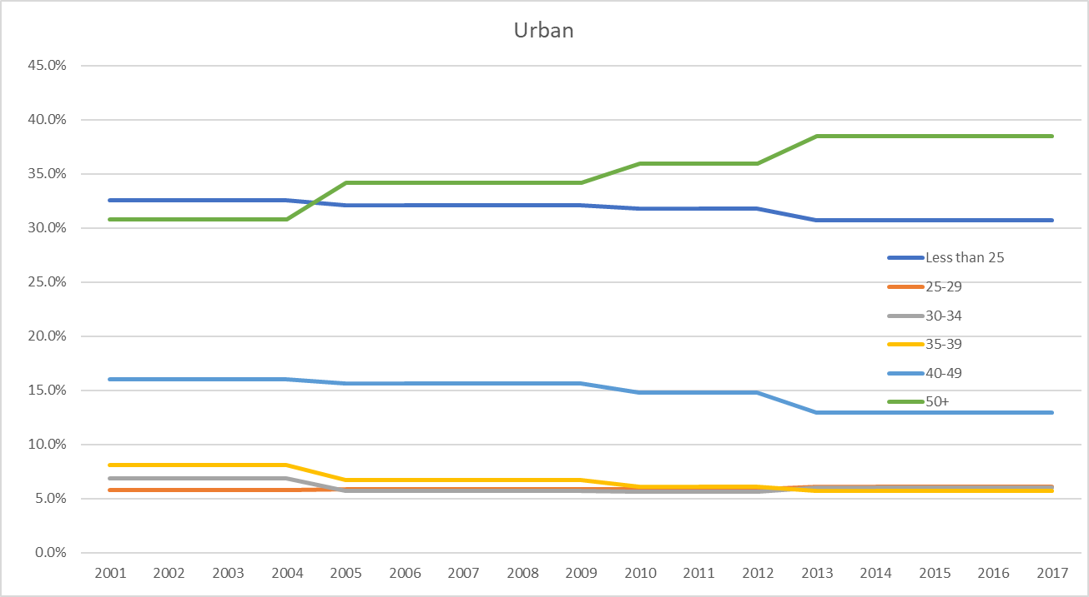
Figure 2.2: Changes in Pennsylvania Population Age Groups: Rural Counties
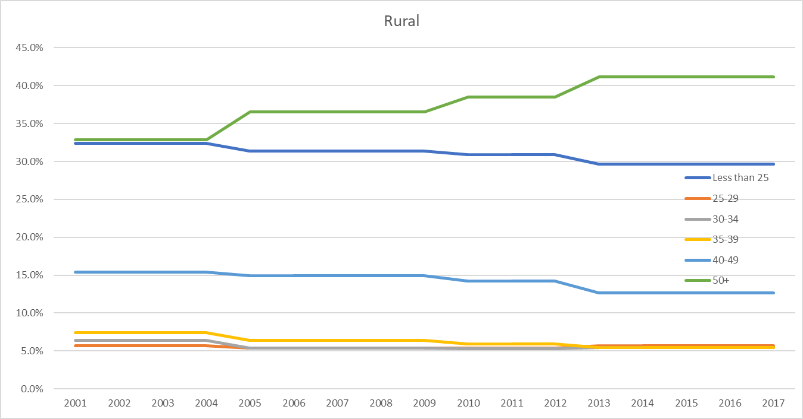
In both rural and urban counties, the proportion of residents aged less than 25 has declined, and the proportion aged 50 or older has substantially increased. In urban counties, the population share of those aged 50 or over increased from 31% in 2001 to 39% in 2017, and the population share of those aged 25 or younger has declined from 33% in 2001 to 31% in 2017. In the rural counties, this shift has been more pronounced. The population share of those aged 50 or over increased from 33% in 2001 to 41% in 2017, and the population share of those aged 25 or younger has declined from 32% in 2001 to less than 30% in 2016.
Furthermore, there have been notable increases in proportions of older arrestees for drug crimes in Pennsylvania since the early 2000s, especially in rural counties. This may reflect the demographic changes shown above, but they also may reflect increased offending among older offenders (e.g., those in their 40s and 50s and up). Below, figures are presented that detail these changes statewide and in rural counties, from the Uniform Crime Reports annual arrest statistics.
Change in Age Percentages for Drug Arrests, 2000-2016, Rural vs. Urban Counties, Figure 2.3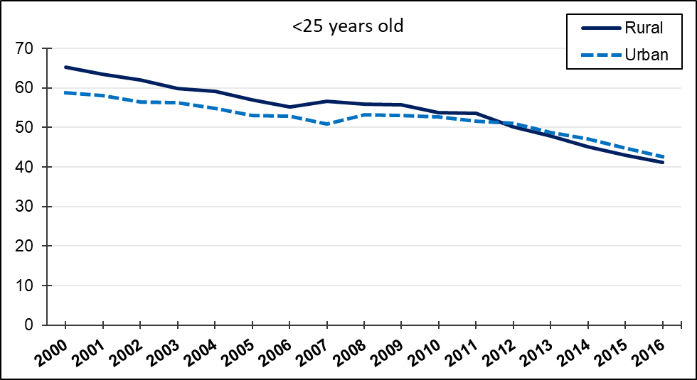
Figure 2.4
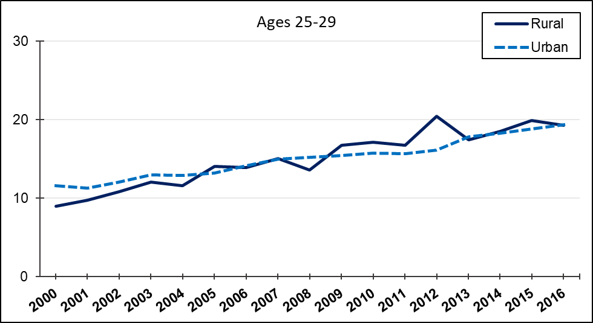
Figure 2.5
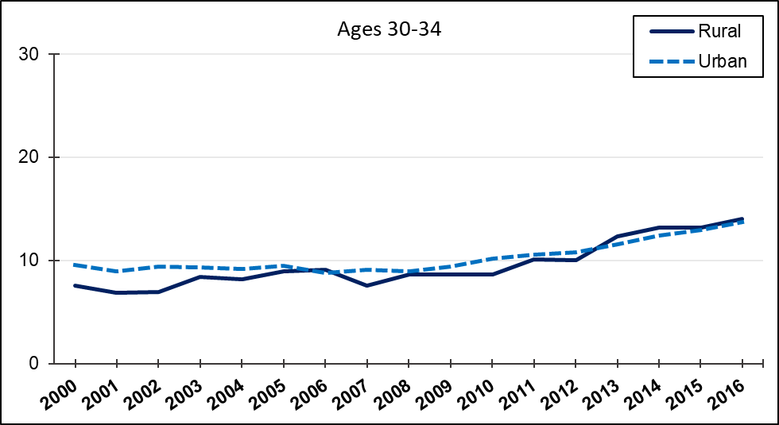
Figure 2.6
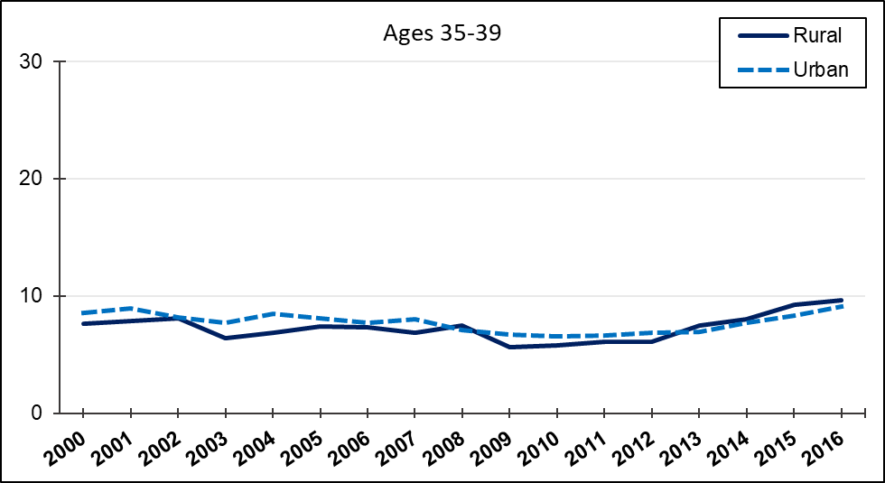

Figure 2.7
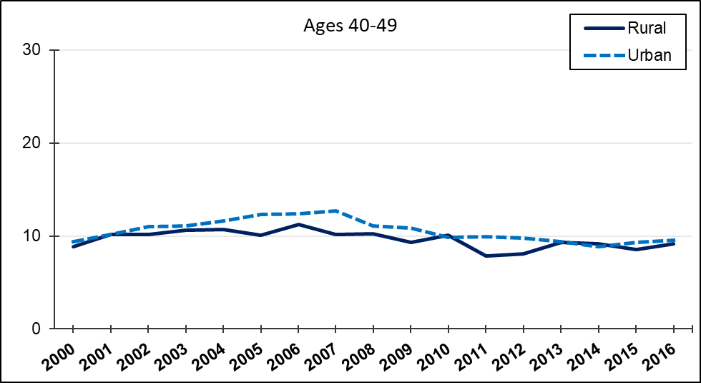

Figure 2.8
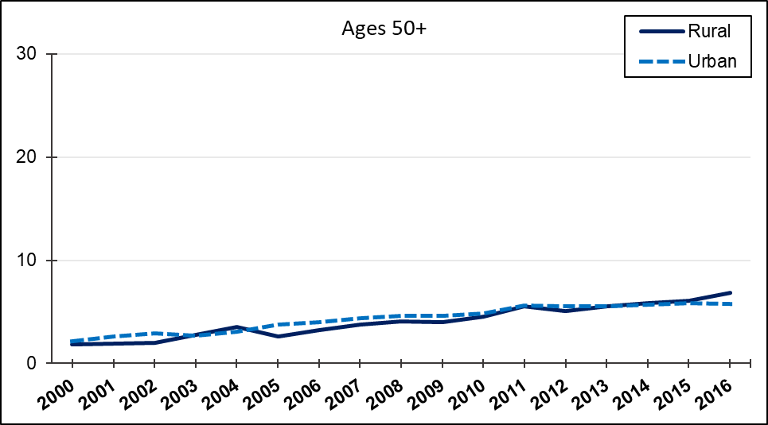
These figures show some common trends, with some moderate differences between rural and urban counties. In general, for both urban and rural counties, the proportion of drug arrestees made up of the youngest offenders declined substantially. For rural counties, this decline was from roughly 65% to 40% in the percent of arrestees aged 25 or less. By contrast, arrestees aged 25-29 increased by about 10% in both rural and urban counties, and those aged 30-34 increased by about 5%. The percent of arrestees aged 35-39 and 40-49 stayed relatively flat. Finally, though arrestees aged 50 or more remain the smallest age group throughout, there is a significant increase in this group’s proportion of drug offense arrestees, especially for rural counties. Those aged 50 or more comprised about 2% of drug arrestees in rural counties in 2000, but about 7% in 2016. For urban counties, this increase was from 2% to 6%. Though arrestees over 50 remain the smallest age group percentage-wise, this would still translate into a noticeable increase in the absolute number of arrestees 50 or over, especially in rural counties. Next, we turn to age-arrest trends for violent/personal arrests from the UCR data.

Change in Age Percentages for Violent Crime Arrests, 2000-2016, Rural vs. Urban Pennsylvania Counties
Figure 2.9
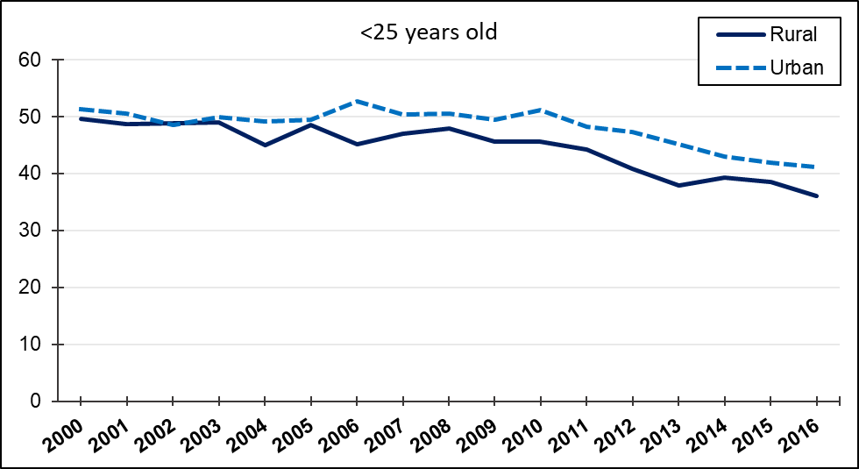
Figure 2.10
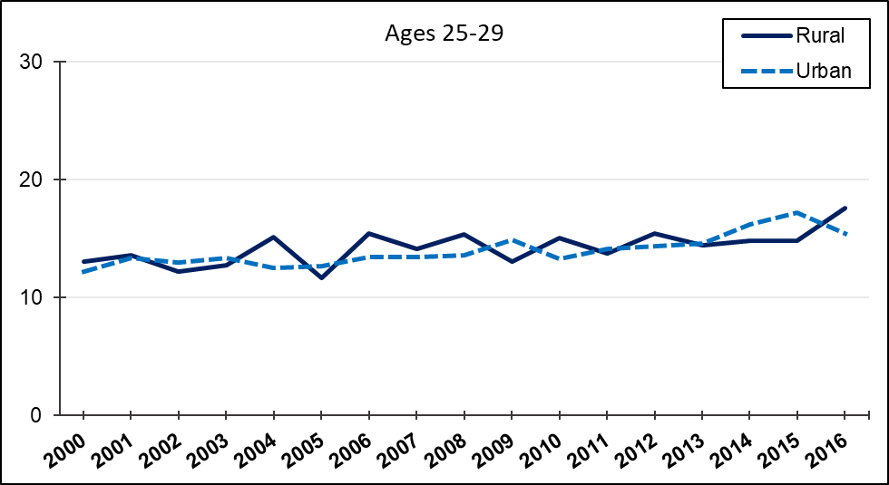
Figure 2.11
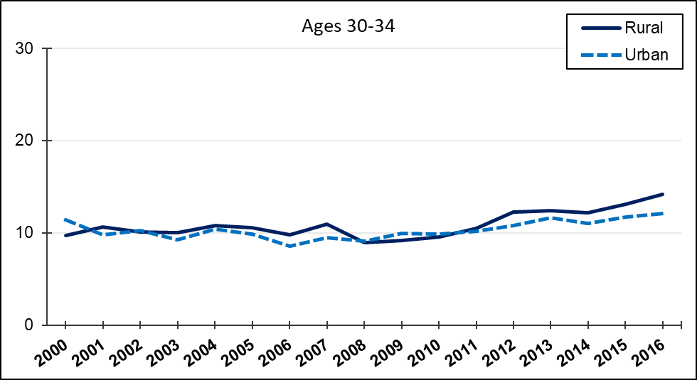

Figure 2.12
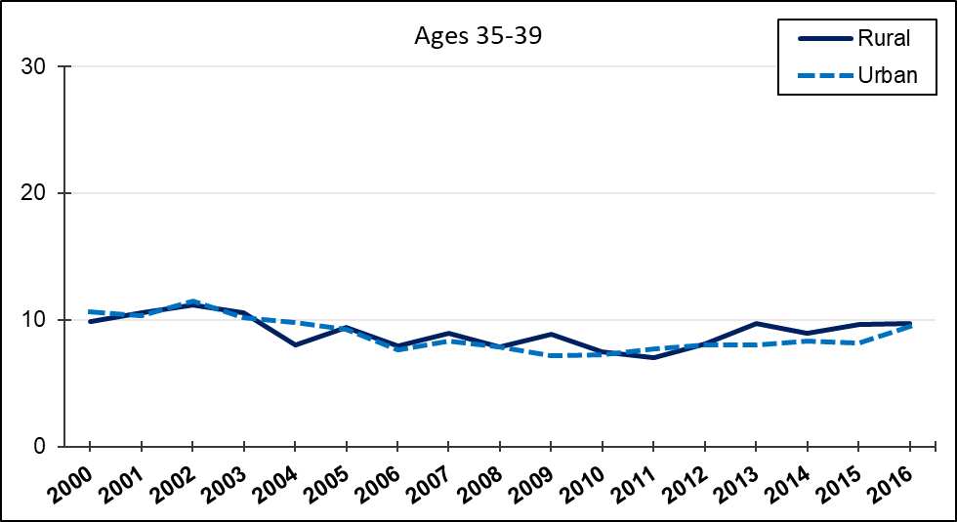
Figure 2.13
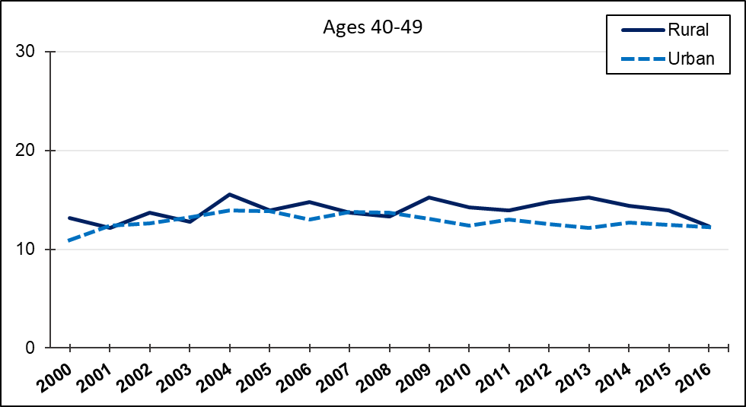
Figure 2.14
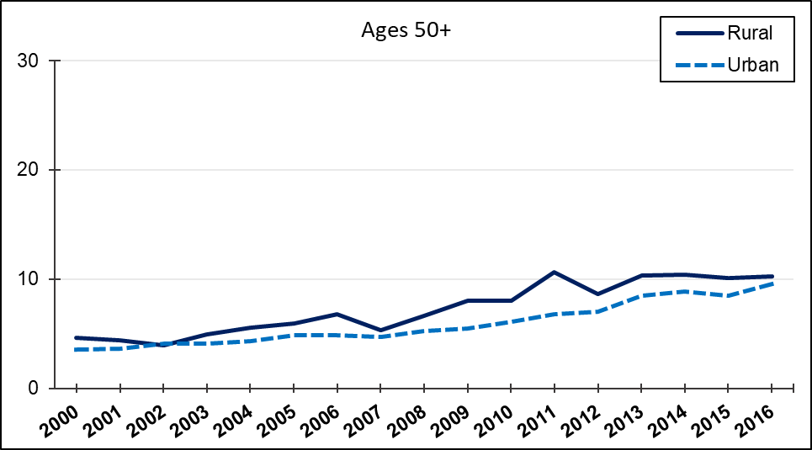
The changes in the age group proportions of arrestees for violent/personal crimes are similar to the drug arrests earlier. As with the drug arrests, the proportion of violent/personal crime arrestees aged less than 25 declined substantially. For rural counties, this decline was from roughly 50% to 36%, and for urban counties it was 51% to 41%. The proportions of arrestees aged 25-29 and 30-34 increased modestly. Again, the proportion of arrestees aged 50 or more roughly doubled. Those aged 50 or more comprised about 5% of violent arrestees in rural counties in 2000, but about 10% in 2016. For urban counties, this increase was from 4% to 10%. Thus, both rural and urban counties saw a substantial increase in the number of violent offense arrestees over 50. Finally, we turn to age-arrest trends for the UCR property arrests.
Change in Age Percentages for Property Crime Arrests, 2000-2017, Rural vs. Urban Pennsylvania Counties
Figure 2.15
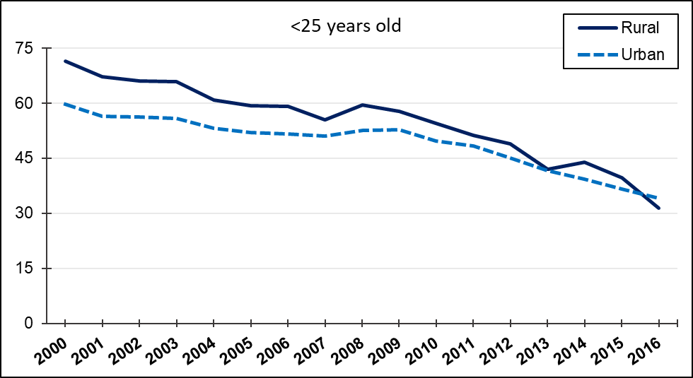

Figure 2.16

Figure 2.17

Figure 2.18

Figure 2.19
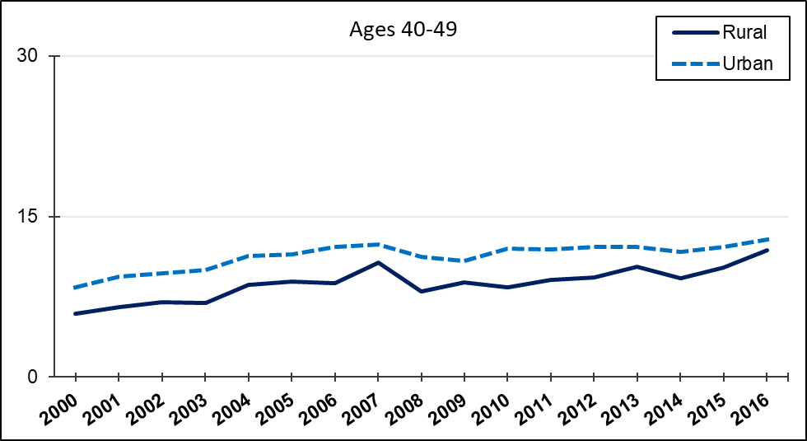

Figure 2.20
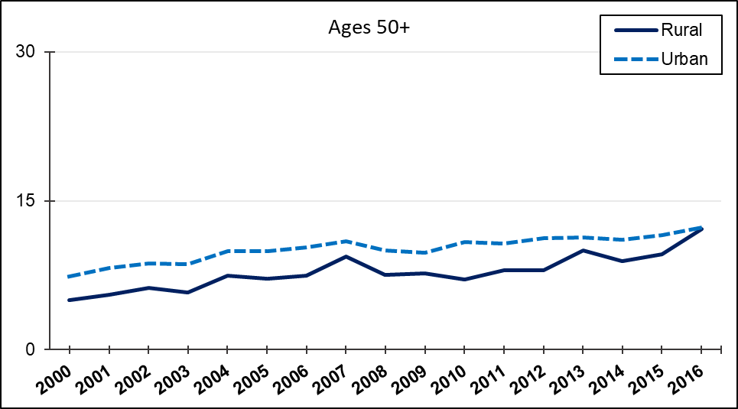
For property offenses, the proportions of the youngest age group among arrests declined the most substantially compared to drug and violent arrests. The percent of property arrests among the less than 25 age group decreased from 72% to 31% in rural counties, and from 59% to 34% in urban counties. All of the other, older age groups increased to varying degrees. The biggest increase was among those aged 25-29, from 7% to 19% of property arrestees in rural counties, and from 9% to 17% in urban counties. Those aged 30-34 increased from 6% to 14% in rural counties and 8% to 14% in urban ones, and the 40-49 age group increased from 6% to 12% in rural counties and 8% to 13% in urban ones. In rural counties, the arrests of those aged 50+ more than doubled from 5% to 12%, while in urban counties this increase was from 7% to 12%. Overall, the arrestee pool has gotten older, with sharp declines across the board among the youngest age group and increases in those in their late 20s, to a lesser extent in those in their 30s and 40s. There were also noticeable increases in the oldest group of arrestees.

III. Changes in the Age of Offenders Sentenced
Has the age composition of offenders convicted and sentenced in Pennsylvania’s Courts of Common Pleas changed in similar ways as the age composition of arrestees for UCR index offenses? The figures below depict the change in the proportions of convicted and sentenced offenders made up of different age groups, from the PCS sentencing data, for Allegheny and Philadelphia counties, and for other urban and rural counties, from 2001-2017.
Figure 3.1
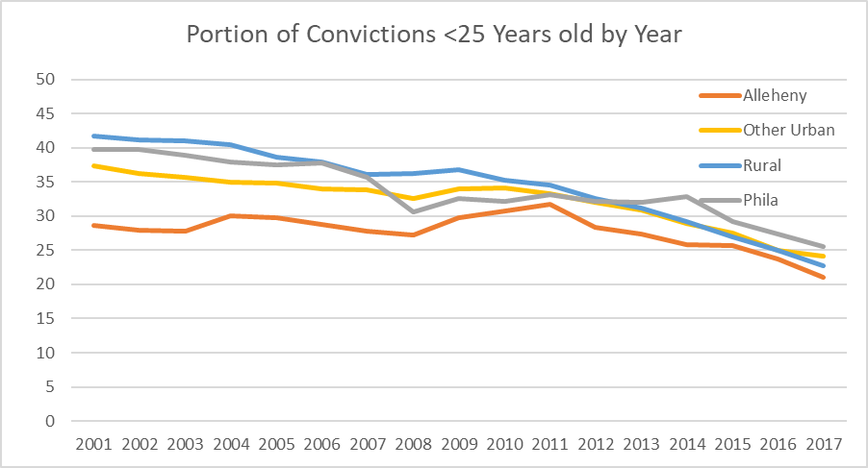

Figure 3.2
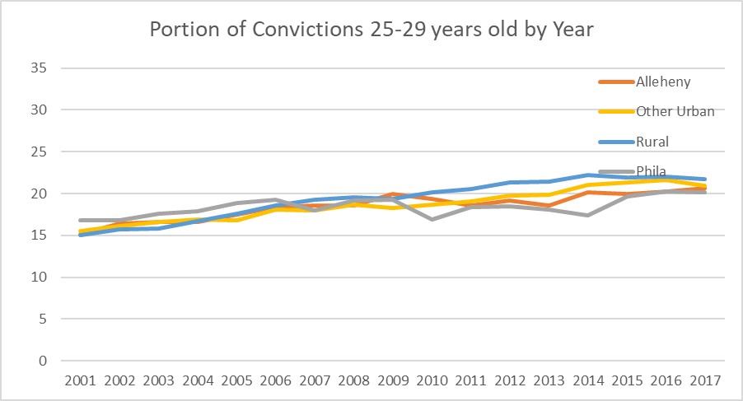
Figure 3.3
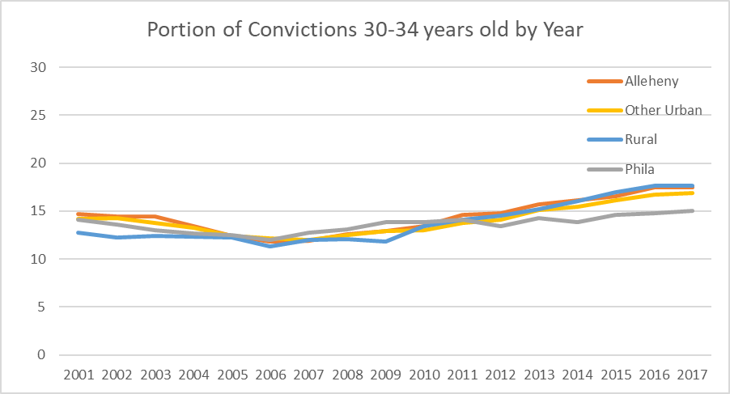

Figure 3.4
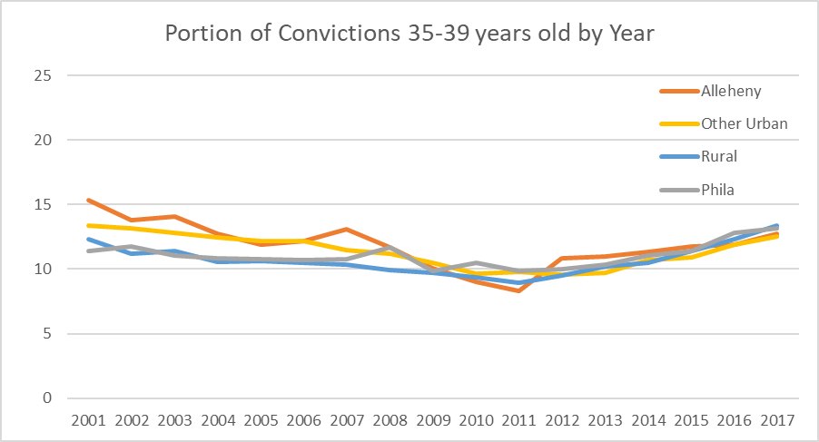
Figure 3.5
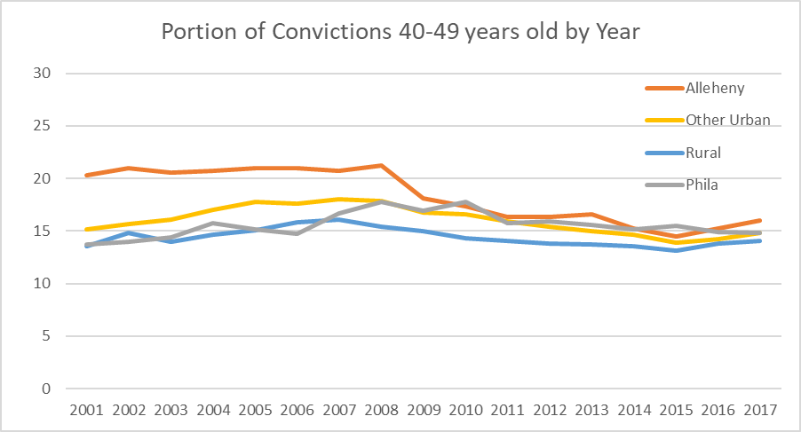

Figure 3.6
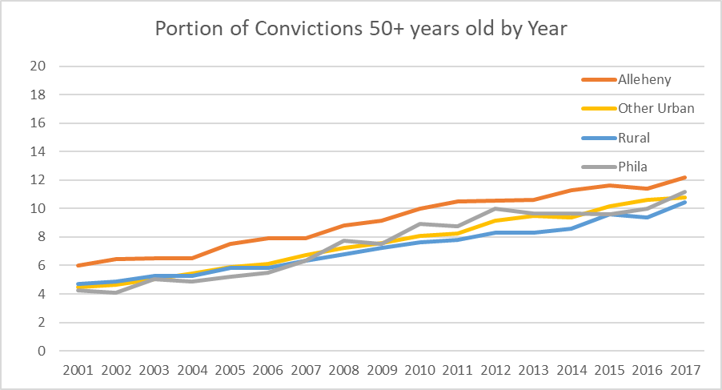
The percent of offenders convicted and sentenced who were aged 24 and under, the typical “crime prone” age group, declined across the state. The extent of this decline, however, varied between the large metro counties, other urban counties, and rural counties. For Allegheny, this decline was from 29% to 20%, for Philadelphia it was 39%-26%, for other urban it was 37-24%, and for rural counties it was the most--42% to 23%. In general, the proportion of offenders ages 25 to 29 increased statewide, but this increase was least in Philadelphia (from 17% to 20%) and most in rural counties (from 15% to 22%). The percentages of the age groups in the middle mostly stayed flat over time, with the exception of Allegheny County, which saw a decline in offenders aged 40-49 from 20% to 16%.
As with arrestees, the state saw an increase in convicted and sentenced offenders aged 50 and over, an age group that typically constitutes a small portion of offenders in criminological research. The trend was the same in Philadelphia, Allegheny, the other urban counties, and rural counties. This group doubled from 6% of offenders in Allegheny County to 12%, and increased from 4% to 11% of offenders in Philadelphia and in the other urban counties. In the rural counties as with Allegheny, the proportion of offenders aged 50 or over also doubled, from 5% to 10%.
Thus, the different-sized counites in the state experienced a similar trend in the age of convicted and sentenced offenders, with a sharp decline in the proportion of the youngest offenders, and increases in offenders aged 25-29, and especially among those aged 50 and over. Again, those aged 50 and over still constitute the smallest portion of offenders, and those aged less than 25 are the largest (though the aged 25-29 group is nearly their equal by the late 2010s).
It is clear that Pennsylvania’s courts have been increasingly confronted with increasingly older offenders. The next section describes and analyzes how courts have sentenced different age groups of offenders, and whether this has changed over the past two decades, given the changes in the age structure of the pool of offenders.
IV. The Age-Sentencing Relationship: Has it Changed?
Descriptive Statistics on Age and Sanctions
Below are figures that give a descriptive of overall patterns in the sanctioning of different age groups. These figures pool together the years 2000 – 2017, and break down sanction types for different age groups in urban and rural counties.

Figure 4.1
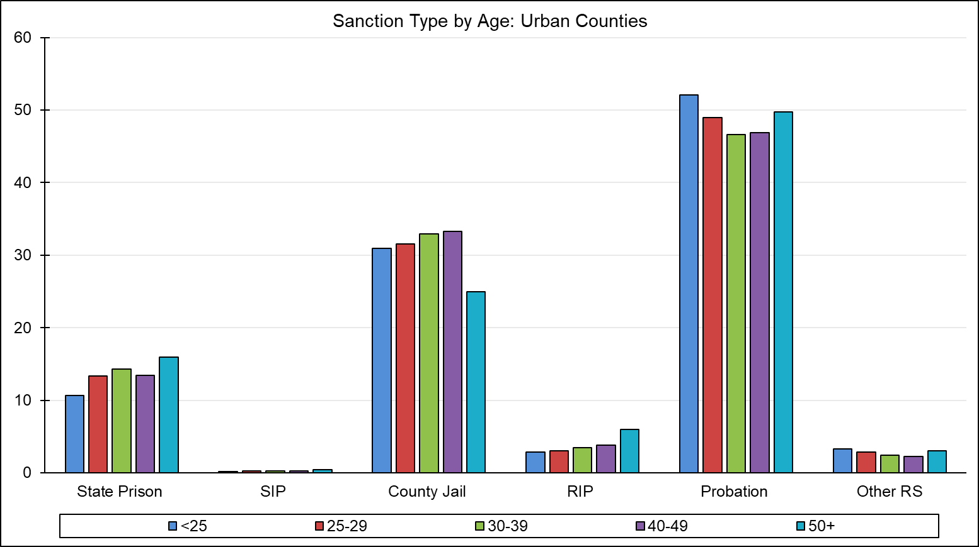
Figure 4.2
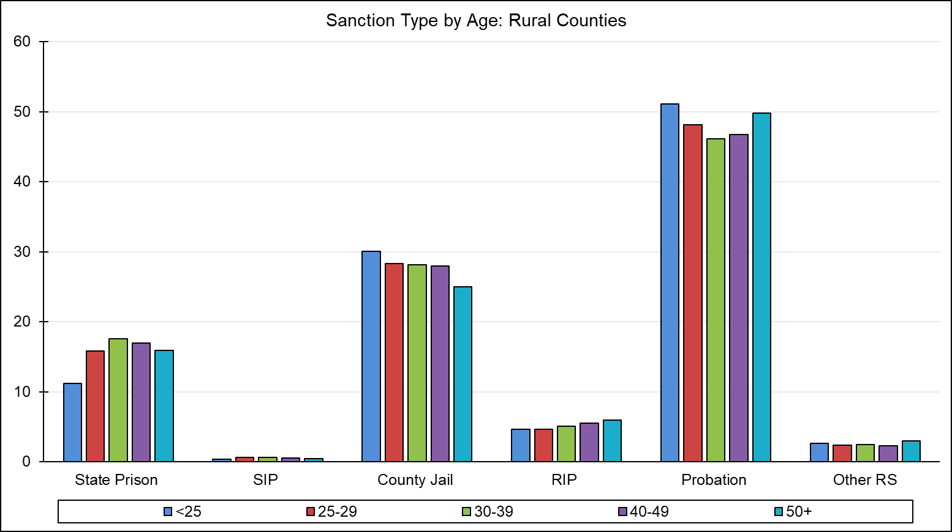
Multivariate Analyses: The Age-Sentencing Relationship Over Time
Given the changes in the age demography of arrestees and criminal offenders in Pennsylvania from 2000 to the late 2010s, what changes, if any, have occurred in the sentencing of younger offenders? Recall that prior research on the age-sentencing relationship, specifically in Pennsylvania, found an inverted U-shaped relationship had been found to characterize the sentencing severity of different age groups in the 1990s. Sentencing severity was being lesser for adolescent offenders, most severe for those in their mid-20s, and then declining steadily after age 30 (Steffensmeier et al. 1995; 1998; 2017). However, little if any research has reassessed this age-sentencing relationship in the 2000s and 2010s.
The analyses below begin by investigating the association between age and sentencing statewide, focusing on four different sentencing outcomes: 1) incarceration, 2) incarceration length, 3) departures below the PA sentencing guidelines, and 3) RIP sentences. Then, the analyses will focus specifically on the rural counties, where some of the changes on the age structure of arrestees and convicted offenders were most pronounced. These rural county sentencing analyses will replicate the statewide analyses with respect to the role of age in predicting the four different sentencing outcomes, and also consider differences in the role of age and sentencing (if any) by offense type: violent, drug, and property offenses.
First, the table below presents a logistic regression model of incarceration (jail and prison combined) for all Pennsylvania counties combined, for the pooled years of 2001 – 2017. The model includes dummy variables for Allegheny, rural counties, and other urban counties, with Philadelphia as reference category. The model also includes year fixed effects, with 2001 as the reference category.

Table 4.1: Logistic Regression Predicting Incarceration Statewide,
with offender age categories and year fixed effects (N = 1,065,968)
County | Odds Ratio |  | Std. Err
Allegheny | 0.43 | *** | 0.005
Rural | 2.96 | *** | 0.031
Medium | 2.46 | *** | 0.023
Philadelphia | Ref.
Age Category
Less than 20 | 0.98 |  | 0.007
20-24 | Ref.
25-29 | 0.98 | ** | 0.007
30-39 | 0.91 | *** | 0.006
40-49 | 0.81 | *** | 0.006
50+ | 0.65 | *** | 0.007
OGS | 1.67 | *** | 0.002
PRS | 1.51 | *** | 0.002
Trial | 2.20 | *** | 0.035
Female | 0.61 | *** | 0.004
Race
Black | 1.36 | *** | 0.007
Hispanic | 1.44 | *** | 0.013
White and Other | Ref.
Crime Type
Other | Ref.
Drug | 0.75 | *** | 0.007
Property | 1.04 | *** | 0.009
Weapons | 0.56 | *** | 0.009
Violent/Personal | 1.18 | *** | 0.011
Year
2001 | Ref.
2002 | 1.06 | *** | 0.016
2003 | 1.06 | *** | 0.016
2004 | 1.02 |  | 0.015
2005 | 0.98 |  | 0.014
2006 | 0.93 | *** | 0.013
2007 | 0.88 | *** | 0.013
2008 | 0.83 | *** | 0.012
2009 | 0.83 | *** | 0.012
2010 | 0.78 | *** | 0.011
2011 | 0.74 | *** | 0.011
2012 | 0.77 | *** | 0.011
2013 | 0.77 | *** | 0.011
2014 | 0.75 | *** | 0.010
2015 | 0.71 | *** | 0.010
2016 | 0.70 | *** | 0.010
2017 | 0.70 | *** | 0.010
* - p < .05, ** - p < .01, *** - p < .001
Beginning with the age effects, there is little difference in incarceration likelihood between offenders aged less than 20, 21-24, and 25-29. This diverges from the findings of Steffensmeier et al. (1995; 1998) for Pennsylvania sentencing in the 1990s, where those aged less than 20 were significantly less likely to be incarcerated than those aged 21-24, and those aged 25-29 were most likely to be incarcerated. Here, all of the offenders in their 20s or less are about equally likely to be incarcerated.
Those aged 40-49 and 50 or over are less likely to be incarcerated, especially those 50 or over. Their odds of incarceration are 35% lower than those aged 20-24. So, we see a negative linear relationship between incarceration likelihood and age, rather than an inverted U-shape non-linear relationship found in earlier studies. After age 30, incarceration odds decline with age. The figure below compares the incarceration odds for the different age groups from the table above.

There are other notable effects in this model. Rural counties are most likely to incarcerate offenders compared to Philadelphia, the reference county. In fact, offenders in the rural counties have incarceration odds almost three times those of offenders in Philadelphia. By contrast, Allegheny County is significantly less likely to incarcerate offenders than Philadelphia, and Allegheny offenders have less than half the incarceration odds of those in Philadelphia. Recall that these county differences are net of the guidelines’ OGS and PRS, the offense type (violent, property, drug, weapons or other), and mode of conviction. Black and especially Hispanic offenders are more likely to be incarcerated, as are men overall. These effects are consistent with other studies using the PA sentencing data in the 2000s and 2010s.
Finally, the year fixed effects show a steady, almost linear decline in the odds of incarceration overall from 2003 to 2017. In 2002-2003, incarceration likelihood is slightly heightened, but starts to decline in 2004. By 2017, incarceration odds for all offenders are 30% less than what they were in 2001. Thus, Pennsylvania’s courts have shown decreasing propensity to incarcerate offenders over the past two decades.
Next, Table 2 presents a similar statewide OLS regression model of incarceration length (logged to address skewness) for the pooled years of 2001-2017. This analysis only includes those offenders who received an incarceration sentence.
Table 4.2: OLS Regression Predicting Incarceration Length (logged) Statewide,
with offender age categories and year fixed effects (N = 457,992)
County | b |  | Std. Err |  | Beta
Allegheny | -0.19 | *** | 0.006 |  | -0.040
Rural | -0.23 | *** | 0.005 |  | -0.080
Medium | -0.25 | *** | 0.040 |  | -0.100
Philadelphia | Ref.
Age Category
Less than 20 | -0.03 | ** | 0.001 |  | -0.003
20-24 | Ref.
25-29 | -0.01 |  | 0.004 |  | -0.002
30-39 | -0.03 | *** | 0.004 |  | -0.010
40-49 | -0.06 | *** | 0.004 |  | -0.020
50+ | -0.08 | *** | 0.005 |  | -0.020
Guideline minimum | 0.04 | *** | 0.000 |  | 0.540
Mandatory | 1.01 | *** | 0.007 |  | 0.150
PRS | 0.06 | *** | 0.005 |  | 0.100
Trial | 0.26 | *** | 0.006 |  | 0.050
Female | -0.23 | *** | 0.004 |  | -0.060
Race
Black | 0.06 | *** | 0.003 |  | 0.025
Hispanic | 0.16 | *** | 0.005 |  | 0.040
White and Other | Ref.
Crime Type
Other | Ref.
Drug | 0.44 | *** | 0.005 |  | 0.160
Property | 0.27 | *** | 0.005 |  | 0.100
Weapons | 0.44 | *** | 0.008 |  | 0.070
Violent/Personal | 0.47 | *** | 0.005 |  | 0.170
Year
2001 | Ref.
2002 | 0.01 |  | 0.008 |  | 0.001
2003 | 0.02 | * | 0.008 |  | 0.004
2004 | -0.03 | *** | 0.008 |  | -0.001
2005 | 0.02 |  | 0.008 |  | 0.003
2006 | 0.02 | * | 0.008 |  | 0.003
2007 | 0.03 | *** | 0.008 |  | 0.005
2008 | 0.03 | *** | 0.008 |  | 0.006
2009 | 0.04 | *** | 0.008 |  | 0.009
2010 | 0.03 | *** | 0.008 |  | 0.006
2011 | 0.06 | *** | 0.008 |  | 0.010
2012 | 0.01 |  | 0.008 |  | 0.001
2013 | 0.01 |  | 0.008 |  | 0.002
2014 | -0.03 | *** | 0.008 |  | -0.006
2015 | -0.02 | * | 0.008 |  | -0.003
2016 | -0.05 | *** | 0.008 |  | -0.010
2017 | -0.04 | *** | 0.010 |  | -0.007
* - p < .05, ** - p < .01, *** - p < .001
For incarceration length, the results look somewhat more similar to the inverted U-shape for the age-sentencing severity relationship found by prior research. When they are incarcerated, those aged less than 20 receive about 3% shorter terms than those aged 20-24, who receive about the same average sentence lengths of those aged 25-29. Then, sentence lengths steadily decline with age, starting among those in their 30s. Those aged 50 or over have sentence lengths that average 8% less than those aged 20-24. The figure below compares the incarceration lengths across the different age groups, from the table above.
Interestingly, while the rural counties were substantially more likely to incarcerate offenders, average sentence lengths in these counties are 23% shorter than in Philadelphia. Allegheny and the medium/other urban counties also give shorter sentences than Philadelphia. Blacks and especially Hispanics receive longer average sentences than whites (6% and 16%, respectively). A less clear trend for sentence lengths across years is evident than for incarceration. Average sentence lengths for all offenders seem to wax and wane, though they decline significantly after 2014.
The next statewide analysis presents a logistic regression model of departures below guidelines, or downward departures, for the pooled years of 2001-2017, similar to the analyses above. Downward departures signify sentences that are below the mitigated range of the sentencing guidelines, and are thus more lenient sentences than called for by even the lowest range of the guidelines.
Table 4.3: Logistic Regression, Departure Below Guidelines Statewide,
with offender age categories and year fixed effects (N = 1,065,968)
County | Odds Ratio |  | Std. Err
Allegheny | 1.53 | *** | 0.022
Rural | 0.30 | *** | 0.005
Medium | 0.50 | *** | 0.007
Philadelphia | Ref.
Age Category
Less than 20 | 1.27 | *** | 0.006
20-24 | Ref.
25-29 | 0.93 | *** | 0.015
30-39 | 0.99 |  | 0.014
40-49 | 1.16 | *** | 0.018
50+ | 1.46 | *** | 0.025
OGS | 1.36 | *** | 0.003
PRS | 2.00 | *** | 0.005
Trial | 0.21 | *** | 0.005
Female | 1.31 | *** | 0.018
Race
Black | 1.03 | ** | 0.011
Hispanic | 0.78 | *** | 0.015
White and Other | Ref.
Crime Type
Other | Ref.
Drug | 1.44 | *** | 0.026
Property | 1.07 | *** | 0.020
Weapons | 1.51 | *** | 0.038
Violent/Personal | 1.25 | *** | 0.024
Year
2001 | Ref.
2002 | 0.91 | ** | 0.029
2003 | 0.93 | * | 0.029
2004 | 0.93 | * | 0.029
2005 | 0.93 | * | 0.029
2006 | 1.01 |  | 0.031
2007 | 1.00 |  | 0.030
2008 | 1.08 | ** | 0.032
2009 | 1.08 | * | 0.032
2010 | 1.13 | *** | 0.033
2011 | 1.20 | *** | 0.035
2012 | 1.36 | *** | 0.040
2013 | 1.34 | *** | 0.040
2014 | 1.44 | *** | 0.041
2015 | 1.49 | *** | 0.043
2016 | 1.56 | *** | 0.044
2017 | 1.49 | *** | 0.042
* - p < .05, ** - p < .01, *** - p < .001
The age association with downward departures somewhat resembles the inverted U-shape found by the 1990s research. Those under 20 are more likely to get downward departures, while those in their 20s and 30 are less likely and about equal to each other. Then, those in their 40s and especially 50 and over are more likely to get downward departures than those in their 20s and 30s. Those under 20 are more likely to get them than those in their 40s, but offenders 50 and above are most likely to get downward departures, having odds that are 56% greater, or 1.56 times those of the offenders aged 20-24. The bar chart below compares the downward departure odds across age groups from the table above.
In other effects, offenders in Allegheny County have more than 50% greater odds of receiving a downward departure than offenders in Philadelphia. Medium/other urban and especially rural counties are much less likely to depart below the guidelines. There is only a negligible difference between black and white offenders in the likelihood of downward departures, but Hispanic offenders are significantly less likely to receive them. Hispanic odds of downward departure are 22% less than whites’. Downward departures are slightly less common from 2002 to 2005 compared to 2001, but then after 2007, downward departures become steadily more likely. By 2015-2017, all offenders have about 50% greater odds of receiving a downward departure than their counterparts in 2001.
The next logistic regression analysis examines county RIP sentences.
Table 4.4: Logistic Regression Predicting County RIP Sentences Statewide,
with offender age categories and year fixed effects (N = 1,065,968)
County | Odds Ratio |  | Std. Err
Allegheny | 0.40 | *** | 0.008
Rural | 0.62 | *** | 0.011
Medium | 0.40 | *** | 0.006
Philadelphia | Ref.
Age Category
Less than 20 | 1.07 |  | 0.041
20-24 | Ref.
25-29 | 0.94 | *** | 0.014
30-39 | 1.05 | *** | 0.014
40-49 | 1.19 | *** | 0.018
50+ | 1.40 | *** | 0.026
OGS | 1.14 | *** | 0.002
PRS | 1.05 | *** | 0.003
Trial | 0.21 | *** | 0.009
Female | 1.31 | *** | 0.016
Race
Black | 0.78 | *** | 0.010
Hispanic | 0.89 | *** | 0.017
White and Other | Ref.
Crime Type
Other | Ref.
Drug | 2.14 | *** | 0.042
Property | 1.20 | *** | 0.024
Weapons | 0.86 | *** | 0.030
Violent/Personal | 0.72 | *** | 0.017
Year
2001 | Ref.
2002 | 1.01 |  | 0.030
2003 | 1.07 | * | 0.031
2004 | 1.00 |  | 0.030
2005 | 0.96 |  | 0.029
2006 | 0.77 | *** | 0.023
2007 | 0.93 | ** | 0.028
2008 | 0.92 | ** | 0.027
2009 | 0.93 | * | 0.027
2010 | 1.13 | *** | 0.030
2011 | 1.03 |  | 0.030
2012 | 0.96 |  | 0.030
2013 | 0.92 | ** | 0.026
2014 | 0.90 | *** | 0.026
2015 | 0.74 | *** | 0.022
2016 | 0.67 | *** | 0.021
2017 | 0.69 | *** | 0.021
* - p < .05, ** - p < .01, *** - p < .001
In terms of the age differences in receiving RIP sentences, those under 20 and those 20-24 have roughly the same chances of receiving them (no statistically significant difference). Those aged 25-29 are slightly less likely to receive these sentences, but the difference is substantively small. In fact, the only group with a substantively stronger difference in RIP sentence odds is the 50 and over offenders. These older offenders have 40% greater odds of RIP sentences compared to those 20-24. In other words, 1.4 offenders aged 50 or over would be expected to receive RIP for every 1 offender aged 20-24. The bar chart below shows the age differences in RIP sentences.
Interestingly, Allegheny, the other urban counties, and the rural counties all are less likely to give out RIP sentences than Philadelphia. Black offenders are also significantly less likely to receive RIP sentences than whites (with 22% lower odds), and to a lesser extent so are Hispanic defendants. Women are also somewhat more likely to receive RIP sentences than men.
Regarding trends, there is no clear linear pattern, but the later years tend to see lower odds of RIP sentences compared to 2001. In particular, the odds of offenders overall receiving RIP sentences steadily declines from 2013 to 2017, compared to 2001. The odds of any offender receiving RIP in 2016 and 2017 are about two-thirds those of offenders in 2001.

Changes in the Statewide Age-Sentencing Relationship Over Time
The next analyses focus specifically on how the effects of age on sentencing outcomes changed over time. The tables list only the effects for the age group variables, the models contain the full complement of control variables in Tables 4.1-4.4, minus the year fixed effects.
Table 4.5: Logistic Regression of Incarceration Statewide, Age Categories, by Time Period
2001 - 2004 (N = 218,480)
Age Category | Odds Ratio |  | Std. Err
Less than 20 | 0.93 | * | 0.030
20-24 | Ref.
25-29 | 0.97 | * | 0.015
30-39 | 0.90 | *** | 0.012
40-49 | 0.80 | *** | 0.013
50+ | 0.58 | *** | 0.014
2005 - 2009 (N = 321,352)
Age Category | Odds Ratio |  | Std. Err
Less than 20 | 0.97 |  | 0.030
20-24 | Ref.
25-29 | 0.97 | ** | 0.012
30-39 | 0.92 | *** | 0.011
40-49 | 0.85 | *** | 0.011
50+ | 0.67 | *** | 0.012
2010 - 2012 (N = 190,139)
Age Category | Odds Ratio |  | Std. Err
Less than 20 | 1.03 |  | 0.050
20-24 | Ref.
25-29 | 0.99 |  | 0.016
30-39 | 0.90 | *** | 0.014
40-49 | 0.80 | *** | 0.015
50+ | 0.66 | *** | 0.015
2013 - 2017 (N = 335,997)
Age Category | Odds Ratio |  | Std. Err
Less than 20 | 1.09 | * | 0.050
20-24 | Ref.
25-29 | 0.97 | * | 0.012
30-39 | 0.89 | *** | 0.011
40-49 | 0.78 | *** | 0.011
50+ | 0.64 | *** | 0.011
* - p < .05, ** - p < .01, *** - p < .001
As an important statistical note, one cannot directly compare the size of odds across these time period models, because the distributions of the dependent and independent variables are different in each time period, as are the standard errors in each time period model. But, we can roughly compare the relative rank orderings of the age groups and relations to each other in likelihood of incarceration within time periods, and look for changes across periods.
There is little major change in the age-incarceration relationship, but there are some subtle changes. In general, in each period, the younger groups are more likely to be incarcerated than the older groups (30-39 and up), and the offenders aged 50 or over consistently have the lowest odds of incarceration. However, there is a change in the ranking of the youngest age group. In 2001-2004, the offenders younger than 20 are slightly but significantly less likely to be incarcerated than those 20-24 and 25-29, and the pattern resembles the inverted U-shape relationship (though weaker) found by Steffensmeier et al. (1995). By the 2005-2009 and 2010-2012 periods, the incarceration odds of those aged less than 20, 20-24, and 25-29 are almost indistinguishable from each other. By 2013-2017, those aged less than 20 are slightly but significantly more likely to be incarcerated than those in their 20s. In fact, in this latest time period, the age-incarceration odds relationship is simply a negative linear one—incarceration odds decline steadily with age. Below are bar charts that depict the age differences in incarceration across time periods from the models above.
Next, Table 4.6 presents similar OLS regression results for sentence length across time periods. As with the sentence length analysis above, these models contain only those offenders who received an incarceration sentence.
Table 4.6: OLS Regression Predicting Incarceration Length Statewide, With Offender Age Categories, by Time Period
2001-2004 (N = 99,183)
Age Category | b |  | Std. Err |  |  | Beta
Less than 20 | -0.02 |  | 0.018 |  |  | -0.002
20-24 | Ref.
25-29 | 0.00 |  | 0.008 |  |  | -0.001
30-39 | -0.05 | *** | 0.007 |  |  | -0.020
40-49 | -0.09 | *** | 0.008 |  |  | -0.028
50+ | -0.08 | *** | 0.013 |  |  | -0.014
2005-2009 (N = 141,815)
Age Category | b |  | Std. Err |  |  | Bet
Less than 20 | -0.05 | ** | 0.020 |  |  | -0.010
20-24 | Ref.
25-29 | -0.01 | * | 0.010 |  |  | -0.005
30-39 | -0.03 | *** | 0.006 |  |  | -0.010
40-49 | -0.07 | *** | 0.010 |  |  | -0.020
50+ | -0.09 | *** | 0.010 |  |  | -0.020
2010-2012 (N = 79,884)
Age Category | b |  | Std. Err |  |  | Beta
Less than 20 | 0.01 |  | 0.024 |  |  | 0.001
20-24 | Ref.
25-29 | -0.01 |  | 0.010 |  |  | -0.005
30-39 | -0.01 |  | 0.010 |  |  | -0.003
40-49 | -0.04 | *** | 0.010 |  |  | -0.012
50+ | -0.07 | *** | 0.013 |  |  | -0.015
2013-2017 (N = 137,110)
Age Category | b |  | Std. Err |  |  | Beta
Less than 20 | -0.03 |  | 0.023 |  |  | -0.003
20-24 | Ref.
25-29 | -0.01 |  | 0.007 |  |  | -0.004
30-39 | -0.02 | *** | 0.007 |  |  | -0.008
40-49 | -0.05 | *** | 0.008 |  |  | -0.013
50+ | -0.08 | *** | 0.010 |  |  | -0.020
* - p < .05, ** - p < .01, *** - p < .001
There is little discernable pattern of change in these sentence length results. In each period except 2005-2009, the sentence lengths of those less than 20 and those in their 20s are not statistically different. In 2005-2009, the age-sentence length relationship resembles the pattern found by Steffensmeier et al. (2015)—the youngest offenders have sentence lengths that are shorter than those in their 20s and 30s. In general, however, across time periods, the only groups with substantially shorter sentences are those in their 40s and 50 and over. When they are incarcerated, those aged 50 and over consistently receive sentences that are 7%-9% shorter than their counterparts who are 20-24, net of the many control variables in the models.
Next, the table below shows the results of logistic regressions for downward departures across time periods.
Table 4.7: Logistic Regression Predicting Departure Below Guidelines Statewide, Offender Age Categories, by Time Periods
2000 - 2004 (N = 218,480)
Age Category | Odds Ratio |  | Std. Err
Less than 20 | 1.04 |  | 0.110
20-24 | Ref.
25-29 | 0.93 |  | 0.035
30-39 | 0.99 |  | 0.032
40-49 | 1.19 | *** | 0.041
50+ | 1.60 | *** | 0.074
2005 - 2009 (N = 321,352)
Age Category | Odds Ratio |  | Std. Err
Less than 20 | 1.31 | *** | 0.110
20-24 | Ref.
25-29 | 0.95 |  | 0.027
30-39 | 0.98 |  | 0.026
40-49 | 1.12 | *** | 0.031
50+ | 1.48 | *** | 0.051
2010 - 2012 (N = 190,139)
Age Category | Odds Ratio |  | Std. Err
Less than 20 | 1.28 | *** | 0.133
20-24 | Ref.
25-29 | 0.93 | * | 0.032
30-39 | 0.98 |  | 0.032
40-49 | 1.12 | *** | 0.040
50+ | 1.35 | *** | 0.052
2013 - 2017 (N = 335,997)
Age Category | Odds Ratio |  | Std. Err
Less than 20 | 1.36 | *** | 0.130
20-24 | Ref.
25-29 | 0.96 |  | 0.026
30-39 | 1.05 | * | 0.026
40-49 | 1.25 | *** | 0.034
50+ | 1.54 | *** | 0.044
* - p < .05, ** - p < .01, *** - p < .001
In 2001-2004, the four youngest age groups are not significantly different in their likelihood of receiving downward departures, and those in their 40s are modestly more likely to receive them (19% greater odds). Those aged 50 or over are most likely to receive these departures, with 60% greater odds than those aged 20-24. The pattern changes in the next three time periods, however. Unlike in the incarceration analysis, where the youngest offenders lost their advantage in incarceration odds over time, the youngest offenders are significantly more likely to receive downward departures in and after the 2005-2009 period. Then, there is little difference in the departure odds of those in their 20s and 30s. However, in each period, those in their 40s are modestly more likely to receive departures below guidelines, and those 50 and over are most likely to receive them of any age group. Bar charts depict the departure results from the tables above.
The final statewide analysis examines age and RIP sentences over time, similarly to the tables above.
Table 4.8: Logistic Regression Predicting County RIP Sentences Statewide, Offender Age Categories, by Time Periods
2000 - 2004 (N = 218,480)
Age Category | Odds Ratio |  | Std. Err
Less than 20 | 1.21 | ** | 0.078
20-24 | Ref.
25-29 | 0.92 | ** | 0.029
30-39 | 0.98 |  | 0.027
40-49 | 1.08 | ** | 0.034
50+ | 1.25 | *** | 0.058
2005 - 2009 (N = 321,352)
Age Category | Odds Ratio |  | Std. Err
Less than 20 | 1.10 |  | 0.073
20-24 | Ref.
25-29 | 0.96 |  | 0.026
30-39 | 1.06 | * | 0.027
40-49 | 1.15 | *** | 0.032
50+ | 1.40 | *** | 0.050
2010 - 2012 (N = 190,139)
Age Category | Odds Ratio |  | Std. Err
Less than 20 | 0.92 |  | 0.091
20-24 | Ref.
25-29 | 0.91 | ** | 0.030
30-39 | 1.06 |  | 0.033
40-49 | 1.26 | *** | 0.043
50+ | 1.38 | *** | 0.056
2013 - 2017 (N = 335,997)
Age Category | Odds Ratio |  | Std. Err
Less than 20 | 0.90 |  | 0.091
20-24 | Ref.
25-29 | 0.97 |  | 0.027
30-39 | 1.04 |  | 0.027
40-49 | 1.25 | *** | 0.034
50+ | 1.44 | *** | 0.048
* - p < .05, ** - p < .01, *** - p < .001
There appears to be some degree of change in the relative likelihood of different age groups receiving RIP sentences. In the earliest period, the youngest offenders are significantly more likely receive RIP sentences, but those in their mid-late 20s are less likely to receive them. Then, the likelihood of RIP sentences increases with age after the 30s, with the offenders in their 50s being about equally likely to receive an RIP sentence as those below 20. This pattern changes notably in the later periods. In 2005-2009, the three younger age groups are statistically similar in their RIP odds, and the offenders in their 40s and especially 50 and above are significantly more likely to receive RIP. In the latter two time periods, it is only the older offenders (40s and 50+) who have notably greater odds of RIP compared to the 20-24 year olds. In the 2013-2017 period, the younger age groups are statistically comparable in their RIP odds, and these groups are all less likely to receive RIP than those in their 40s and especially 50s and over. Those 50+ have 44% greater odds of RIP sentences than those aged 20-24. Put another way, 1.44 offenders aged 50+ receive RIP sentences for every one offender aged 20-24. Below are bar charts comparing the age differences in RIP sentences.
V. Rural Counties and the Changes in the Age-Sentencing Relationship
Earlier, this report documented notable changes in the age-arrest demographics for the whole state of Pennsylvania, but also demonstrated that these changes were particularly pronounced for the state’s rural counties. Namely, the state, and especially rural counties, saw a sharp decrease in the percentage of offenders in the youngest, “crime prone” age group, and saw increases in the percentage of offenders in their later 20s, and also in the percentage of offenders aged 50 and over. These changes were seen across drug, violent, and property offense types, but seemed especially pronounced for drug arrests. Changes in convicted offenses largely mirrored these age proportion changes in arrests.
Therefore, this section presents a set of detailed analyses of changes in age-sentencing patterns from 2001 – 2017, similar to that above for the whole state. First, overall patterns for incarceration, incarceration length, downward departures, and RIP sentences are presented for the pooled years of 2001-2017. Next, analyses of changes in these sentencing outcomes across years are presented for all offenses, and then for grouped drug, violent, and property offenses.
Incarceration
Below, Table 5.1 presents a logistic regression model of incarceration odds
Table 5.1: Logistic Regression Predicting Incarceration in Rural Counties, with offender age categories and year fixed effects (N = 275,025)
County | Odds Ratio |  | Std. Err
Age Category
Less than 20 | 1.06 |  | 0.035
20-24 | Ref.
25-29 | 0.94 | ** | 0.012
30-39 | 0.84 | *** | 0.011
40-49 | 0.75 | *** | 0.011
50+ | 0.59 | *** | 0.011
OGS | 1.75 | *** | 0.005
PRS | 1.53 | *** | 0.005
Trial | 2.90 | *** | 0.130
Female | 0.60 | *** | 0.007
Race
Black | 1.38 | *** | 0.019
Hispanic | 1.81 | *** | 0.050
White and Other | Ref.
Crime Type
Other | Ref.
Drug | 0.83 | *** | 0.014
Property | 0.98 |  | 0.015
Weapons | 0.57 | *** | 0.023
Violent/Personal | 1.18 | *** | 0.020
Year
2001 | Ref.
2002 | 0.96 |  | 0.029
2003 | 0.98 |  | 0.030
2004 | 0.94 | * | 0.028
2005 | 0.91 | ** | 0.027
2006 | 0.89 | *** | 0.026
2007 | 0.86 | *** | 0.025
2008 | 0.84 | *** | 0.025
2009 | 0.83 | *** | 0.024
2010 | 0.88 | *** | 0.026
2011 | 0.88 | *** | 0.026
2012 | 0.86 | *** | 0.025
2013 | 0.89 | *** | 0.026
2014 | 0.88 | *** | 0.025
2015 | 0.78 | *** | 0.022
2016 | 0.78 | *** | 0.021
2017 | 0.74 | *** | 0.021
* - p < .05, ** - p < .01, *** - p < .001
This model of incarceration for rural counties is somewhat similar to that for the statewide analysis. However, there is a more pronounced and clear linear decline in incarceration odds with age. As with the statewide analysis, we also see a fairly straightforward linear decline over time in incarceration. That is, each year generally brings a decline in the odds of any given offender being incarcerated in these rural counties. Another interesting feature of this analysis is that Hispanic defendants face substantially greater incarceration odds than whites. Though not directly comparable across models, these Hispanic incarceration odds are also greater than in the statewide analysis. The figure below show a bar chart for the age differences in the above table.
Next, as with tables 4.5-4.8, we examine changes in the age-incarceration relationship across four time periods in the rural counties: 2001-2004, 2005-2009, 2010-2012, and 2013-2017. As with the earlier tables 4.5-4.8, all of the control variables are included in the models but not shown. Below is a set of logistic regression models for incarceration in rural counties across time periods.

Table 5.2: Logistic Regression Predicting Incarceration in Rural Counties, With Offender Age Categories, by Time Periods
2001 - 2004 (N = 51,328)
County | Odds Ratio |  | Std. Err
Less than 20 | 0.99 |  | 0.060
20-24 | Ref.
25-29 | 0.92 | ** | 0.029
30-39 | 0.85 | *** | 0.024
40-49 | 0.73 | *** | 0.025
50+ | 0.50 | *** | 0.026
2005 - 2009 (N = 78,681)
County | Odds Ratio |  | Std. Err
Less than 20 | 1.05 |  | 0.060
20-24 | Ref.
25-29 | 0.87 | *** | 0.022
30-39 | 0.83 | *** | 0.020
40-49 | 0.76 | *** | 0.020
50+ | 0.62 | *** | 0.024
2010 - 2012 (N = 50,193)
County | Odds Ratio |  | Std. Err
Less than 20 | 1.08 |  | 0.090
20-24 | Ref.
25-29 | 0.98 |  | 0.030
30-39 | 0.85 | *** | 0.026
40-49 | 0.79 | *** | 0.028
50+ | 0.64 | *** | 0.029
2013 - 2017 (N = 94,823)
County | Odds Ratio |  | Std. Err
Less than 20 | 1.17 | * | 0.090
20-24 | Ref.
25-29 | 0.99 |  | 0.023
30-39 | 0.85 | *** | 0.019
40-49 | 0.71 | *** | 0.020
50+ | 0.57 | *** | 0.018
* - p < .05, ** - p < .01, *** - p < .001
In the rural counties, it appears that the offenders under 20 and those in their early 20 have very similar incarceration odds until the 2013-2017 period, where the youngest offenders are slightly more likely to be incarcerated. Across the time periods, however, incarceration odds decline with age, especially from the 30s onward. This pattern is consistent from the early 2000s to 2013-2017. The oldest offenders, those aged 50 and over, are the age group least likely to be incarcerated in each period. This pattern also characterized the statewide analysis presented earlier. Below are bar charts depicting the age differences in incarceration for each time period.
Below, a series of bar charts show results from logistic regressions of incarceration and age over time, for drug, violent, and property offenses.

Logistic Regressions Predicting Incarceration in Rural Counties, Drug Offenses, With Offender Age Categories, by Time Periods

Logistic Regression Predicting Incarceration in Rural Counties, Violent Offenses, With Offender Age Categories, by Time Periods

Logistic Regression Predicting Incarceration in Rural Counties, Property Offenses, With Offender Age Categories, by Time Periods

The following are key points of interest among the findings for age differences in incarceration for drug, violent, and property offenses in the rural counties:
- For rural drug offenses, in each time period, the older two groups of offenders are, as usual, the least likely to be incarcerated. The younger three age groups are statistically similar in their likelihood of incarceration. One time period is an exception, however. In 2010-2012, rural drug offenders under 20 are substantially less likely to be incarcerated than those in their 20s, and have slightly lower incarceration odds than those 50 and above.
- For rural violent offenses, offenders under 20 have greater odds of incarceration than those in their early and late 20s, and in two time periods this difference is statistically significant (2005-2009 and 2013-2017). Thus, the youngest violent offenders tend to be incarcerated more frequently than those in their 20s and 30s. Of course, in each time period, older offenders are least likely to be incarcerated among the rural violent offenders in each time period.
- For rural property crimes, the age-sentencing patterns more resemble the pattern for drug offenses, with a couple exceptions. In each time period, the incarceration odds of those under 20 and those 20-24 are statistically indistinguishable. However, in the earlier two periods (2001-2004 and 2005-2009), those aged 25-29 are significantly less likely to be incarcerated than those 20-24. This changes in the latter two periods, where they are incarcerated as similar likelihoods as those in their early 20s.
Incarceration Length
This section replicates the analyses above for incarceration length. Below is a similar pooled-years OLS model for sentence length in rural counties.
Table 5.3: OLS Regression Predicting Incarceration Length (logged) in Rural Counties, with Offender Age Categories and Year Fixed Effects (N =119,326 )
County | b |  | Std. Err |  | Beta
Age Category
Less than 20 | -0.05 | ** | 0.018 |  | -0.006
20-24 | Ref.
25-29 | 0.02 | * | 0.007 |  | 0.005
30-39 | -0.01 | * | 0.007 |  | -0.005
40-49 | -0.06 | *** | 0.008 |  | -0.017
50+ | -0.03 | *** | 0.011 |  | -0.007
Guideline minimum | 0.05 | *** | 0.000 |  | 0.560
Mandatory | 0.90 | *** | 0.017 |  | 0.115
PRS | 0.09 | *** | 0.001 |  | 0.160
Trial | 0.31 | *** | 0.014 |  | 0.048
Female | -0.17 | *** | 0.007 |  | -0.050
Race
Black | 0.09 | *** | 0.007 |  | 0.029
Hispanic | 0.08 | *** | 0.014 |  | 0.012
White and Other | Ref.
Crime Type
Other | Ref.
Drug | 0.45 | *** | 0.010 |  | 0.160
Property | 0.34 | *** | 0.009 |  | 0.140
Weapons | 0.39 | *** | 0.018 |  | 0.050
Violent/Personal | 0.46 | *** | 0.010 |  | 0.178
Year
2001 | Ref.
2002 | 0.00 |  | 0.016 |  | 0.000
2003 | 0.04 | * | 0.016 |  | 0.007
2004 | -0.01 |  | 0.016 |  | -0.001
2005 | 0.03 | * | 0.016 |  | 0.006
2006 | 0.05 | ** | 0.016 |  | 0.009
2007 | 0.00 |  | 0.016 |  | 0.001
2008 | 0.01 |  | 0.016 |  | 0.002
2009 | 0.05 | *** | 0.016 |  | 0.011
2010 | 0.04 | * | 0.016 |  | 0.008
2011 | 0.04 | ** | 0.016 |  | 0.009
2012 | 0.03 | * | 0.015 |  | 0.007
2013 | 0.02 |  | 0.015 |  | 0.005
2014 | 0.00 |  | 0.015 |  | 0.001
2015 | 0.01 |  | 0.015 |  | 0.002
2016 | -0.02 |  | 0.015 |  | -0.005
2017 | 0.00 |  | 0.015 |  | 0.000
* - p < .05, ** - p < .01, *** - p < .001
As with the statewide analysis of incarceration length, this model only includes those offenders who were incarcerated, and the incarceration variable combines county jail and state prison sentences. When they are incarcerated, those aged less than 20 years receive 5% shorter sentences than those 20-24. The incarceration lengths of those in the 25-29 and 30-29 age groups are not substantively different from those in the 20-24 group. Those aged 40-49 receive incarceration sentences that are 6% shorter than those 20-24, and the 50+ offenders receive sentences 3% shorter. In terms of other effects, black and Hispanic defendants receive incarceration sentences that are 8% and 9% longer than whites, respectively. As to changes in incarceration sentence lengths over time, there appears to be no clear pattern of consistent increase or decrease. Below is a bar chart of the age differences in sentence length.

Next, the analyses below depict age differences in incarceration length in rural counties across time for all offenses, and for drug, violent, and property offenses.
Table 5.4: OLS Regression Predicting Incarceration Length (logged) in Rural Counties by Time Periods, with Offender Age Categories
2001-2004 (N = 23,103)
 | b |  | Std. Err |  | Beta
Less than 20 | -0.04 |  | 0.035 |  | -0.005
20-24 | Ref.
25-29 | 0.00 |  | 0.017 |  | 0.000
30-39 | -0.05 | *** | 0.014 |  | -0.020
40-49 | -0.09 | *** | 0.018 |  | -0.026
50+ | -0.06 | * | 0.028 |  | -0.011
2005-2009 (N = 34,225)
 | b |  | Std. Err |  | Beta
Less than 20 | -0.06 |  | 0.031 |  | -0.010
20-24 | Ref.
25-29 | 0.01 |  | 0.013 |  | -0.003
30-39 | -0.01 |  | 0.013 |  | -0.004
40-49 | -0.06 | *** | 0.014 |  | -0.018
50+ | -0.02 |  | 0.020 |  | -0.005
2010-2012 (N = 21,980)
 | b |  | Std. Err |  | Beta
Less than 20 | -0.05 |  | 0.045 |  | -0.006
20-24 | Ref.
25-29 | 0.04 | * | 0.017 |  | 0.013
30-39 | 0.02 |  | 0.017 |  | 0.006
40-49 | -0.02 |  | 0.019 |  | -0.005
50+ | 0.02 |  | 0.024 |  | 0.004
2013-2017 (N = 40,018)
 | b |  | Std. Err |  | Beta
Less than 20 | -0.07 |  | 0.040 |  | -0.007
20-24 | Ref.
25-29 | 0.02 |  | 0.012 |  | -0.007
30-39 | -0.01 |  | 0.012 |  | -0.002
40-49 | -0.05 | *** | 0.015 |  | -0.015
50+ | -0.05 | ** | 0.017 |  | -0.011
* - p < .05, ** - p < .01, *** - p < .001
Below, bar charts depicts these changes in age differences in length across time periods for all offenses in rural counties.

In the table and bar charts above, there are few major age differences in incarceration length, and few clear patterns of change. However, overall there seems to be a slight decrease over time in the extent to which older offenders receive shorter incarceration sentences. In 2001-2004, offenders in their 30s, 40s, and 50s received significantly shorter sentences than those in their early 20s—of 5%, 9%, and 6% respectively. This sentence length advantage dissipates somewhat in later time periods, though. In 2013-2017 offenders in their 40s and 50+ receive 5% shorter sentences than those in their early 20s.
Next, bar charts show age differences in sentence length across the time periods for the rural counties for drug, violent, and property offenses.
OLS Regression Predicting Incarceration Length (logged) in Rural Counties, Drug Offenses, With Offender Age Categories, by Time Periods

OLS Regression Predicting Incarceration Length (logged) in Rural Counties, Violent Offenses, With Offender Age Categories, by Time Periods

OLS Regression Predicting Incarceration Length (logged) in Rural Counties, Property Offenses, With Offender Age Categories, by Time Periods

In the rural counties, the relationships between age and sentence length differs considerably between offense types, in the following ways
- For drug offenses, the youngest defendants receive the shortest sentences—in three of the four time periods, significantly and substantially so. When they are incarcerated, those under 20 convicted of drug offenses in rural counties receive sentences that are 22% to 36% shorter than those aged 20-24, in each time period except 2010-2012. In general, all offenders older than 20 receive longer sentences than those under 20, but generally the over 20 age groups are not significantly different from each other except for the 2010-2012 period, where all the groups older than 20-24 receive substantially longer sentences.
- For rural violent offenses, the younger age groups show almost no significant differences in sentence lengths across time periods. In general, the older offenders, mainly those above 40, receive shorter incarceration sentences. Thus, for rural violent offenses, those under 40 receive statistically similar sentence lengths, and those 40-49 and 50+ receive significantly shorter incarceration terms. This pattern generally characterizes each time period.
- Rural property offenses show the fewest significant age differences in any of the time periods. In 2000-2004, the two oldest groups receive significantly shorter sentences, while in 2005-2009 only those 40-49 do, and in 2010-2012 only those 50 and over do. In each time period but one, the younger groups receive statistically similar sentence lengths. The exception is the latest time period, 2013-2017, where those aged 25-29 receive terms that are 5% longer than those 20-24.
Downward Departures
This section analyzes downward departures, or sentences that departure below the mitigated range of the guidelines, for the rural counties. The next table shows a logistic regression model for downward departures, for the pooled years.
Table 5.5: Logistic Regression Predicting Departure Below Guidelines, Rural Counties, with offender age categories and year fixed effects (N = 275,025)
County | Odds Ratio |  | Std. Err
Age Category
Less than 20 | 1.33 | * | 0.180
20-24 | Ref.
25-29 | 1.09 | * | 0.047
30-39 | 1.11 | ** | 0.045
40-49 | 1.23 | *** | 0.053
50+ | 1.47 | *** | 0.073
OGS | 1.34 | *** | 0.007
PRS | 2.03 | *** | 0.015
Trial | 0.15 | *** | 0.015
Female | 1.39 | *** | 0.051
Race
Black | 1.00 |  | 0.032
Hispanic | 0.74 | ** | 0.066
White and Other | Ref.
Crime Type
Other | Ref.
Drug | 1.27 | *** | 0.063
Property | 1.04 |  | 0.050
Weapons | 1.88 | *** | 0.138
Violent/Personal | 1.45 | *** | 0.073
Year
2001 | Ref.
2002 | 0.89 |  | 0.080
2003 | 0.86 |  | 0.075
2004 | 0.89 |  | 0.089
2005 | 0.84 | * | 0.073
2006 | 0.74 | ** | 0.064
2007 | 0.79 | ** | 0.066
2008 | 0.70 | *** | 0.060
2009 | 0.82 | * | 0.070
2010 | 0.74 | *** | 0.062
2011 | 0.74 | *** | 0.062
2012 | 0.73 | *** | 0.061
2013 | 0.72 | *** | 0.058
2014 | 0.83 | * | 0.065
2015 | 0.85 | * | 0.066
2016 | 0.88 |  | 0.068
2017 | 0.81 | ** | 0.063
* - p < .05, ** - p < .01, *** - p < .001
This analysis somewhat resembles the statewide model for downward departures, except that in the statewide analysis departures were less likely among the 25-29 and 30-29 group, and here in the rural counties these groups have slightly greater odds of downward departures. As with the statewide analysis, though, those under 20 and those 50 and over are most likely to receive downward departures, with those in their 40s also significantly more likely to receive them. Those 50 and above have departure odds that are 47% greater, and those under 20 have odds 33% greater, than those aged 20-24. The following bar chart depicts the age differences in downward departure odds from the table above.

In other effects of interest, black and white defendants have statistically identical downward departure odds in these rural counties, but Hispanic defendants are significantly and meaningfully less likely to receive them, with odds 26% less than those of whites. This pattern is also similar to the statewide analysis. As for changes in departures over time, all of the years have lesser odds of downward departures than the reference year, 2001. However, only the middle years of the time period (e.g., 2008, 2010-2013) have substantively and significantly lower departures. Thus, downward departures for all defendants were less common in the late 2000s and early 2010s than in 2001.
Next, the analyses below depict age differences in downward departures in rural counties across time. As above, all offenses are first examined, and then drug, violent, and property offenses separately.
Table 5.6: Logistic Regression Predicting Departure Below Guidelines, Rural Counties, Offender Age Categories, by Time Periods (all controls included but not shown)
2000 - 2004 (N = 51,328)
 | Odds Ratio |  | Std. Err
Less than 20 | 1.51 | NS | 0.360
25-29 | 1.07 | NS | 0.110
30-39 | 1.18 | NS | 0.107
40-49 | 1.33 | ** | 0.130
50+ | 1.87 | *** | 0.230
2005 - 2009 (N = 78,681)
 | Odds Ratio |  | Std. Err
Less than 20 | 1.46 | NS | 0.330
25-29 | 1.07 | NS | 0.090
30-39 | 1.00 | NS | 0.080
40-49 | 1.16 | * | 0.090
50+ | 1.46 | *** | 0.140
2010 - 2012 (N = 50,193)
 | Odds Ratio |  | Std. Err
Less than 20 | 1.30 | NS | 0.400
25-29 | 1.09 | NS | 0.110
30-39 | 1.09 | NS | 0.100
40-49 | 1.20 | NS | 0.122
50+ | 1.17 | NS | 0.140
2013 - 2017 (N = 94,823)
 | Odds Ratio |  | Std. Err
Less than 20 | 0.92 | NS | 0.310
25-29 | 1.14 | NS | 0.088
30-39 | 1.20 | ** | 0.086
40-49 | 1.28 | ** | 0.100
50+ | 1.55 | *** | 0.130

In the tables and figures above, the exact downward departure odds associated with each age group varies over time, and as mentioned earlier, the size of the odds are not directly comparable across the time period models. However, the relative position of the different age groups to each other stays somewhat consistent across time. Though the sizes of the departure odds among the younger age groups varies widely, in general the younger groups are not significantly different from each other. In each time period but one, the only age groups with significantly greater chances of downward departures is the 40-49 and 50+ groups, especially the latter. Thus, a fairly consistent pattern across time in the rural counties is that the older offenders, particularly those 50 and over, are meaningfully more likely to receive sentences that fall below the mitigate range of the guidelines. The younger groups all have statistically similar chances of departures in the rural counties.
RIP Sentences
The analyses examine RIP sentences in the rural counties. Below are results from a logistic regression predicting RIP sentences for the pooled years.
Table 5.7: Logistic Regression Predicting County RIP Sentences Statewide, with offender age categories and year fixed effects (N = 275,025)
County | Odds Ratio |  | Std. Err
Age Category
Less than 20 | 1.00 |  | 0.068
20-24 | Ref.
25-29 | 1.01 |  | 0.026
30-39 | 1.12 | *** | 0.028
40-49 | 1.25 | *** | 0.036
50+ | 1.41 | *** | 0.049
OGS | 1.14 | *** | 0.004
PRS | 1.00 |  | 0.005
Trial | 0.37 | *** | 0.034
Female | 1.26 | *** | 0.026
Race
Black | 0.85 | *** | 0.024
Hispanic | 0.80 | *** | 0.050
White and Other | Ref.
Crime Type
Other | Ref.
Drug | 1.83 | *** | 0.063
Property | 1.28 | *** | 0.043
Weapons | 1.20 | ** | 0.085
Violent/Personal | 0.93 | * | 0.035
Year
2001 | Ref.
2002 | 1.18 | * | 0.066
2003 | 1.03 |  | 0.058
2004 | 0.93 |  | 0.053
2005 | 0.91 |  | 0.052
2006 | 0.74 | *** | 0.043
2007 | 0.90 | * | 0.051
2008 | 0.84 | ** | 0.047
2009 | 0.84 | ** | 0.047
2010 | 0.84 | *** | 0.047
2011 | 0.85 | ** | 0.047
2012 | 0.95 |  | 0.050
2013 | 0.91 |  | 0.050
2014 | 0.84 | ** | 0.046
2015 | 0.72 | *** | 0.040
2016 | 0.70 | *** | 0.039
2017 | 0.82 | *** | 0.044
* - p < .05, ** - p < .01, *** - p < .001
In the rural counties, the likelihood of an RIP sentence seems to consistently increase with age. This pattern is roughly similar to the statewide analysis. The younger age groups, from under 20 to those 25-29, have statistically indistinguishable RIP sentence odds. Those in their 30s have slightly greater RIP odds, but the odds of RIP sentences do not increase appreciably until the 40s and 50+ age groups. Fitting a consistent pattern, the oldest group of offenders has the greatest likelihood of receiving RIP sentences, with odds of 1.41. This means that 1.41 offenders 50 and over receive RIP sentences for every one offender aged 20-24. Below are the age differences in RIP sentences for rural counties in bar chart form.

In other effects, Hispanic and black offenders are modestly less likely to receive RIP sentences in the rural counties, not unlike the statewide analysis. There also seems to be a inconsistent but notable trend toward fewer RIP sentences over time. All offenders were more likely to receive RIP sentences in the early 2000s. From 2006-2011 and 2014-2017, odds of RIP sentences for any offender are significantly lower than 2001 in the rural counties. This pattern is somewhat different from the statewide analysis, where RIP odds rose and fell over time, but ended up substantially lower from 2015-2017 than in 2001.
Below, the final set of analyses show the age group differences in RIP sentences across time for in rural counties.

Table 5.8: Logistic Regression Predicting County RIP Sentences Statewide, Offender Age Categories, by Time Periods (all controls included but not shown)
2000 - 2004 (N = 218,480)
 | Odds Ratio |  | Std. Err
Age Category
Less than 20 | 1.21 | ** | 0.078
25-29 | 0.92 | ** | 0.029
30-39 | 0.98 | NS | 0.027
40-49 | 1.08 | ** | 0.034
50+ | 1.25 | *** | 0.058
2005 - 2009 (N = 321,352)
 | Odds Ratio |  | Std. Err
Age Category
Less than 20 | 1.10 | NS | 0.073
25-29 | 0.96 | NS | 0.026
30-39 | 1.06 | * | 0.027
40-49 | 1.15 | *** | 0.032
50+ | 1.40 | *** | 0.050
2010 - 2012 (N = 190,139)
 | Odds Ratio |  | Std. Err
Age Category
Less than 20 | 0.92 | NS | 0.091
25-29 | 0.91 | ** | 0.030
30-39 | 1.06 | NS | 0.033
40-49 | 1.26 | *** | 0.043
50+ | 1.38 | *** | 0.056
2013 - 2017 (N = 335,997)
 | Odds Ratio |  | Std. Err
Age Category
Less than 20 | 0.90 | NS | 0.091
25-29 | 0.97 | NS | 0.027
30-39 | 1.04 | NS | 0.027
40-49 | 1.25 | *** | 0.034
50+ | 1.44 | *** | 0.048

Below are bar charts based on the models above.

This analysis of RIP in the rural counties are almost identical to the RIP analysis for the age differences in statewide RIP sentences across time. At the beginning of the 2000s, those under 20 were significantly more likely to receive RIP sentences than those 20-24, and those 25-29 were slightly less likely to receive them than the 20-24 year olds. Those 50+ were most likely to receive RIP sentences. Over time, those under 20 become less likely to receive RIP sentences, and by the 2013-2017 period, the younger groups are all statistically similar in their chances of receiving RIP sentences. By the latter periods, only those 40-49 and especially over 50 have increased chances of receiving RIP sentences.
VI. Conclusion
Age Changes Among Arrestees and Convicted Defendants.
Pennsylvania’s population did indeed “age” from 2000 – late 2010s. In both rural and urban counties, the proportion of residents aged less than 25 declined, and the proportion aged 50 or older substantially increased. This population shift has been relatively more pronounced in the rural counties. However, changes in the age distribution of arrests does not seem to match the population age changes—they seem to be more pronounced than the population changes. That is, there has been a substantial decline in the proportion of younger arrestees across the board, and an increase among older arrestees. This pattern was true of drug, property, and violent arrests, though there were differences in the size of the age changes across offense types, and some moderate differences between rural and urban counties. Among the rural counties, the proportion of drug arrestees aged 25 or less declined from 65% to 40% from 2000 to 2017. By contrast, drug arrestees aged 25-29 increased by about 10% in both rural and urban counties, and those aged 30-34 increased by about 5%. Those aged 50 or more increased from 2% of drug arrestees in rural counties to 7%, and in urban counties, this increase was from 2% to 6%. Though arrestees over 50 remain the smallest age group percentage-wise, this would still translate into a noticeable increase in the percentage and absolute number of arrestees 50 or over. Indeed, in percentage increase terms, the number of arrestees aged 50+ increased 250% over the past two decades in the rural counties, and 200% in the urban counties.
The proportion of violent crime arrestees aged less than 25 also declined substantially, from 50% to 36% in rural counties and 51% to 41% in urban ones. The proportions of arrestees aged 25-29 and 30-34 increased modestly, but the proportion of arrestees aged 50 or more roughly doubled. Both rural and urban counties saw a substantial increase in the number of violent offense arrestees over 50. For property offenses, the proportions of the youngest age group among arrests declined the most substantially compared to drug and violent arrests. All of the other, older age groups increased to varying degrees. In rural counties, the arrests of those aged 50+ more than doubled from 5% to 12%, while in urban counties this increase was from 7% to 12%. Overall, then, the arrestee pool in Pennsylvania has gotten older, with sharp declines across the board among the youngest age group and increases in those in their late 20s, to a lesser extent in those in their 30s and 40s. There were also noticeable increases in the oldest group of arrestees.
It is also notable that the changes in age structure of arrests do not seem to closely match the changes in age structure of Pennsylvania’s population over time, depicted earlier. The declines in the proportions of arrestees aged less than 25 are much greater than the declines in this age group’s proportion of the Pennsylvania’s population. Those aged less than 25 declined from 32% to roughly 30% of the population over the past twenty years, while the declines in the arrests of this group ranged from -10% to -30%, depending on the crime type. The changes in the middle age ranges of arrestees don’t match the relatively flat proportions of these Pennsylvania population age groups over time. On the other hand, the proportion of Pennsylvania’s population age 50+ increased from 33% to 41% from 2000 to 2017, while the increases in the arrests of this group, though notable in terms of the age/crime relationship, were smaller than the population increase. Thus, overall, it is less likely that the change in age-arrest patterns in Pennsylvania from 2000 to 2016 is due to the state’s changing demography alone.
The percent of offenders convicted and sentenced who were aged 24 and under, the typical “crime prone” age group, also declined across the state. The extent of this decline, however, varied between the large metro counties, other urban counties, and rural counties, with the decline being the most dramatic in rural counties. In the rural counties, the proportion of convicted and sentenced offenders aged 24 or less decreased from 42% to 23%. In general, the proportion of offenders ages 25 to 29 increased statewide. As with arrestees, the state saw an increase in convicted and sentenced offenders aged 50 and over, an age group that typically constitutes a small portion of offenders in criminological research. The trend was the same in Philadelphia, Allegheny, the other urban counties, and rural counties—the percentage of offenders aged 50+ roughly doubled in each.
Two things are remarkable about the changes in the ages of offenders from 2000/2001 to the late 2010s. First, the proportional size of the increases (roughly 100% among convicted offenders, 200% or more among arrestees) in the oldest group of offenders is surprising, since this is an age group that should be far less crime involved, according to some criminological theories (Hirschi and Gottfredson 1983; Sampson and Laub 1993), and the typical findings of age and U.S. crime research in the late 20th Century (Greenberg 1985; Steffensmeier et al. 1989; Steffensmeier and Streifel 1991). Second is the surprising decline across the state in the youngest group of offenders, the so-called “crime prone age group.” This decline was also strongest in rural counties.
Overall, these two developments really constitute a substantial change in the age-crime curve in Pennsylvania from 2000 to the late 2010s, at least as indicated by arrests. This change also is a departure from the so-called “typical” U.S. modern age-crime curve, which is said to be a sharp inverted U-shape, with up to 66% of crimes accounted for by the “crime prone” age group of 15-24 year olds, and negligible proportions of crime among those in their 40s and over 50 (see Hirschi and Gottfredson 1983; Sampson and Laub 1993). Instead, Pennsylvania has seen a “flattening” of the traditional U.S. age-crime curve, with the a smaller proportion of offenders in the “crime prone” age group, increases among those in their later 20s and 30s, and a noteworthy increase among offenders 50 and over. This supports the argument that the age-crime relationship is not invariant, but rather changes across time and place (Greenberg 1985; Steffensmeier et al. 1989; 2017; 2020; Steffensmeier and Streifel 1991; Ulmer and Steffensmeier 2015). It is unclear what demographic, societal, or criminal justice factors are behind these trends in the age composition of arrestees and convicted offenders. What is clear, however, is that Pennsylvania’s courts have been increasingly confronted with increasingly older offenders.
Changes in the Age-Sentencing Relationship?
Research on the role of defendant age Pennsylvania sentencing using data from the 1980s and 1990s found an inverted U-shaped relationship between age and sentencing severity. Sentencing severity was lesser for adolescent offenders, most severe for those in their mid-20s, and then declining steadily after 40 (Steffensmeier et al. 1995; 1998; 2017). However, there has been little if any in-depth research on the age and sentencing relationship since the 1990s, in Pennsylvania or elsewhere (Steffensmeier et al. 2017). This report examined the association between defendant age and key sentencing outcomes overall, and changes in that association over time. The analyses focused on the state as a whole, and then specifically on the rural counties, since the changes in the age structure of offending were more pronounced in rural Pennsylvania.
Incarceration statewide
For the combined years of 2001-2017 for the whole state, the age-sentencing relationship differed from that found by Steffensmeier et al. (1995; 1998). In the 2000s and 2010s, there was little difference in the chances of incarceration between offenders aged less than 20, 21-24, and 25-29. Those aged 40-49 and 50 or over are less likely to be incarcerated, especially those 50 or over. So, a negative linear relationship between incarceration likelihood and age characterizes the past two decades, rather than an inverted U-shape non-linear relationship found in earlier studies. Also of note, the pooled year findings showed a steady, almost linear decline in the odds of incarceration overall from 2003 to 2017. By 2017, incarceration odds for all offenders are 30% less than what they were in 2001. Thus, Pennsylvania’s courts have shown decreasing propensity to incarcerate offenders over the past two decades.
In general, there were a few subtle changes in the age-incarceration relationship from 2001-2017. In each period (2001-2004, 2005-2009, 2010-2012, 2013-2017), the younger groups were more likely to be incarcerated than the older groups (30-39 and up), and the offenders aged 50 or over consistently had the lowest odds of incarceration. However, the incarceration chances of those under 20 changed relative to the other age groups. In 2001-2004, the youngest offenders were significantly less likely to be incarcerated than those 20-24 and 25-29, and the pattern resembled the inverted U-shape relationship found by Steffensmeier et al. (1995). But by the 2005-2009 and 2010-2012 periods, the incarceration odds of the age groups under 30 were not significantly different from each other. By 2013-2017, those aged less than 20 were slightly but significantly more likely to be incarcerated than those in their 20s. In sum, by the latter 2010s, there was a linear negative relationship between age and incarceration.
Incarceration length statewide
For incarceration length, the pooled statewide results for 2001-2017 look somewhat more similar to the inverted U-shape for the age-sentencing severity relationship found by prior research, but the differences between the younger age groups are very small. When they are incarcerated, those aged less than 20 receive about 3% shorter terms than those aged 20-24, who receive about the same average sentence lengths of those aged 25-29. Then, sentence lengths steadily declined with age, starting among those in their 30s.
There was little discernable change in the sentence length results over time. In each period except 2005-2009, the sentence lengths of those less than 20 and those in their 20s are not statistically different. Substantively, however, across time periods, the only groups with meaningfully shorter sentences are those in their 40s and 50 and over.
Downward departures statewide
For the pooled years, the age association with downward departures somewhat resembles the inverted U-shape found by the 1990s research. Those under 20 are more likely to get downward departures, while those in their 20s and 30 are less likely and about equal to each other. Then, those in their 40s and especially 50 and over are more likely to get downward departures than those in their 20s and 30s. Another interesting pattern was that downward departures became steadily more likely after 2007. By 2015-2017, all offenders have about 50% greater odds of receiving a downward departure than their counterparts in 2001. Thus, guideline conformity seems to have declined throughout the past two decades.
Over time, there were some changes in the chances of departures below guidelines for the youngest offenders. Unlike in the incarceration analysis, where the youngest offenders lost their advantage in incarceration odds over time, the youngest offenders were significantly more likely to receive downward departures than those 20-24 in and after the 2005-2009 period. Also, in each period, those in their 40s were modestly more likely to receive departures below guidelines, and those 50 and over were most likely to receive them.
RIP sentences statewide
In terms of the age differences in receiving RIP sentences across all years statewide, those under 20 and those 20-24 have roughly the same chances of receiving them. The only group with a substantively stronger difference in RIP sentence odds is the 50 and over offenders. These older offenders have 40% greater odds of RIP sentences compared to those 20-24. Regarding trends in RIP sentences for all offenders, the later years tend to see lower odds of RIP sentences compared to 2001. In fact, the odds of any offender receiving RIP in 2016 and 2017 are about two-thirds those of offenders in 2001.
There appears to be some notable change in the relative likelihood of different age groups receiving RIP sentences. If we interpret the meting out of RIP sentences as an effort at rehabilitation, as argued by Painter-Davis and Ulmer (2020), or as representing what Galvin and Ulmer (2021) call offender “salvageability” via rehabilitative programs, we would see a greater likelihood of RIP sentences for different age groups as a signal of greater rehabilitative effort expended for some ages than others.
In the earliest period, the pattern for RIP sentences resembles the inverted U-shape noted for incarceration/length by Steffensmeier et al. (1995), in that the youngest offenders were significantly more likely receive these rehabilitatively oriented sentences, but those in their mid-late 20s were less likely to receive them, and offenders in their 50s were about equally likely to receive an RIP sentence as those below 20. This pattern changes in the later periods. In 2005-2009, the three younger age groups are statistically similar in their RIP odds. By the 2010s, only the older offenders (40s and 50+) have notably greater odds of RIP.
The Age-Sentencing Relationship in Rural Counties
The notable changes in the age-arrest demographics for Pennsylvania were particularly pronounced for the state’s rural counties. Therefore, a set of detailed analyses of changes in age-sentencing patterns was presented for the rural counties.
Incarceration in rural counties
The pattern of age and incarceration for rural counties was similar to that for the statewide analysis, but the decline in incarceration odds with age was stronger and more pronounced in the rural counties. As with the statewide analysis, there was also a decline over time in the odds of any given offender being incarcerated in rural counties. As for change in the age relationship with incarceration over time, there was mostly little in evidence for the rural counties. Across the time periods, incarceration odds decline with age, especially from the 30s onward, and there was little difference in the incarceration chances of the younger age groups. The oldest offenders, those aged 50 and over, are the age group least likely to be incarcerated in each period. This pattern also characterized the statewide analysis presented earlier.
The analysis also examined the role of age in incarceration in the rural counties for drug, violent, and property offenses separately. For drug offenses and property offenses, in each time period, the older two groups of offenders (40-49 and 50+) were consistently the least likely to be incarcerated. The younger three age groups were generally similar in their likelihood of incarceration. For violent offenses, the youngest group of offenders (under 20) generally were incarcerated more frequently than those in their 20s and 30s. As with the other analyses, older offenders were consistently least likely to be incarcerated among the rural violent offenders.
Incarceration length in rural counties
When pooling the years 2001-2017, the youngest offenders, and those 40-49 and 50+ received significantly shorter incarceration sentences. When considering changes over time, there were few major age differences in incarceration length, and few clear patterns of change. There did seem to be a slight decrease over time in the extent to which older offenders received shorter incarceration sentences. That is, the sentence length advantage among older offenders dissipated somewhat in later time periods.
When considering age and sentence length for drug, violent, and property offenses, the relationships between age and sentence length differs considerably between offense types. For drug offenses, the youngest defendants generally received the shortest sentences across the time periods, even shorter than those for older offenders. Rural drug offense sentence lengths, then, provide one exception to the general pattern of the greatest leniency being given to older offenders. For rural violent offenses, the younger age groups show almost no significant differences in sentence lengths across time periods. In general, the older offenders, mainly those above 40, receive shorter incarceration sentences. Thus, for rural violent offenses, those under 40 receive statistically similar sentence lengths, and those 40-49 and 50+ receive significantly shorter incarceration terms in each period. Rural property offenses showed the fewest significant age differences in any of the time periods, even for the older offenders.
Downward departures in rural counties
In the pooled years, the pattern for age and downward departures in rural counties generally resembled the statewide model for downward departures. Those under 20 and those 50 and over are most likely to receive downward departures, with those in their 40s also significantly more likely to receive them. In the analysis of changes in the age effects on downward departures over time, in general the younger groups were not significantly different from each other. Generally, the only age groups with significantly greater chances of downward departures is the 40-49 and especially the 50+ group. Thus, a consistent pattern across time in the rural counties is that the older offenders, particularly those 50 and over, are meaningfully more likely to receive sentences that fall below the mitigate range of the guidelines. This is a notable difference from the pattern for the whole state. Statewide, the older offenders were more likely to receive downward departures, but the offenders under 20 were also significantly more likely to receive departures below the guidelines.
RIP sentences in rural counties
In the pooled years for the rural counties, the likelihood of an RIP sentence consistently increased with age. This pattern was roughly similar to the statewide analysis. The younger age groups, from under 20 to those 25-29, had basically the same RIP sentence odds. The odds of RIP sentences do not increase appreciably until the 40s and 50+ age groups.
Over time, the age patterns for RIP sentences in the rural counties were almost identical to the RIP analysis for statewide RIP sentences across time. At the beginning of the 2000s, those under 20 were significantly more likely to receive RIP sentences than those 20-24, and those 25-29 were slightly less likely to receive them than the 20-24 year olds. Those 50+ were most likely to receive RIP sentences. Over time, those under 20 become less likely to receive RIP sentences, and only those 40-49 and especially over 50 have increased chances of receiving RIP sentences.
Thus, addressing the goals of this report:
1) There has been a substantial decline from 2001–2017 in the proportion of younger arrestees and convicted offenders (those under 24), and an increase among older arrestees and convicted offenders. This pattern was true of drug, property, and violent arrests.
2) Overall, there have been some changes in the age-sentencing relationship in Pennsylvania from 2001 – 2017. For some sentencing outcomes (incarceration, RIP), there is a very different association with age compared with the inverted U-shaped relationship found in older research.
3) In the rural counties, older offenders generally received the most lenient sentences, and there was little change over time in this pattern. This was especially true for older drug offenders in rural counties. In the rural counties offenders in their 40s and 50+ were the only age groups substantially more likely to get RIP sentences, and this pattern became stronger over time.
Overall, then:
- Pennsylvania has seen a decline in the numbers and proportions of defendants in the traditional “crime prone” age group, but an increase in the presence of older offenders. This trend was especially pronounced in rural counties.
- Older offenders consistently receive the most lenient sentences, and are most likely to receive RIP sentences. To some extent, the youngest offenders, even though there are fewer of them, receive more severe sentences and have seen declining likelihood of RIP sentences.
- Given the increased number of older offenders, and the greater likelihood that they will receive non-incarceration sentences, there should be further inquiry into the extent to which counties, especially rural ones, have adequate probation, treatment, and RIP resources geared toward older offenders.
- Further study might also examine more closely the seemingly increased severity of sentences for young offenders relative to older ones, inquiring into the reasons for, and appropriateness of, this trend.

