*Message from the Director*

Happy end of the year! This fall, the Center has had

several important developments. First, we have a new

name! We are now the Penn State University Criminal

Justice Research Center (CJRC). This name better

reflects our mission of connecting researchers to

criminal justice agencies and policies. To accomplish

our mission, we recently selected our second annual cohort of seed funded projects and will support a strong new group of researchers in the coming year. Second, and sadly for us, our administrative coordinator, Laura Reddington Moser, moved to a grants management position in the College of Agriculture. Good luck, Laura! We welcome Thomas Hunt aboard as our administrative support assistant. Third, with the help of our new outreach & enrichment coordinator, Rebecca Reitz, we are building an exciting portfolio of undergraduate internships, including opportunities within the Department of Corrections, Commission on Sentencing, University and State Police, Ethics Commission, and Commission on Human Trafficking. Finally, we are in the process of building an online network to connect students, practitioners, alumni, and academics. We hope to roll out this new network in the Spring semester, so stay tuned! Thank you for your continued support.

*Dr. Derek Kreager*

**The Criminal Justice Research Center is housed within the College of the Liberal Arts**

The Docket December 2018

**PENN STATE**

*Criminal justice research center*

Derek Kreager, Director

Gary Zajac, Managing Director

# New Center Name, Criminal Justice Research Center

The former Penn State Justice Center for Research kicked off the fall semester by changing its name to the Criminal Justice Research Center (CJRC). “We are excited about the center’s name change as it more clearly summarizes our focus on criminal justice research and is well-timed to coincide with several emerging outreach and student enrichment initiatives,” noted CJRC director Derek Kreager.

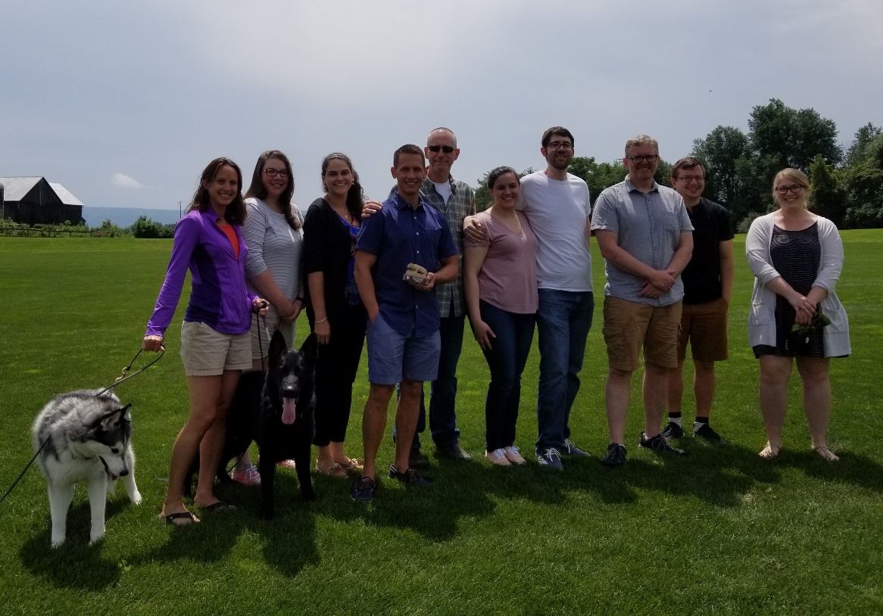

*Picture from end of the year picnic. From left to right: Rebecca Reitz, Laura Reddington Moser, Elaine Arsenault, Glenn Sterner, Gary Zajac, Alexandra Russo, Sam Nur, Derek Kreager, Corey Whichard, and Kim Davidson*

***OUTREACH AND ENRICHMENT ACTIVITIES***

Hello from Outreach and Enrichment! Fall semester has certainly been a busy one as I’ve gotten settled in my new role here while working to start bringing together various initiatives we’re working towards.

First of all, we’ve already established some recurring internships through the center that support multiple students at each site! The Re-Entry Services Office internship with the Pennsylvania Department of Corrections (specifically SCI Rockview) has been extremely successful with two inaugural interns during the summer and has now grown to offer positions to four students for the spring semester. Additionally, the Pennsylvania Commission on Sentencing hires two undergraduate research assistants each year and just this semester we’ve created two internship positions with the Penn State University Police and Public Safety Office! I’m currently working with alumni and additional agencies to continue to grow this portfolio to offer even more exciting opportunities to our students!

In order to build awareness not only of the internships we’re offering but of the center generally as well as the work I am doing, I’ve made it a point to engage in several promotional activities. Kicking off fall was the College of Liberal Arts Undergraduate Festival-loads of fun for the students and a wonderful way for me to talk about the major, internships, and generate a lot of interest in what’s coming up. Additionally, I’ve attended some criminal justice themed tabling events and gone into classrooms to talk with students about the work we’re doing.

Finally, the Criminal Justice Research Center hosted the first ever Pathways To Pardons event at Penn State! This program is offered through the Lieutenant Governor’s Office and offers people with criminal records a second chance to become participants in the community. Several agency partners as well as local politicians Representative Scott Conklin and Centre County DA Bernie Cantorna were present as about 80 students learned about the pardons process in Pennsylvania. Even more exciting is that this has opened the door for an ongoing partnership with the Pennsylvania Board of Pardons for internship opportunities!

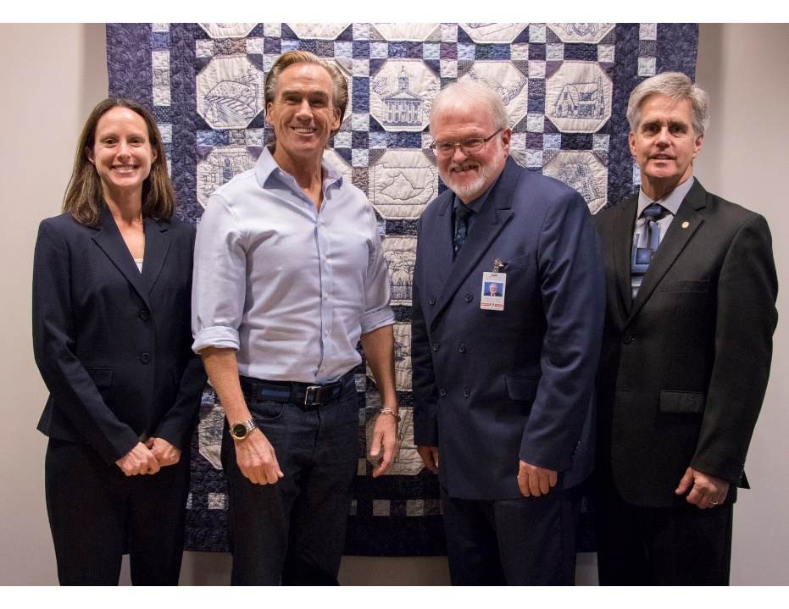

*From left to right: Rebecca Reitz, Lieutenant Governor Mike Stack, Secretary PA Board of Pardons Steven Burke, and Representative Scott Conklin*

Fall Criminology Forums

This Fall semester speakers presented their research at our two Criminology Forums.

“Murder Case Processing and the Death Penalty in PA: 2000-2010.” Jeffery Ulmer, Ph.D., Professor of Sociology and Criminology, Associate Department Head and Gary Zajac, Ph.D., Managing Director, Criminal Justice Research Center

"Decision-Making and Desistance: The Relative Importance of Changing Expectations and Changing Preferences." Kyle Thomas, Ph.D., Assistant Professor at the University of Missouri- St. Louis

***COURTS AND SENTENCING***

***CORRECTIONS AND RE-ENTRY***

Results from the Women's Prison Inmate Networks Study (WO-PINS)

A recent session at the annual American Society of Criminology (ASC) meeting provided preliminary results from WO-PINS, a NIJ-supported study of the prison and re-entry experiences of female inmates incarcerated in Pennsylvania prisons. Investigators examined units' informal organization and culture using innovative social network data that maps units’ friendship networks and status hierarchies. Parole-eligible inmate respondents are also administered semi-structured qualitative and network interviews to garner their future expectations, social capital, and preparations for community re-entry. Contemporaneously, child and caregiver interviews are conducted for inmate respondents who are mothers. See the complete list of presentations given by researchers at the Criminal Justice Research Center below.

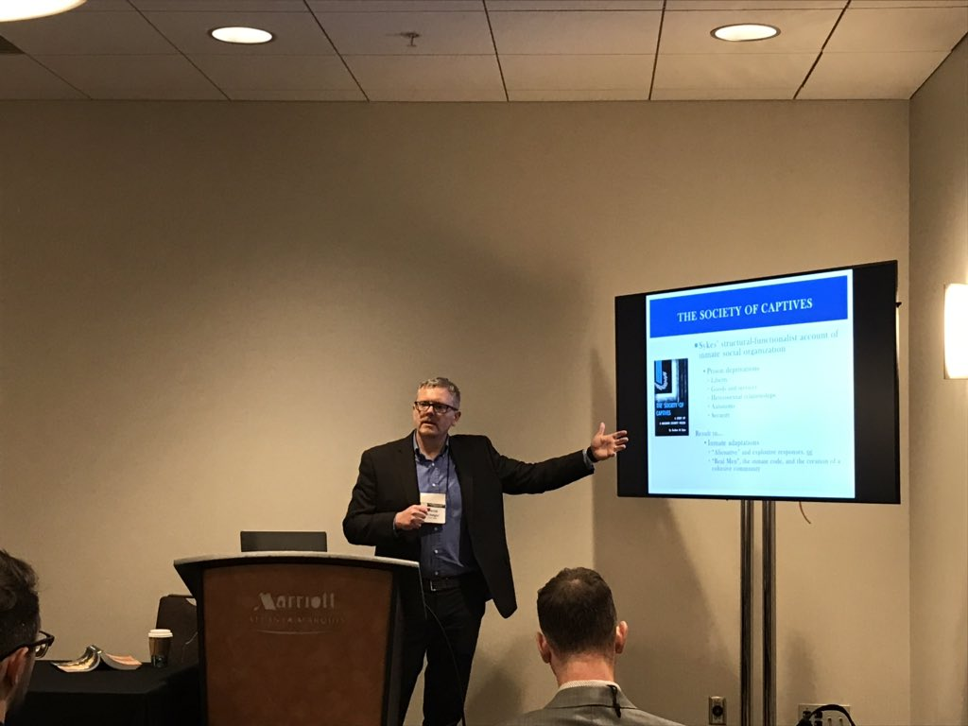

*Center Director Derek Kreager presenting at ASC*

Social Networks and Health in a Prison Unit article published in Journal of Health and Social Behavior

The Prison Inmate Networks Study (PINS) research team recently published an article in the *Journal of Health and Social Behavior* on “Social Networks and Health in a Prison Unit.” The article discusses health characteristics and peer relationships of justice-involved individuals. The authors include: Dana Haynie (The Ohio State University), Corey Whichard (The State University of New York, Albany, The Pennsylvania State University, Criminal Justice Research Center Graduate Student Assistant Alumni), Derek Kreager (The Pennsylvania State University, Criminal Justice Research Center Director), David Schaefer (University of California, Irvine), and Sara Wakefield (Rutgers University).

View the [article](http://journals.sagepub.com/doi/full/10.1177/0022146518790935) and one-page [policy brief](http://journals.sagepub.com/eprint/xcq4QvJxArjRuuXHdSSp/full).

***SUBSTANCE ABUSE AND TREATMENT***

Share Your Opioid Story Project

The Share Your Opioid Story project which told the individual stories of the opiate crisis in the Philadelphia region received the following press.

Local news station WJAC recently did a story on the Share Your Opioid Story website. Criminal Justice Research Center Faculty Affiliate Glenn Sterner explained the project to Alexis Wainwright. [Watch the story](https://wjactv.com/news/local/share-your-opioid-story-website-bringing-awareness-buzz-of-opioid-epidemic)

Listen to Dr. Glenn Sterner talk about the [Share Your Opioid Story](http://shareyouropioidstory.com/) project on the latest Scroll Down: True Philadelphia Stories podcast ["Because That's What Families Do,"](https://kywnewsradio.radio.com/media/audio-channel/36-because-thats-what-families-do) on Grandfamilies.

Social Science Research Institute Awards Seed Grant

The Social Science Research Institute (SSRI) recently awarded a seed grant in the amount of $20,000 to support a new project titled ["Linking accidental overdoses to medical professionals and pharmacies: A population-based social network analysis."](https://news.psu.edu/story/536309/2018/09/13/research/seed-grants-support-opioid-research-announced?utm_source=newswire&utm_medium=email&utm_term=536862_HTML&utm_content=09-17-2018-07-19&utm_campaign=liberal%20arts%20headlines%20issue)The project is being led by Glenn Sterner, former Criminal Justice Research Center Postdoctoral Scholar now at Penn State Abington; Oren M. Gur, Penn State Abington; and Sabahattin Gokhan Ozden, Penn State Abington.

Annual American Society of Criminology Meeting Conference Presentations

The following is a list of the presentations given by the Criminal Justice Research Center researchers at the Annual American Society of Criminology Meeting in Atlanta, Georgia in November.

### Comparing Inmate Social Networks in Male and Female Prison Units- Derek Kreager, Criminal Justice Research Center Director, Dana Haynie, The Ohio State University, David Schaefer, University of California, Irvine, Martin Bouchard, Simon Fraser University, Jacob Young, Arizona State University, Gary Zajac, Criminal Justice Research Center Managing Director

* Who are the Role Models in Prison-Based Therapeutic Communities?- Kim Davidson, Criminal Justice Research Center Graduate Student Assistant
* Exploring the relationship between Sleep, Health, and Length of Incarceration.- Theodore Greenfelder, Criminal Justice Research Center Graduate Student Assistant
* Parental Incarceration and Youth Health Outcomes: The Influence of Familial and Community Social Support.- Nicole Harrington, Criminal Justice Research Center Graduate Student Assistant
* Sources of Support during Re-Entry: Gender, Kinship, and Social Network Position- Corey Whichard, Criminal Justice Research Center Graduate Student Alumni, Sara Wakefield, Rutgers University, Newark
* Access to Opioids: An Exploration of User Networks for Innovative Interdiction Methods- Glenn Sterner, Criminal Justice Research Center Faculty Affiliate, Katherine McLean, Penn State University, Greater Allegheny, Aston Verdery, Criminal Justice Research Center Faculty Affiliate, Shannon Monnat, Syracuse University, Khary Rigg, University of South Florida
* Telling the Stories of the Opioid Epidemic in the Philadelphia Region: A Collaboration between Penn State University, The Independence Blue Cross Foundation, and Pennsylvania Department of Drug and Alcohol Programs Elaine Arsenault, Criminal Justice Research Center Researcher, Glenn Sterner, Criminal Justice Research Center Faculty Affiliate

***ANNOUNCEMENTS***

Criminal Justice Research Center Graduate Student Assistant Defends Dissertation

Corey Whichard, Ph.D. successfully defended his dissertation “Social Ties During Incarceration and Community Reentry: A Network Approach to Prison Life, Reentry Preparation, and the Return Home,” in August. Corey is currently an Assistant Professor, at the School of Criminal Justice, SUNY Albany. Congratulations Corey on your defense and new position!

# Criminal Justice Research Center Postdoctoral Scholar Receives Outstanding Postdoc Award

The Criminal Justice Research Center congratulates our recent post-doctoral scholar Glenn Sterner (now an Assistant Professor at PSU Abington) on receiving the Penn State Postdoc Society 2018 Outstanding Postdoc Award. Glenn is being recognized for his remarkable contributions to research during his very productive tenure with the Center. Glenn received his award at the Society’s 11th Annual Postdoc Research Exhibition at the HUB on September 28. We’re proud of you Glenn on this well-deserved honor!

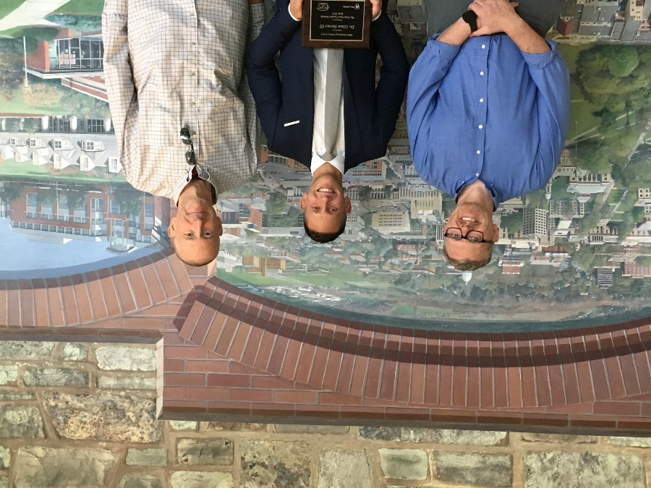

*From left to right: Center Director, Derek Kreager, Criminal Justice Research Center Alumni Postdoctoral Scholar, Glenn Sterner, Center Managing Director, Gary Zajac*

# Criminal Justice Research Center Welcomes New Personnel

**Jonathan Dirlam** joined the Criminal Justice Research Center in August as a postdoctoral research scholar. His research analyzes racial disparities within the criminal justice system such as the application of deadly force by the police. He has also studied the impact of Stand-Your-Ground Laws on several different homicide outcomes including the killing of police officers. Jonathan received BA degrees in both Sociology and Economics from the University of California, San Diego. He has also received a MA degree in Economics from the University of California, Irvine and a Ph.D. in Sociology from Ohio State University. His future research will investigate the influence of legal cynicism and residential racial segregation on a number of criminal justice system outcomes.

**Thomas Hunt** joined the Criminal Justice Research Center in November 2018 as the Administrative Support Assistant. Tom came from the Miner Training Program in the Department of Energy and Mineral Engineering. Previously he worked in Workforce Education the College of Education. As an Administrative Assistant at Penn State, Tom’s duties have focused on organizing seminars and conferences, managing calendars and budgets, and ordering supplies. Tom has a wide variety of computer experiences from which to draw upon. He has built and repaired computers, programmed in a variety of computer languages, and worked as a graphic designer and web coder. Tom is an expert user of Excel and proficient with most business and graphic design applications.

**Nicole Harrington** is a doctoral candidate in the department of Criminology at Penn State University, and recently joined the Criminal Justice Research Center as a Graduate Student Assistant. Her research interests center around the collateral consequences of incarceration including negative youth outcomes (e.g. mental health and externalizing behaviors) following the incarceration of a parent. Nicole has assisted in collecting survey data in prisons as part of the Women’s Prison Network Study (WO-PINS). She has also assisted in conducting qualitative interviews for both the Therapeutic Community Re-Entry Prison Network Study (TCR-PINS) and the Women’s Re-Entry Prison Network Study (WOR-PINS). Nicole’s dissertation research focuses on the experiences of parents who currently have a child incarcerated in a women’s prison in Pennsylvania, emphasizing how these parents cope with such an event and the impact that a child’s incarceration can have on family members relationships with others in the community. Nicole received her M.A. in Criminology from Penn State University and her B.A. in Criminology, with a minor in Psychology, from Saint Anselm College. Prior to coming to Penn State, she worked with juvenile delinquents at the John H. Sununu Youth Services Center in Manchester, New Hampshire as part of an internship.

**Theodore Greenfelder** is a graduate student in the department of Criminology at Penn State University, and recently joined the Criminal Justice Research Center as a Graduate Student Assistant. His research interests include visitation and health while incarcerated, as well as the juvenile justice system. Theodore has assisted in collecting survey data in prisons as part of the Therapeutic Community Prison Inmate Network Study (TC-PINS) and as the interview team leader for the Women’s Prison Inmate Network Study (WO-PINS). He has also cleaned and maintained the datasets generated from TC-PINS and WO-PINS. Theodore received his M.A. in Criminology from Penn State University and his B.S. from Central Michigan University with a double major in Sociology with a concentration in Social and Criminal Justice and Anthropology. Prior to his time at Penn State, Theodore interned with the Juvenile Court of Isabella County where he worked with both the Juvenile Drug Court and the Community Youth Garden.

# Criminal Justice Research Center Departures

The Criminal Justice Research Center bids a fond farewell to Diana Samardzic and Laura Reddington Moser.

Diana Samardzic has led the evaluation of the Pennsylvania Child Support Enforcement Training Institute (PACSETI) program for the past four years. The evaluation of PACSETI has been a joint effort of the Center and the Justice and Safety Institute (JASI) within Penn State Outreach. Diana has made great strides in developing and implementing a rigorous program evaluation agenda that has contributed to a better understanding of PACSETI operations and to program development efforts. We are all very pleased with and proud of the work that Diana has accomplished here. She will be focusing on the completion of her Ph.D. studies in Sociology at SUNY Buffalo. We are sorry to see her go, but wish her the best of luck in the completion of her degree and in her future professional endeavors. Thanks for the great work Diana!

Laura Reddington Moser has been the Administrative Coordinator at the Criminal Justice Research Center for the last four years. Laura has been an essential part of the Criminal Justice Research Center team, overseeing the daily operations within the Center and managing the grants for the Center’s projects. We are very grateful for Laura’s hard work and commitment to the Center, and we wish her much success in her new position as a Research Administrator with the College of Agricultural Sciences at Penn State!

Criminal Justice Research Center

The Pennsylvania State University

304 Oswald Tower

University Park, PA 16802

814-867-3292

[www.justicecenter.la.psu.edu](http://www.justicecenter.la.psu.edu)

December 2018