*Message from the Director*

Greetings! As you will see below, the Center has had

another busy quarter! We have made substantial

progress on studies in our core themes and have

connected our findings to policies that matter, including

murder convictions, responses to the opiate crisis,

and prisoner rehabilitation. We are sad to see our

productive post-doctoral scholar, Dr. Glenn Sterner, leave the center, but he will remain an affiliate at PSU Abington. Good luck, Glenn! In addition, we welcome to the Center Rebecca Reitz, our new outreach and enrichment coordinator. We have an ambitious student, alumni, and agency outreach initiative that Rebecca will spearhead and we hope to roll out in the fall semester, so stay tuned! As part of this initiative, we will prioritize establishing and supporting new internship opportunities for our outstanding criminology majors. We recently created a successful internship with the SCI Rockview Reentry Services Office and hope to extend this and similar opportunities in the future, as well as identify friends of the Center who may be able to help support these wonderful learning experiences. Expect a call or e-mail from Rebecca soon! Thanks and have a great summer.

*Dr. Derek Kreager*

The Docket JUNE 2018

**The Justice Center for Research is a Partnership of the College of the Liberal Arts and University Outreach**

**PENN STATE**

*Justice Center for Research*

Derek Kreager, Director

Gary Zajac, Managing Director

***COURTS AND SENTENCING***

Senate Resolution 6 Report on the Death Penalty Released

In 2011, the Pennsylvania State Senate passed Resolution #6, which called for a portfolio of research on 17 topics related to the death penalty in Pennsylvania.  The Justice Center for Research was named as a research advisor to this effort, with the PA Joint State Government Commission (JSGC) serving as overall project manager.  Center members, including Center Managing Director Gary Zajac, Center Director Derek Kreager, and Center affiliates John Kramer and Jeff Ulmer, contributed research to several of the topics, including collateral consequences of death sentencing, public opinion, mental health, and disparity in sentencing.  The JSGC has just released to final overall report for the SR6 project. [Read the final report.](http://justicecenter.psu.edu/research/projects/files/pennsylvania-senate-resolution-6-2013-capital-punishment)

# Examining Murder Convictions and Punishment project receives award from National Science Foundation

A new Justice Center project, Examining Murder Convictions and Punishment recently received a $300,000 award from the National Science Foundation. The project will be led by Jeffery Ulmer (Justice Center Faculty Affiliate), Gary Zajac (Justice Center Managing Director), and John Kramer (Justice Center Faculty Affiliate). This study will examine the decisional processes employed in capital case prosecution and sentencing, as well as build upon the analysis previously conducted under the death penalty study recently completed by Drs. Kramer, Ulmer and Zajac.

***CORRECTIONS AND RE-ENTRY***

# Prison Inmate Networks Study (PINS) Annual Project Meeting

Justice Center researchers attended the 5th Annual Prison Inmate Networks Study (PINS) Project Meeting at Hunter College, CUNY on March 26-27th. The PINS team recently completed its second data collection in a PA women’s prison (WO-PINS) to understand female inmate informal networks and health, as well as the experience of motherhood during incarceration and family reunification upon release. This two-year project is funded by the National Institute of Justice and is in cooperation with the PA Dept. of Corrections. More information on the PINS projects: <http://justicecenter.psu.edu/research/pins-1>

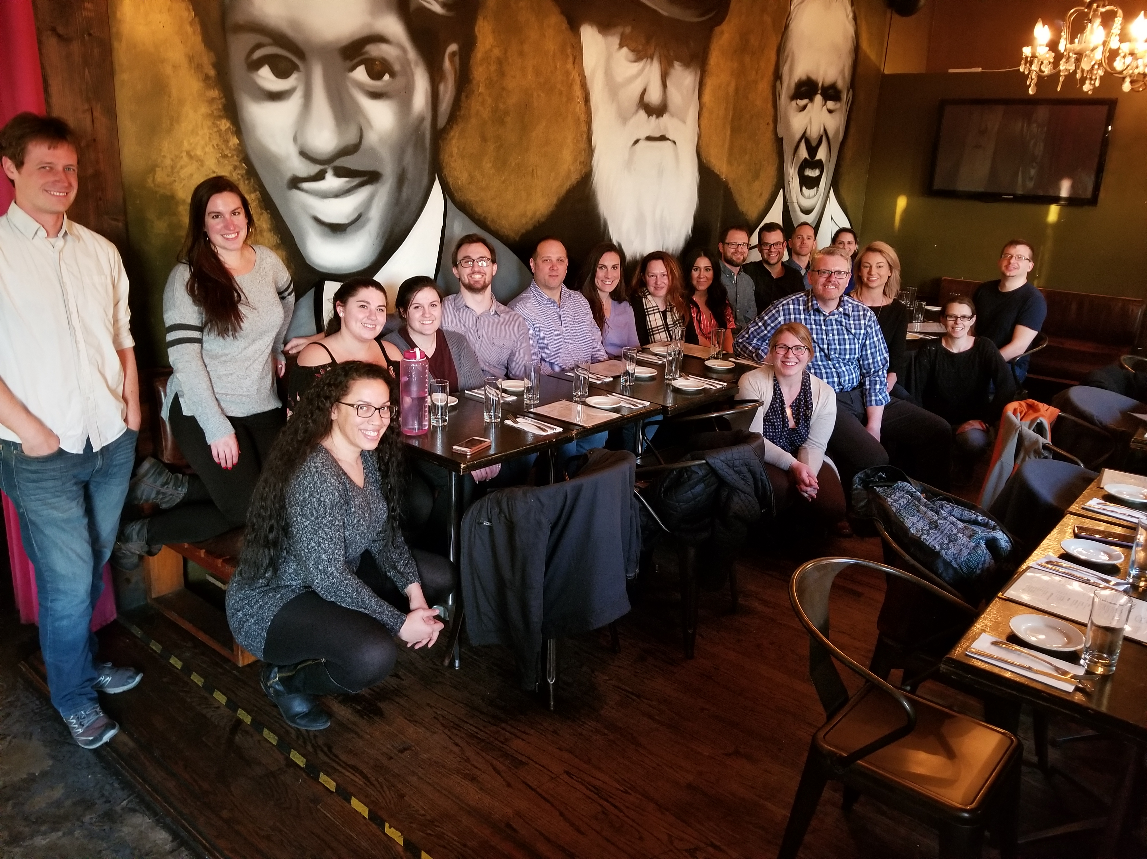

From left to right back row: Scott Duxbury (OSU Graduate Student), Marin Wenger (Assistant Professor, FSU), Nicole Harrington (PSU Graduate Student Assistant), Alex Russo (PSU Graduate Student Assistant), Ted Greenfelder (PSU Graduate Student), Bret Bucklen (PADOC Research Director), Chase Montagnet (RU Graduate Student Assistant), Sara Wakefield (Associate Professor RU), Sadaf Hashimi (RU Graduate Student Assistant), David Schaefer (Associate Professor UCI), Martin Bouchard (Professor SFU), Jacob Young (Associate Professor ASU), Elaine Arsenault (Justice Center for Research Researcher). Front row: Sade Lindsay (OSU Graduate Student Assistant), Kim Davidson (Justice Center for Research Graduate Student Assistant), Derek Kreager (Justice Center for Research Director), Dana Haynie (Professor OSU), Michaela Soyer (Assistant Professor Hunter College CUNY), Corey Whichard (Justice Center for Research Graduate Student Assistant)

Justice Center Founding Director presents at the Congressional Briefing on the Prospects for Criminal Justice in the U.S.

Justice Center Founding Director Doris MacKenzie and Pam Lattimore, Director of the Center for Justice, Safety, and Resilience, at RTI International recently presented at the Congressional Briefing on the Prospects for Criminal Justice in the U.S. The article, [“To Rehabilitate or Not Rehabilitate: That Is the Question for Corrections!”](https://onlinelibrary.wiley.com/doi/abs/10.1111/1745-9133.12364) is published in *Criminology & Public Policy*.

***POLICY AND EVALUATION***

Outcome Findings from the HOPE Demonstration Field Experiment article in top 20 most downloaded recent papers

The article “Outcome Findings from the HOPE Demonstration Field Experiment,” published in *Criminology & Public Policy* was one of the journal’s top 20 most downloaded recent papers, within the first 12 months of online publication.

Justice Center Managing Director, Dr. Gary Zajac led the process evaluation component of the HOPE DFE along with Researcher Elaine Arsenault, and Justice Center Founding Director Dr. Doris Layton MacKenzie was a Co-PI on the outcome evaluation phase with RTI.

View the article here: <http://onlinelibrary.wiley.com/doi/10.1111/1745-9133.12248/full>

***SUBSTANCE ABUSE AND TREATMENT***

Share Your Opioid Story Website Depicts Stories of Individuals Impacted by the Opioid Crisis

The Share Your Opioid Story project is a collaboration between Independence Blue Cross Foundation, The Department of Drug and Alcohol Programs, and Penn State University. Led by Justice Center Postdoctoral Scholar, Dr. Glenn Sterner, the Share Your Opioid Story website depicts the stories of individuals impacted by the opioid crisis. [Share Your Opioid Story website](http://shareyouropioidstory.com/)

# National Institute of Justice Grant Award to Study Opiate Flows in Pennsylvania

A grant was awarded in the amount of $990,002 from the National Institute of Justice in January. The project team consists of Co-Principal Investigators: Glenn Sterner, Post-Doctoral Scholar, Justice Center for Research, and Ashton Verdery, Assistant Professor of Sociology and Demography, Co-Investigators: Shannon Monnat; Syracuse University, Maxwell School of Citizenship and Public Affairs; Pete Forster, Associate Dean for Online and Professional Education in Penn State’s College of Information Sciences and Technology, Gary Zajac, Managing Director of the Justice Center for Research at Penn State.

This project seeks to understand, describe, and disrupt networks of illicit sales of opiates from a public safety perspective in partnership with Pennsylvania State Police, Pennsylvania Department of Drug and Alcohol Programs, The Center for Rural Pennsylvania, and local treatment facilities. This project will help to understand hotspots of drug distribution and access, while addressing the utility of community based policing in addressing this complex issue.

Blog Post by Justice Center for Research Postdoctoral Scholar, Glenn Sterner, on “Fighting the Stigma of Addiction Through Personal Stories of the Opioid Epidemic”

Dr. Glenn Sterner discusses the ways to counter the stigma surrounding opioid addiction in new blog post. The blog details the [Share Your Opioid Story Project](http://shareyouropioidstory.com/) which highlights the stories of those impacted by the opioid crisis.

[Fighting the Stigma of Addiction Through Personal Stories of the Opioid Epidemic](http://infocus.ibxfoundation.org/fighting-the-stigma-of-addiction-personal-stories/)

# Justice Center Postdoctoral Scholar Glenn Sterner Interviewed by Comcast Newsmakers

Dr. Glenn Sterner, Justice Center Postdoctoral Scholar, was recently interviewed by Comcast Newsmakers about his research on the opioid crisis.  In the interview Glenn discusses Justice Center for Research projects, including Identifying and Informing Strategies for Disrupting Drug Distribution Networks: An Application of Community Policing to Opiate Flows in Pennsylvania, Share Your Opioid Story: A Collaboration between Independence Blue Cross Foundation, The Department of Drug and Alcohol Programs, and Penn State University, and Understanding the Individual and Social Network Characteristics of Opiate Users in Rural Pennsylvania with Host Sheila Hyland. [Watch the interview](https://comcastnewsmakers.com/Videos/2018/6/8/Understanding-Opioid-Trafficking?autoplay) here.

Justice Center Director, Derek Kreager and colleagues publish book chapter in Social Networks and the Life Course

[“A Life Course and Networks Approach to Prison Therapeutic Communities”](https://link.springer.com/chapter/10.1007/978-3-319-71544-5_20) was published in the edited volume, [*Social Networks and the Life Course: Integrating the Development of Human Lives and Social Relational Networks*](https://link.springer.com/book/10.1007/978-3-319-71544-5)*.* The chapter discusses the work from the [Therapeutic Community Prison Inmate Networks Study (TC-PINS)](http://justicecenter.psu.edu/research/pins-1), and ”applies life course and social network perspectives to understand prison TC processes and demonstrate the feasibility and promise of our approach with preliminary findings from a cross-sectional study of a small TC (N = 20) in a maximum-security men’s prison.” Authors include: Derek Kreager, Justice Center Director, Martin Bouchard, Professor at Simon Fraser School of Criminology, George De Leon, Clinical Professor of Psychiatry at NYU School of Medicine, David Schaefer, Associate Professor at UC Irvine Sociology, Michaela Soyer, Justice Center Postdoctoral Scholar Alumni, now at Hunter College, Jacob Young, Associate Professor at ASU School of Criminology & Criminal Justice, and Gary Zajac, Justice Center for Research Managing Director.

Justice Center Postdoctoral Scholar Glenn Sterner presents at Research Unplugged

Glenn Sterner, Ph.D. presented "A Comprehensive Criminological Research Agenda to Address the Opioid Crisis" at Research Unplugged in Schlow Library. The event took place on Thursday April 12th from 12:30-1:30pm in the Downsbrough Community Room. Dr. Sterner’s talk examined three active Justice Center projects that target specific populations associated with the opioid crisis: current opioid users, illegal distributors of opioids, and those who stigmatize opioid addiction.

***ANNOUNCEMENTS***

Glenn Sterner, Ph.D. named one of the Independence Blue Cross’s Future Leaders in Community Health for Philadelphia

Justice Center for Research Postdoctoral Scholar, Glenn Sterner, Ph.D.  was named one of Independence Blue Cross’s Future Leaders in Community Health for Philadelphia. Read the [article](https://mydigimag.rrd.com/publication/?i=488662&ver=html5&p=4&sf187654313=1#%7B%22page%22:%224%22,%22issue_id%22:488662%7D) on Glenn’s work in the current *Journal of Change* issue. Congratulations Glenn!

# Welcome Rebecca Reitz, Justice Center Outreach and Enrichment Coordinator

Hello! I’m extremely happy to introduce myself as the new Outreach and Enrichment Coordinator for the Justice Center for Research! We have a lot of great plans to look forward to and I will be keeping you all up to date on those but, first, let me give you a little background on myself.

Though new to the center I have been at Penn State since 2011, having worked with Career Services and then as an academic adviser for both Biobehavioral Health and Energy and Mineral Engineering. Prior to Penn State I held a variety of roles including K-12 special education teacher, psychological assessment assistant, and probation officer.



I grew up in the Atlanta, GA area but my family is from west central Pennsylvania. I have several ties to the criminal justice field-probation being the most direct but my psychological assessment work focused primarily on court-ordered evaluations and my role as a special education teacher often involved work with court officials and community agencies. I also did some liaison work with the Office of Student Conduct while at Career Services. More personally, several family members and friends have worked in law enforcement careers. I’m looking forward to combining my experience and interests into this position!

The first big project that I’ll be working on is the creation of our very own Criminal Justice Network (CJN) which will be a fantastic resource for connecting alumni, agency partners, and students! This is an exciting undertaking and much more info on this and other endeavors will be coming soon!

# Justice Center for Research Postdoctoral Scholar honored at the 2018 Philadelphia Business Journal Faces of Philanthropy Awards

# Justice Center Postdoctoral Scholar Glenn Sterner’s work on the [Share Your Opioid Story](http://justicecenter.psu.edu/research/active-funded-research-projects-2) project in collaboration with the Independence Blue Cross Foundation is being honored by the 2018 Philadelphia Business Journal Faces of Philanthropy Awards. Congratulations Glenn!

# Justice Center Postdoctoral Scholar Departure

We are pleased to announce that Justice Center Post Doctoral Scholar Dr. Glenn Sterner has accepted a position as Assistant Professor (tenure track) of Criminal Justice at Penn State Abington, beginning in August 2018. Glenn joined the Center in 2015, after having completed his Ph.D. in Rural Sociology here at Penn State. During his time with the Center, Glenn has established himself as a leader in Pennsylvania on research and community outreach related to the opiate crisis, which is one of the most salient contemporary criminal justice and public health issues. He has secured external support of over $1 million on this topic (see the other write up in this issue of the Docket on his latest NIJ grant), and established partnerships with dozens of state agencies and community organizations. Glenn has been recognized repeatedly for his groundbreaking work on the opiate crisis, most recently by the Independence Blue Cross Foundation as a Future Leader in Community Health for Philadelphia. This work has embodied the spirit of the engaged university, most critically on a topic of high policy relevance and importance. Glenn's portfolio of work and accomplishments as a post doc on the study of the opiate crisis and on various other topics are too numerous to summarize here, but are well documented on the Center's website and in prior issues of the Docket. Glenn will continue to work closely with the Center on these and other projects as he embarks on the new phase of his very promising career, and we are grateful for the opportunity for ongoing collaboration with him.

Spring Research Talks

This spring, the Justice Center hosted several lectures through theCriminology Forum.

* **Criminology Forum**
  + "*Putting the 'Gang' back in Gang Research: Group-level Characteristics of Gangs in the Texas Prison System*," David Pyrooz, Assistant Professor of Sociology, University of Colorado Boulder
  + *“Early Childhood Risk Factors and Adolescent Problem Behavior: How Early is too Early to Target?”* Thomas Loughran, Professor of Sociology and Criminology, Penn State University
* **Social Thought Program Annual Conference “Bourdieu, Wacquant, and Criminality”** 
  + Loic Wacquant, Professor of Sociology, University of California/Berkeley

Justice Center for Research

The Pennsylvania State University

304 Oswald Tower

University Park, PA 16802

814-867-3292

[www.justicecenter.la.psu.edu](http://www.justicecenter.la.psu.edu)

June 2018