*Message from the Managing Director*

Spring has been a busy time at the Justice Center for

Research. We were honored to have Professor Peggy

Giordano be part of our Distinguished Speaker

Series. Glenn Sterner, Ph.D., spoke at the Third Annual

Penn State Addiction Symposium about his research

on the opioid epidemic. The PINS research team

traveled to Rutgers University for a successful project

meeting. Please read on to find out what else is

on *The Docket* this month at the Justice Center.

*Dr. Gary Zajac*

The Docket APRIL 2017

**The Justice Center for Research is a Partnership of the College of the Liberal Arts and University Outreach**

**PENN STATE**

*Justice Center for Research*

Gary Zajac, Managing Director

Justice Center Director and Affiliates received recognition at the Liberal Arts Researcher Appreciate Reception

On April 12th, Justice Center for Research Director, Gary Zajac, was recognized at the College of the Liberal Arts 2017 Researcher Appreciation Reception for having six consecutive years of external funding. Faculty Affiliates Wayne Osgood, Derek Kreager, Jeff Ulmer, Eric Baumer and Aston Verdey were also recognized for their outstanding accomplishments.

**10-14 years of consecutive funding-** D. Wayne Osgood and Derek Kreager

**5-9 years of consecutive funding-** Jeff Ulmer and Gary Zajac

**First Grants as Penn Staters-** Eric Baumer and Ashton Verdery

Distinguished Lecture Series Speaker Peggy Giordano, Ph.D.

We were honored to have Professor Peggy Giordano present at the Distinguished Lecture Series on April 10th. Professor Giordano’s talk was titled, “Parental Incarceration and Adolescent and Young Adult Well-being.” At the talk, Professor Wayne Osgood presented Professor Giordano with the Justice Center for Research Distinguished Lecturer Award.

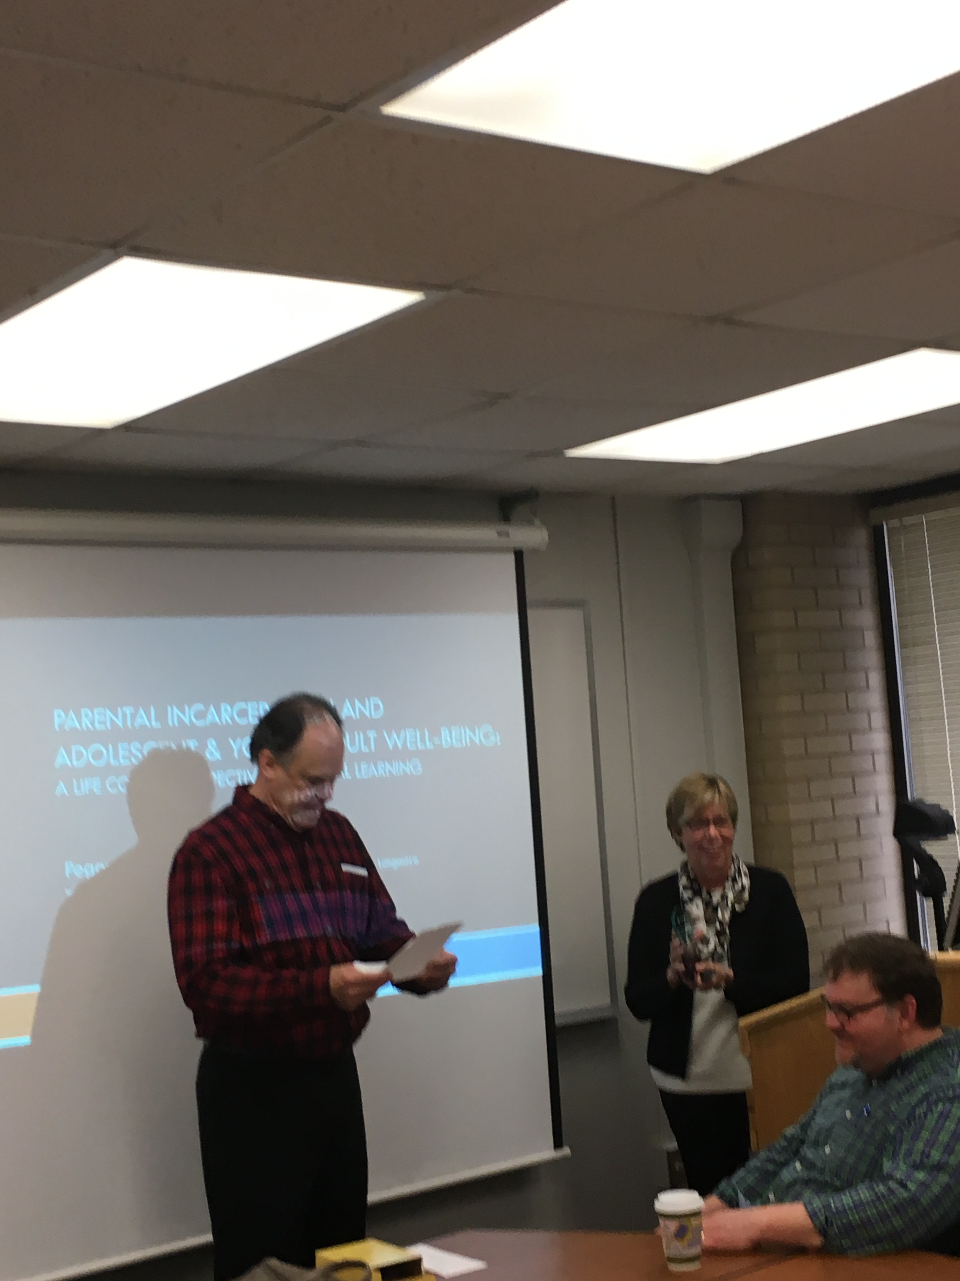

Researchers head to Rutgers University for PINS Meeting

Justice Center researchers attended the Prison Inmate Networks Study (PINS) Project Meeting at Rutgers University on March 27-28th. The PINS team consists of investigators: Derek Kreager (Justice Center for Research Faculty Affiliate), Gary Zajac (Justice Center for Research Director), Sara Wakefield (Rutgers University), Dana Haynie (Ohio State University), David Schaefer and Jacob Young (Arizona State University), Martin Bouchard (Simon Fraser University), and Michaela Soyer (Hunter College).

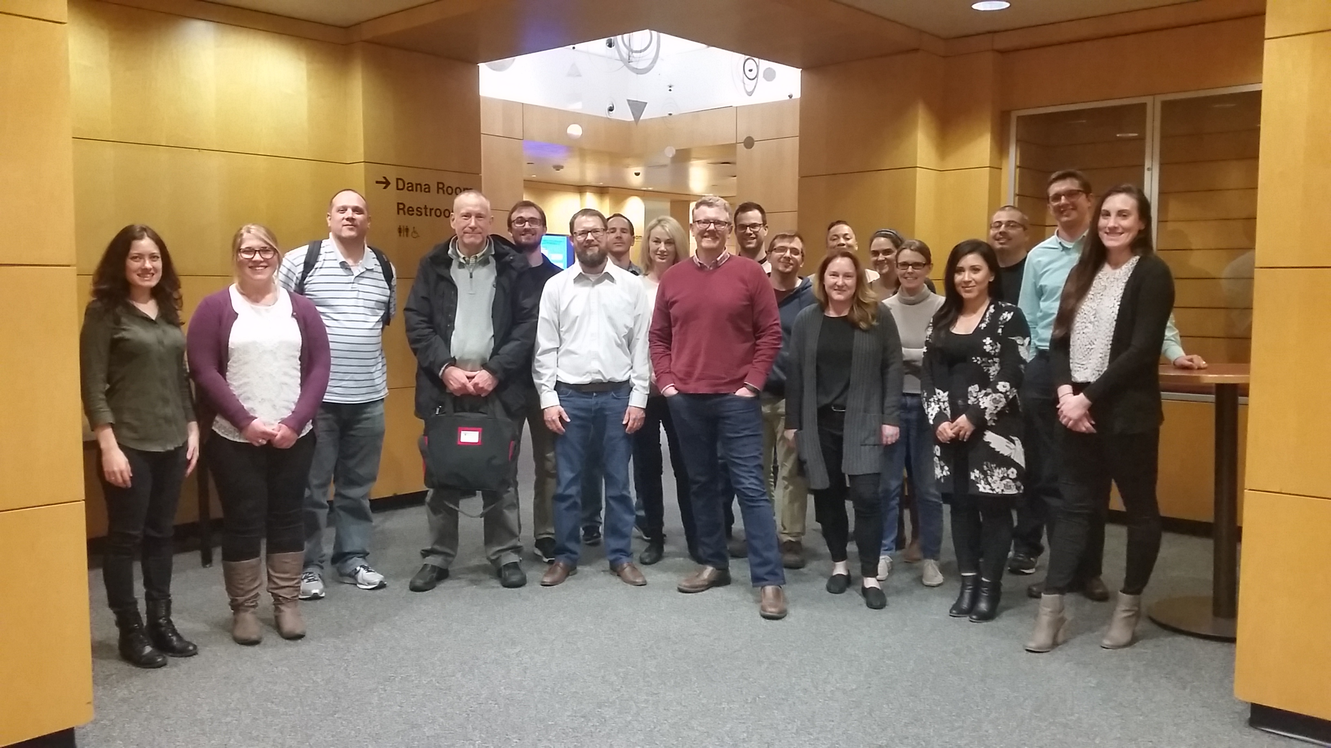

From left to right front row: Brianna Jackson (Graduate Student Assistant Justice Center for Research), Kim Davidson (PSU Graduate Student), Bret Bucklen (PADOC Research Director), Gary Zajac (Justice Center for Research Director), David Schaefer (Associate Professor ASU), Derek Kreager (Justice Center for Research Faculty Affiliate), Sara Wakefield (Associate Professor Rutgers University), Sadaf Hashimi (Rutgers University Graduate Student), Chase Montagnet (Rutgers University Graduate Student). Back row: Ted Greenfelder (PSU Graduate Student), Jacob Young (Assistant Professor ASU), Dana Haynie (Professor OSU), Martin Bouchard (Associate Professor Simon Fraser University), Corey Whichard (Graduate Student Assistant Justice Center for Research), Sade Lindsay (OSU Graduate Student), Elaine Arsenault (Research Assistant, Justice Center for Research), Michaela Soyer (Assistant Professor Hunter College), Gerardo Valente Cuevas (PSU Graduate Student), and Wade Jacobsen (PSU Graduate Student)

More information on the PINS projects:

<http://justicecenter.psu.edu/research/pins>

Grant Submissions

* NIJ: Identifying and Informing Strategies for Disrupting Drug Distribution Networks: An Application to Opiate Flows in Pennsylvania Glenn Sterner (Justice Center for Research Postdoctoral Scholar), Ashton Verdery and Shannon Monnat (Justice Center Faculty Affiliates), Gary Zajac (Justice Center Director) Peter Forster (IST), and Scott Yabiku (Sociology and Demography)
* BJA: Commonwealth of Pennsylvania State Police: Smart Policing Initiative: PA State Police TRIAD Project Evaluation Glenn Sterner(Justice Center for Research Postdoctoral Scholar), Jennifer Gibbs and Joongyeup Lee (PSU Harrisburg Faculty Affiliates)
* NSF: An International Perspective on the Age and Crime Relationship: Does Late-20th Century Modernization Matter? Darrell Steffensmeier and Jeffery Ulmer (Justice Center Faculty Affiliates)
* NIJ: Employment in Prison and Post-Release Outcomes Holly Nguyen (Justice Center Faculty Affiliate), Gary Zajac (Justice Center Director), Derek Kreager and Jeremy Staff (Justice Center Faculty Affiliates), and Elaine Arsenault (Justice Center Research Assistant)
* State of Pennsylvania: Commonwealth of Pennsylvania Independent Evaluation Services for Pay for Success Project to Reduce Recidivism and Increase Employment Proposals Daniel Crowley (HDFS), Gary Zajac (Justice Center Director), Holly Nguyen (Justice CenterFaculty Affilaite), Sebrina Doyle Fosco (PRC), Damon Jones (PRC)

Glenn Sterner, Ph.D., publishes article on scholarship of teaching and learning

Justice Center Postdoctoral Scholar, Glenn Sterner, Ph.D. published an article in the recent North American Colleges and Teachers of Agriculture volume. Glenn and his colleagues, Alison Harrell, Theodore R. Alter, and Jean Lonie, article, “Student Perceptions of the Impact of their Diverse Student Abroad Experiences,” details the motivations of undergraduates to participate in studying abroad.

Glenn Sterner, Ph.D. addressed the Third Annual Penn State Addiction Symposium

Justice Center Postdoctoral Scholar Glenn Sterner, Ph.D. presented at the Third Annual Penn State Addiction Symposium on Tuesday, April 4th in the Junker Auditorium in the Penn State College of Medicine. The title of his talk “Corrective Connections: Exploring Network Based Approaches to Alleviating the Opioid Epidemic” detailed his work with social networks associated with the opioid epidemic. Following the event, Glenn spoke at Innovations to Address Opiate Addiction.

Spring Criminology Forums

This spring the Criminology Forum featured speakers Shannon Monnat, Ph.D. (Justice Center Faculty Affiliate), Gary Zajac, Ph.D., (Justice Center Director), Michaela Soyer, Ph.D., (Justice Center Postdoctoral Scholar Alumni, Assistant Professor Hunter College), and Harrington “Bo” Cleveland, Ph.D., (Associate Professor PSU), and Eric J. Connolly, Ph.D. (Assistant Professor PSU). The speakers covered a variety of topics including the U.S. Drug, Alcohol, and Suicide Morality rates, the Honest Opportunity Probation Enforcement (HOPE) evaluation findings, young minorities and incarceration, and future directions for research on genetics and crime, respectively.

Justice Center Postdoctoral Scholar serves as an expert panelist to The Penn State Abington Opioid Overdose Task Force

On Thursday, March 30, Justice Center Postdoctoral Scholar, Glenn Sterner, Ph.D., sat on a panel of experts to hear and evaluate Penn State Abington students’ innovative ideas on how to address the opiate epidemic. These students have worked on this project this semester as part of their CrimJ 415 course on Drug control Policy in Comparative Perspective, taught by Professor Oren Gur, Assistant Professor of Criminal Justice at Penn State Abington.

Justice Center personnel receive certificate for completing Mental Health First Aid: Suicide Prevention Training

Laura Reddington Moser, Justice Center for Research Administrative Coordinator, and Elaine Arsenault, Research Assistant, participated in training on Mental Health First Aid and Suicide Prevention on March 24 at the Student Health Center at Penn State. Laura and Elaine learned strategies and solutions to assist individuals and participated in engaging activities that depicted the course content. Laura and Elaine received a certificate for the completion of the 8 hour training course.

Justice Center for Research

The Pennsylvania State University

304 Oswald Tower

University Park, PA 16802

814-867-3292

[www.justicecenter.la.psu.edu](http://www.justicecenter.la.psu.edu)

April 2017