An Examination of Rural Prisoner Reentry Challenges

By: Gary Zajac, Ph.D., Robert Hutchison, and Courtney A. Meyer Pennsylvania State University

March 2014

Executive Summary
This study explored issues and challenges surrounding the reentry of state prison and county jail inmates to rural communities in Pennsylvania. Reentry refers to the process of a prisoner transitioning to the community after a period of secure connement in a state or federal prison or county jail.
The research used secondary data from the Pennsylvania Department of Corrections and the Pennsylvania Board of Probations and Parole and used primary data from interviews and surveys to: estimate the number and charac-teristics of state prison and county jail prisoners likely to be released into rural Pennsylvania communities over the next 5 years; identify and document reentry programs and services available to released state and local prisoners in rural Pennsylvania; conduct a gap analysis of reentry services available in rural Pennsylvania for successful reentry; and provide public policy considerations.
According to the research results, releases of county jail inmates to rural counties are projected to hold constant over the next 5 years; however, releases of state inmates are projected to increase slightly over the same period. The most likely explanation for the slight increase in releases of state inmates is that state parole approval rates have increased somewhat over the past several years. The most notable demographic trends among released in-mates are an increase in the number of older inmates being released, and a slight increase in the number of female inmates being released.
Signicant reentry needs for returning rural inmates include assistance with employment, housing and transpor -tation. Transportation is crucial to the reentry process as the lack of public transit in rural areas can hamper return-ing inmates in nding and getting to jobs and housing, getting to treatment groups and medical and mental health appointments, and making required meetings with their parole agents. The challenges of nding work and suitable housing are magnied for “hard to place” offenders, such as those with serious mental illness and sex offenders,
as the latter face signicant restrictions on where they can live and work. This research also found that returning inmates also face some stigma for their status as ex-offenders. This is most notable for returning sex offenders. While there appears to be a reasonably robust network of social services and programs in rural counties for
returning inmates, these services are unevenly distributed between rural counties. Most notably, there are very few reentry programs for sex offenders in rural counties, and almost no programs that specically address the most important rehabilitative needs of ex-offenders, including programs that address ex-offenders’ thinking, decision-making and problem-solving skills and their peer networks, all of which are strongly linked to recidivism reduc-tion.

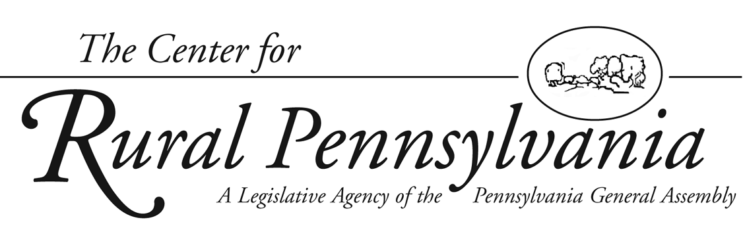
This project was sponsored by a grant from the Center for Rural Pennsylvania, a legislative agency of the Pennsylvania General Assembly.
The Center for Rural Pennsylvania is a bipartisan, bicameral legislative agency that serves as a resource for rural policy within the Pennsylvania General Assembly. It was created in 1987 under Act 16, the Rural Revitalization
Act, to promote and sustain the vitality of Pennsylvania’s rural and small communities.

Information contained in this report does not necessarily reect the views of individual board members or the Center for Rural Pennsylvania. For more information, contact the Center for Rural Pennsylvania, 625 Forster St., Room 902, Harrisburg, PA 17120, telephone (717) 787-9555, email: info@rural.palegislature.us, www.rural.palegislature.us.

Introduction
Reentry refers to the process of a prisoner transition-ing to the community after a period of secure conne -ment in a state or federal prison or county jail1. Reentry is one of the most popular topics in the corrections eld (Petersilia, 2003). Research on reentry includes evalu-ations of prisoner reentry programs, as well as more basic research on how individual offenders navigate
the process of reentry. Most of the national reentry research has focused on urban reentry, with relatively less focus on rural reentry. Even within Pennsylvania, reentry research has focused heavily on urban settings (Bucklen and Zajac, 2009; Latessa, et al., 2009; Smith and Suttle, 2008). Successful reentry hinges on pre-release planning, continuity of treatment and services in the community, and following the known principles of effective intervention—for example, targeting key treatment needs (such as antisocial attitudes and sub-stance use), using evidence-based programs, and pro-viding community-based aftercare services (Andrews and Bonta, 2003; LaVigne, et al., 2008; Lowenkamp, et al., 2006; MacKenzie, 2006).
There is a critical need to examine reentry in rural Pennsylvania communities. Pennsylvania led the nation in 2009 with the largest absolute increase in its state prison population (Pew Center on the States, 2010). The overall recidivism rate, which is the total number of inmates who returned to prison for a new crime or parole violation, for state prisoners in Pennsylvania is 62 percent at 3-years post release, suggesting signi -cant challenges to successful reentry (Pennsylvania Department of Corrections, 2013). While statewide reentry programs operated by the Pennsylvania Depart-ment of Corrections (PADOC) have been evaluated (Latessa, et al., 2009; Smith and Suttle, 2008), very little is known about county jail reentry efforts. Finally, Pennsylvania spent nearly $1.9 billion on corrections
at the state level in scal year 2011-12, a 40 percent

Table of Contents

Introduction....................................................2 Goals and Objectives ....................................2 Methodology..................................................2 Results...........................................................4 Conclusions.................................................19 Policy Considerations..................................19 References..................................................22

2

increase over the past 5 years, reecting an increase in the prison population of more than 20 percent during that time (PADOC, 2012a). The nancial and policy implications of successful reentry are highly signicant and timely.
Thus, reentry is a primary focus of the criminal justice system, yet research related to rural reentry -a signicant element of Pennsylvania’s corrections environment - is lacking. Much of the extant reentry
research has focused on urban areas, which admittedly receive the bulk of returning offenders, at the cost of understanding the challenges faced by offenders return-ing to rural areas.

Goals and Objectives
This research, conducted in 2012-1013, examined the challenges and issues related to prisoner reentry to rural Pennsylvania, including release trends and projections, using a mix of original data collected from surveys and interviews with state and local corrections ofcials, as well as secondary data and other information obtained from their agencies. The four primary research goals were to: estimate the number and characteristics of state prison and county jail prisoners likely to be released into rural Pennsylvania communities over the next 5 years; identify and document reentry programs and services available to released state and local prisoners in rural Pennsylvania; conduct a gap analysis of reentry services available in rural Pennsylvania for successful reentry; and provide public policy considerations.

Methodology
The study used existing data and also collected origi-nal data through interviews and surveys. The methods used for each research goal are detailed below.
The study used the Center for Rural Pennsylvania’s rural denition to identify rural counties: a county is ru -ral when the number of persons per square mile within the county is less than 284. Counties that have 284 persons or more per square mile are considered urban. According to this denition, 48 of Pennsylvania’s 67 counties (72 percent) are rural.

1. This report generally substitutes the term “inmate” for “prisoner,” as in-mate is used by the Pennsylvania Department of Corrections and Pennsylva-nia Board of Probation and Parole. Terminology varies between county jails. Scholarly and practitioner writings on reentry use the terms prisoner, inmate and offender interchangeably, thus, there is no standard term used. Offender is often used to refer to those with a criminal conviction, whether or not currently incarcerated.

The Center for Rural Pennsylvania

Release Trends and Demographics

Projections of inmate releases to the 48 rural counties during the period 2012-2017 were based on inmate re-lease trends for the preceeding 5 years. Data on releases of state prisoners were collected from PADOC and the Pennsylvania Board of Probation and Parole (PBPP). These combined datasets provided information on all state inmate releases during the period 2007-2011, showing essential demographics (race, gender, age) as well as the county from which they had been committed to prison, the county to which they were rst paroled, and the county in which they were residing when the data were accessed. For inmates who were released as “max-outs” (meaning the inmates are not under parole supervision, but at the completion of their maximum sentence without any supervision), no data are tracked on the county in which they reentered. Thus, the county from which they were committed was used as a proxy for the county to which they returned. National reentry research has found residential stability among returning inmates to be quite high, with 72 percent of released inmates in one study residing at the same address 2 years after release, and just 10 percent having moved more than once since release, with the average distance between rst and last known residence being 2.79 miles (La Vigne and Parthasarathy, 2005). Thus, the commit-ting county is a reasonable estimation of the release county for max-outs. While PADOC conducts its own population projections, it does not estimate releases per county, so the researchers were not able to simply use PADOC’s projections.
Data on releases of county inmates and their demo-graphics over the past 5 years were abstracted from the study of county jails sponsored by the Center for Rural Pennsylvania (Zajac and Kowalski, 2012).
The researchers analyzed the changes in population over time for each county, and then calculated the slope of a line using the least-squares method. This “line of best t” method represents the number of releases in each county. Projection numbers were generated by extending the line of best t through 2017.
While the line is not expected to accurately predict exact numbers, it can forecast reasonable estimates given recent trends. The reliability of the forecast can be estimated by using the r2 statistic, which is reported for each county. This number ranges from 0 to 1 where 1 represents a perfectly predictable trend. The predict-ability of the trend for each county is impacted by
the direction of recent trends (increasing, decreasing, or both increasing and decreasing over time) and the size of recent trends (small growth vs. large growth).

An Examination of Rural Prisoner Reentry Challenges

Thus, while a county with consistent growth is easy to predict, the line for a county with large uctuations of growth and decline is less reliable. Naturally, as the projection goes further in time, it will become less ac-curate.

Interviews and Surveys

At the state level, the researchers solicited key cor-rections ofcials to participate in structured, in-person interviews to examine key needs and challenges facing prisoners returning to rural Pennsylvania, as well as how state corrections agencies in Pennsylvania re-spond to those challenges. Targeted state agencies were PADOC, PBPP, and the Pennsylvania Commission on Sentencing (PCS). For PADOC, the researchers target-ed for interviews the secretary of Corrections, execu-tive deputy secretary, deputy secretary for Specialized Facilities and Programs (who oversees all treatment and reentry programs), PADOC reentry program manager, director of the Bureau of Planning, Research, Statistics and Reentry, director of the Bureau of Community Cor-rections, director of the Bureau of Treatment Services, and chief of Treatment Services within the Bureau of Treatment Services.
For PBPP, the researchers targeted all nine Parole Board members, the director of the Bureau of Offender Reentry Coordination, board secretary, and assistant to the board secretary.
The researchers targeted the executive director of PCS. Overall, the researchers interviewed 13 of the 21 tar-
geted subjects, for a response rate of 62 percent. The state ofcials were asked about the various
challenges and issues related to offender reentry in Pennsylvania, based on their professional work expe-rience in corrections in Pennsylvania. The interview topics included employment, housing, family support, life skills, availability of community services, health issues (including mental health), criminogenic needs, and others. The respondents were asked to rate items on a scale of 1 to 10, with 1 indicating that the issue was not a signicant reentry challenge, and 10 indicating it was a very signicant challenge. The respondents were also given the opportunity to make open-ended com-ments. In addition, a key informant was identied in PADOC and PBPP to respond to eight additional ques-tions about the specic reentry programs in operation
or in development in those two agencies (PCS does not delivery reentry services directly).
To get input from Pennsylvania’s rural county jails, the researchers conducted a mail survey of the 44 war-

3

dens/sheriffs2 of each rural county jail3. The survey followed the basic Dillman Tailored Design Method (Dillman, et al., 2009). Survey participants’ names and addresses came from PADOC. Twenty-four of the 44 jails responded to the survey, for a response rate of 55 percent. It is unclear why more counties did not respond. There were no clear geographic or other patterns to the non-responders.

Identication of Rural Reentry Services
The researchers used information about in-prison corrections reentry programs collected through the interviews/surveys discussed above. As part of the interviews conducted with PADOC, the researchers learned that PADOC has compiled detailed directories of community-based services available in Penn-sylvania counties over the past several years. The PADOC reentry program staff had contacted each of the county human services depart-ments to compile lists of all human services providers in each county, supplemented by searches of county websites to learn about additional programs. This information is compiled into a resource directory for the counties, which are available on PADOC’s website4. While it is unclear how often these directories are updated by PADOC, the current versions were prepared within 1 to 3 years of the research and were con-sidered reasonably current. The re-searchers downloaded and analyzed these directories and coded the pro-grams into eight service categories. While these directories do not pro-vide detailed information relating
to the quality of the programs, such
as staff qualications, numbers of clients that can be served, and fees for service, or how they coordinate services among themselves, they do provide valuable information on the numbers and types of programs
operating in rural counties. It should be noted that the directory programs are available to any member of
the community, regardless of their status as ex-offenders, but these programs represent resources that are available to returning offend-ers. PBPP also maintains a similar database of programs that may
be used by parole agents as they seek to link parolees to community services. The county wardens were also asked to list programs to which they refer released county inmates, as part of the wardens’ survey dis-cussed above.

Gap Analysis
The gap analysis compared the number of state and local inmates returning to each county to the total number of programs available in each county to gauge the num-ber of released inmates who may need services to service capacity (i.e. total number of programs) in each county. As noted earlier, the total number of programs does not
provide insight into program quality or into true service capability, but, given the large number of programs in operation across all rural coun-ties, it was beyond the capacity of this study to do any sort of program evaluation. It was not possible to estimate how many community programs may be in operation over the next 5 years, so this study simply used the current number of programs and returning inmates
to create a snapshot of the current
match between returning offenders and service capacity in each county.
To examine the match between released inmate needs and commu-nity service capacity, the research-ers collected data from PADOC on several types of treatment needs for released state inmates, so that those specic needs could be compared
to the specic types of treatment programs available in the counties. Data were acquired from PADOC on the need for drug treatment, educational services and mental health needs, based on assessments conducted by PADOC on state inmates. Detailed needs assessment data were not available for county inmates, as many small jails lack the capability to conduct in-depth needs assessments on their inmate popula-tions.

Results State Prison Release Estimates
Based on trends from 2007-2011, the number of overall releases from the state prison system was pro-jected to increase at a rate of about 380 releases per year across all rural counties for the period 2012 – 2017.
Table 1 presents the estimates of changes in the numbers of state prison inmates to be released to each of the 48 rural counties from 2012 – 2017.
As indicated in Table 1, the number of state inmates released to some counties, such as Adams and Blair, was relatively stable.
Therefore, the researchers had more condence in these population projections. Other counties, such as Armstrong and Susquehanna, had signicant changes in the number of

2. In most states, jails are run by the sheriff’s ofce. Pennsylvania jails, however, are typically run by wardens, who are not associated with the sheriff’s of -ce, except for McKean and Potter county jails, which are run by the dually titled warden/sheriff.
3. According to the Pennsylvania Department of Corrections, the ve rural counties that do not operate their own jails are Cameron, Forest, Fulton, Juniata and Sullivan. Juniata County closed its jail in July of 2012 (during the course of this study), with those inmates being transferred to the Mifin County Jail. 4. See: http://www.portal.state.pa.us/portal/server.pt/directory/resource_guides/155964?DirMode=1.

4 The Center for Rural Pennsylvania

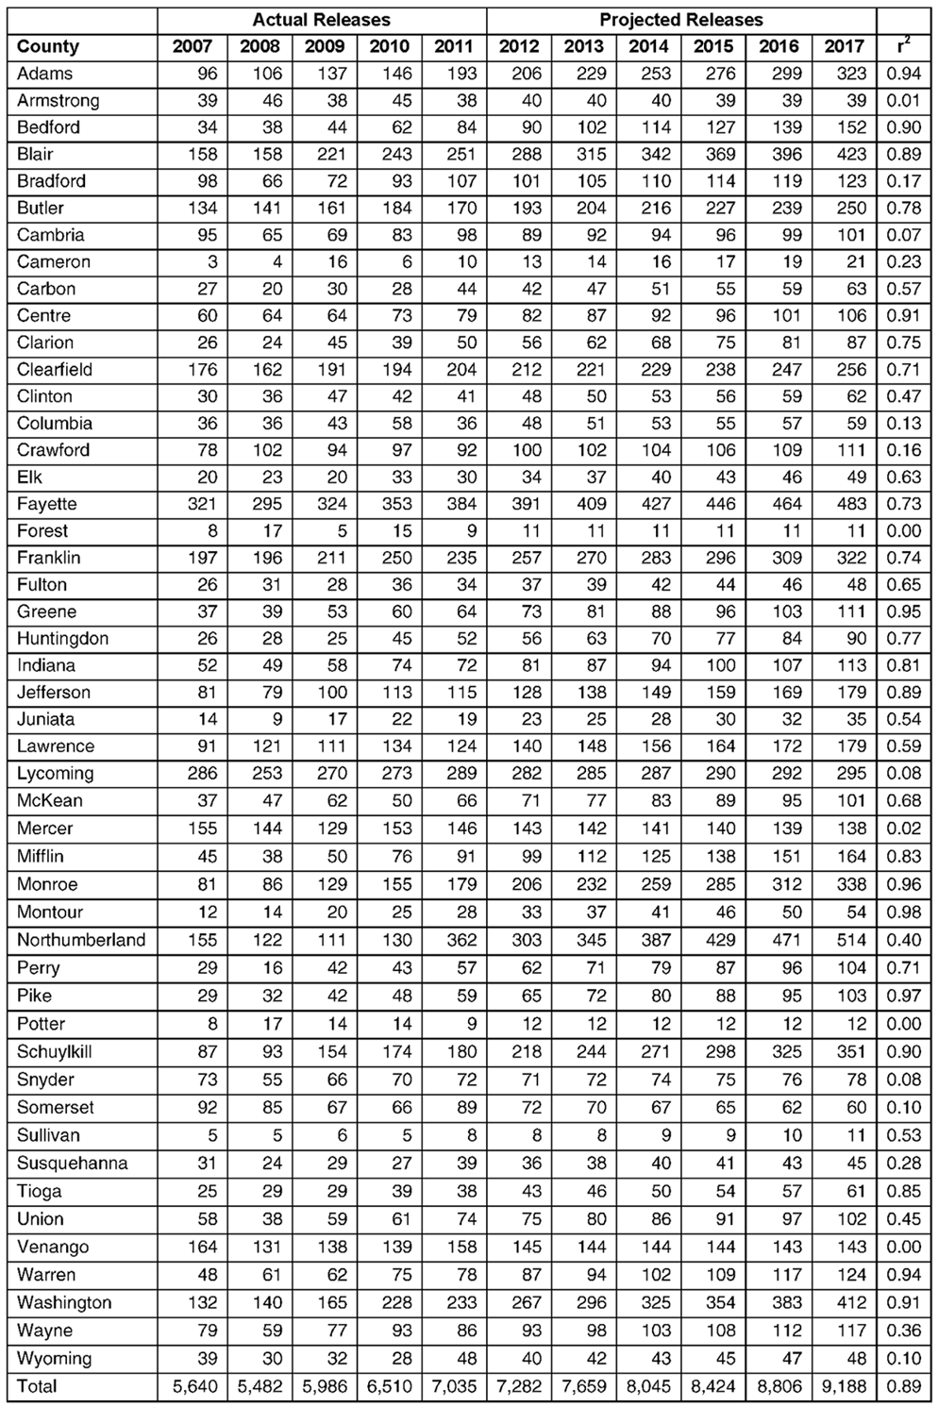
state inmates released from year to year, so the researchers had somewhat less condence in the population projections in those counties. For example, although Armstrong uctuated only be -tween 38 and 45 inmates, these uctuations represented a very large proportion of the jail’s total population. More impor-tantly, the uctuations changed directions, neither consistently decreasing nor increasing. The projected releases in Armstrong still reect the average number of inmates one would expect
in a given year, but the low r2 value means that this projection will likely have more “error”— a larger proportional difference between the projection and the actual population in any indi-vidual year. In general, year-to-year trends are more difcult
to predict for jails with smaller populations due to greater proportional changes in their populations over a short period of time. Conversely, counties, such as Adams, show a con-sistent change (increase in this case) in their population over the study period, thus present-ing a more plausible case for prediction, which is what the r2 statistic represents.

Table 1: Projected Releases from State Prisons to Rural Counties, 2012-2017

County Jail Release Estimates
Overall, rural Pennsylva-nia county jail releases were
predicted to increase at a slow pace of about 220 releases per year across all rural county jails for the period 2012 – 2017 (See
Table 2 on Page 6). These county-by-county projections are based on the inmates released from each county jail, for that county. Several conditions should be noted. First, as documented in Zajac and Kowalski (2012), there is a small degree of movement of inmates be-tween county jails, but detailed data on such movement

An Examination of Rural Prisoner Reentry Challenges

Data source: PADOC and PBPP.

were not available. Thus, for the purposes of these pro-jections, the researchers considered each county jail’s releases as belonging to that county. Second, as noted earlier, Cameron, Forest, Fulton, and Sullivan coun-ties do not have their own jails, and have not had them over the time period of the study. Therefore, no county

5

jail release projections were made for those counties. Presumably, there were a very small number of county inmates from those four counties so the inability to account for their releases should introduce little error into the overall picture of rural county inmate reentry. Juniata County closed its jail midway through this study (July 2012), with its inmates being transferred to the Mifin County jail. Since data were available on prior releases from the Juniata County jail (which were

among the smallest of all the counties), the researchers conducted a county jail projection for Juniata, as its inmates would presumably return to Juniata County after their release from the Mifin County jail. Finally, data were missing for some counties for some years. Data for Potter County were available for only 1 year, so no projection could be made for Potter County.
Looking at Table 2, some counties show relative stability in the trend of the number of county inmates

Table 2: Projected Releases from Rural County Jails, 2012-2017

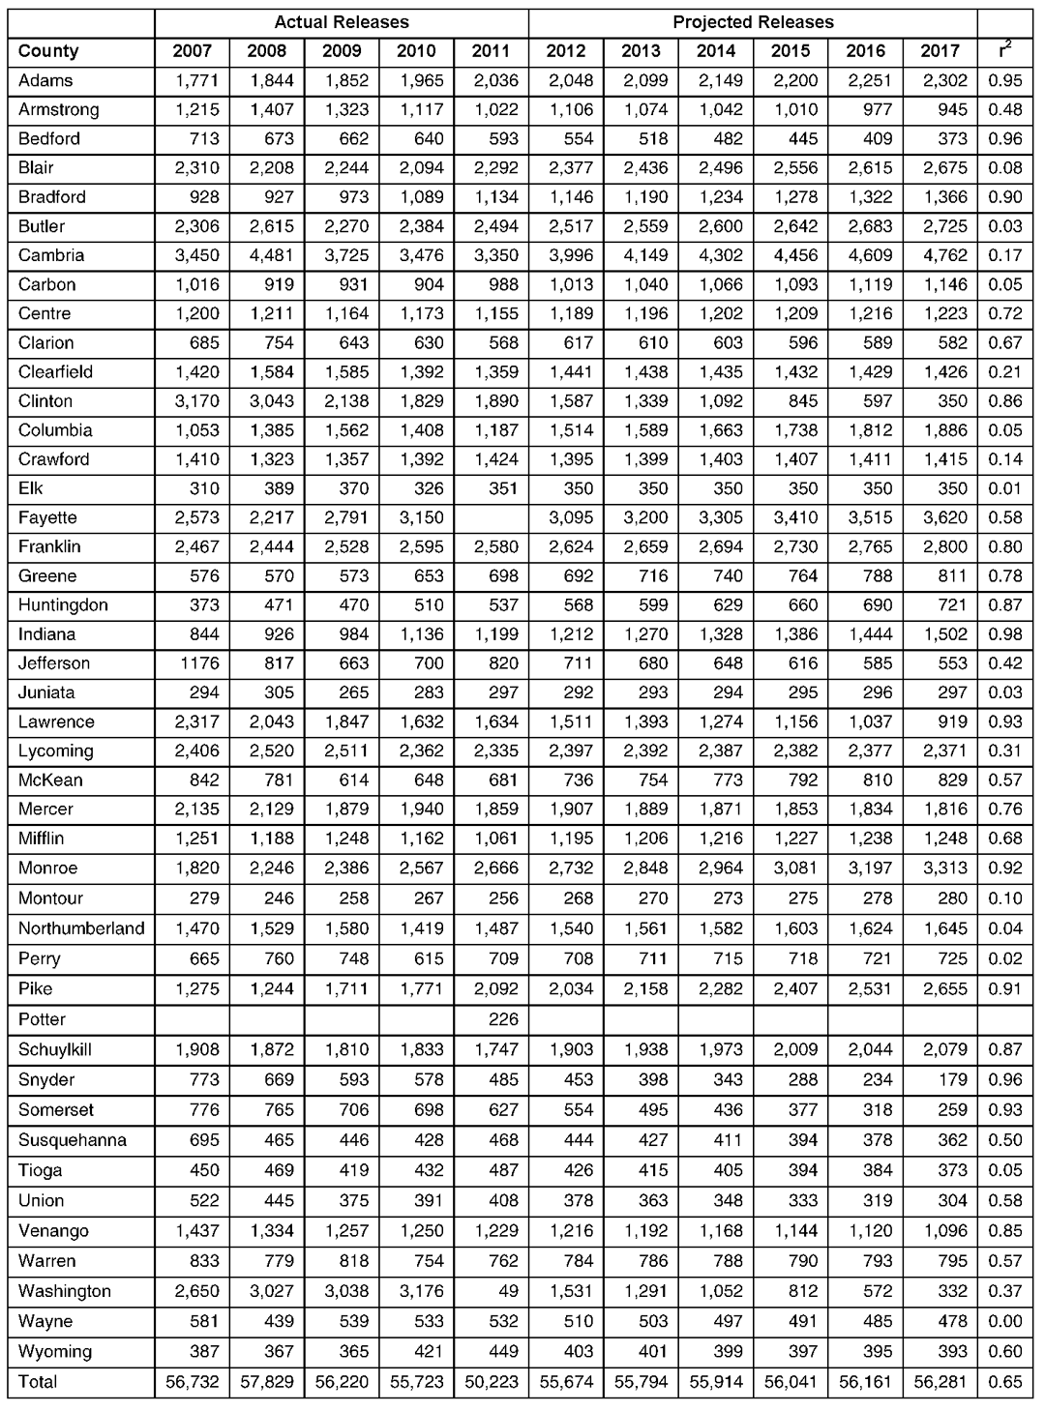
Data source: Zajac and Kowalski (2012).

6
released (the r2 statis-tic), such as Adams and Bradford, so the researchers were more condent in these population projections.
For other counties, such as Carbon and Elk, the release trends were less clear, so the researchers had somewhat less con-dence in those popula -tion projections.
Total admissions and discharges from rural county jails from 2007-2010 were highly cor-related (r = 0.93 where r ranges from -1 to 1 and 1 means perfect positive correlation). This indi-cates that discharges in-crease when admissions increase and discharges decrease when admis-sions decrease. This correlation should be interpreted with caution because of the small number of years of
data available; three or four more years of data would have provided more concrete evidence in terms of statistical signicance. How -
ever, this correlation is consistent with the high turnover in the county jail system. Thus, the annual number of

The Center for Rural Pennsylvania

releases in rural county jails seems to Figure 1: Parolee Movement Between Rural and Urban Counties, be closely related to the annual number 2007-2011
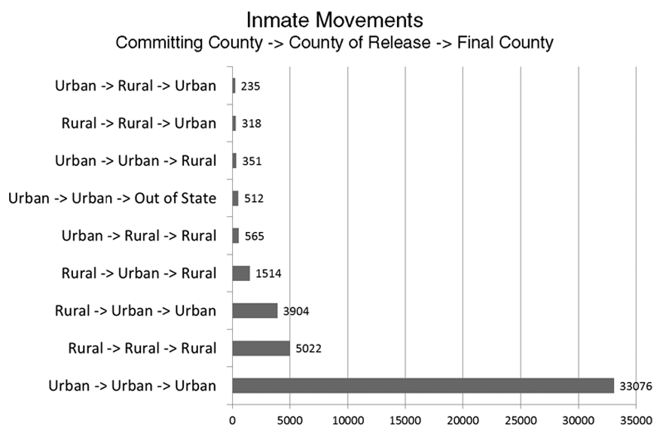
of admissions. Admissions data for the state prisons were not available, so this analysis was conducted only for county jails.
The projected releases for rural coun-ty jail inmates over the next 5 years were basically at. Therefore, there were no dramatic changes projected in releases of rural county jail inmates. For state prison inmates, the projected
trend was for a slow but steady increase in releases of state inmates to rural counties. This continues the docu-mented trend of increases in releases of state prison inmates to rural counties over the previous 5 years, upon which
these projections were based. The most Data source: PADOC and PBPP. plausible explanation for this increase
is that the approval rate of state inmates applying for most state inmates committed from a rural county are parole showed a similar slow-but-steady increase. The initially paroled back to a rural county, and remain in a parole approval rate dipped to 52 percent in 2008 and rural county (although there may be transfers between 51 percent in 2009 due to the moratorium on parole rural counties not accounted for here). Moreover, there imposed by then-Governor Ed Rendell5. Since then, are far more cases of state inmates committed from
the parole approval rate has increased to 61 percent in rural counties being paroled to urban counties than of 20126. PADOC and PBPP have also been making ef- state inmates committed from urban counties being pa-forts to expedite the actual release of inmates from state roled to rural counties. This analysis indicated that rural prison once they have been approved for parole. While reentry is a relatively self-contained process, with state these parole approval rates are statewide and are not inmates being paroled to the same type of county from available for each county, it remains a reasonable con- which they came. It is the same for urban reentry. It clusion that the increase in state prison releases to rural should be noted that this analysis applied only to state counties can be attributed at least in part to this shift in parole releases and not those who are maxing out. Also, parole decisional processes and the “rebound” in parole the county from which a state inmate is committed is rates after the moratorium. not always the county where the inmate was living, but
The projected steady state for rural county jail re- instead is the county where the inmate was convicted. leases and the projected increase in the release of state
prison inmates to rural areas signals that rural reentry Demographic Prole of Inmates Who Are will remain a signicant issue in Pennsylvania.
Likely To Be Released
Finally, Figure 1 illustrates the extent to which state inmates from urban counties are paroled to rural coun-
The demographic trends for released state prison in-
mates were projected for the period 2012 – 2017, based
ties, and vice versa. In the majority of cases, a state on the known age, race and gender demographics of rst paroled back to an urban county, and remains in an released state inmates for the period 2007-2011. urban county (although there may be transfers between to continue its steady decline since its peak in 2008 at
inmate who was committed from an urban county is
urban counties not accounted for here). Similarly,
The percentage of minority releases was projected
about 22.5 percent at a rate of about 0.5 percent per year. The proportion of female inmates has steadily
5. See: “Pa. ends moratorium on parole for violent felons.” USA Today.
climbed since a 2007 low of 12 percent at a rate of

December 1, 2008.hhttp://usatoday30.usatoday.com/news/nation/2008-12- about 0.7 percent per year. Similar to the jail trends, the 6. Data and explanation on parole decisional rates supplied by Fred Klunk, proportion of state prison releases for those over age 44 director, Statistical Reporting and Evidence-Based Program Evaluation is expected to increase at about 0.5 percent per year.
01-2116996479_x. tm.
Ofce, PBPP.

An Examination of Rural Prisoner Reentry Challenges 7

The county jail data had no information available on the de-mographic breakdowns of actual inmate releases per year. Therefore, the demographic trends for released county jail inmates were projected for the period 2012 – 2017, based on age, race and gender demograph-ics of the in-house jail population for the period 2007-2011.
Based on trends since 2007, county jail releases will be increas-ingly composed of minority in-mates, increasing at a rate of about one half of 1 percent per year. The proportion of female releases was projected to remain stable, decreas-ing at a rate of less than 0.1 percent per year. According to recent trends, the age of persons released from
jail will proportionally increase in the future. The proportion of county inmates under age 30 was projected to decrease at about 3.5 percent per year while the proportion of older county inmates was projected to increase.
In sum, with the exception of releases of female state inmates and older inmates from both the state and county levels, both of which are projected to show a modest increase, there are few remarkable trends in the projected demograph-ics of inmates to be released to rural areas over the next 5 years. For
most demographic categories, few if any changes are projected, and most changes are projected to be gradual.

Interview and Survey Results Critical Rural Reentry Challenges
Table 3 presents the mean scores from the results of the interviews with state corrections ofcials and the survey of county jail wardens.
The responses from the state and county corrections ofcials are
quite consistent. The shaded rows in Table 3 indicate items where there was a statistically signicant differ -

8
Table 3: State Corrections Ofcials and County Jail Wardens Ratings of Rural Reentry Topic Areas as Key Challenges
(1 = No Challenge; 10 = Very Signicant Challenge)

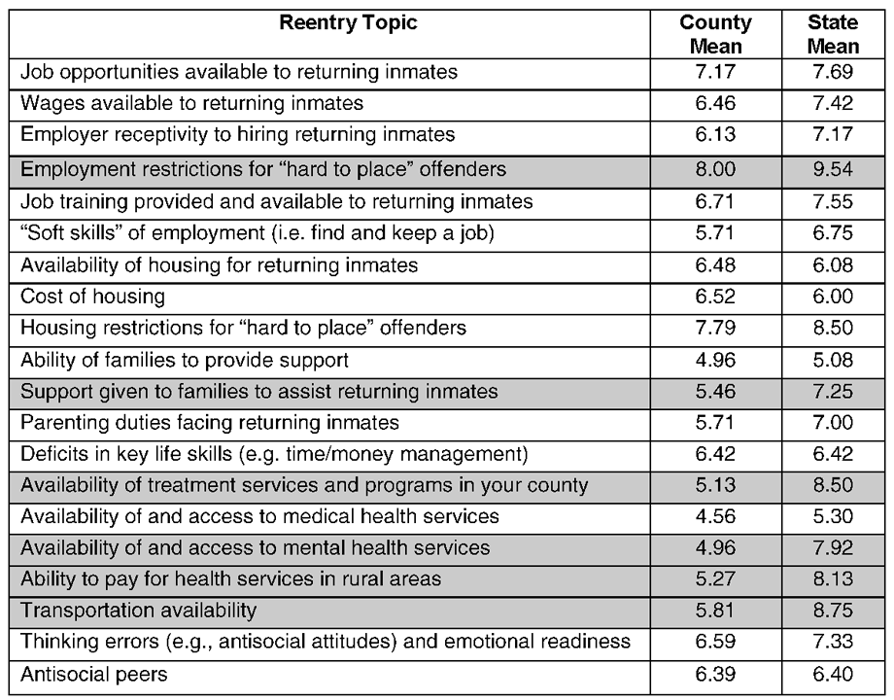
Source: Interviews with 13 state corrections ofcials and survey administered to 24 rural jail wardens. Note: Shaded columns indicate a statistically signicant difference (at least p<0.05).

ence between the ratings given by wardens. Conversely, the reentry state ofcials and county jail war - topics rated as least challenging by dens (at least at the p<0.05 level). both groups of respondents were the Both groups agreed on 14 of the ability of families to provide sup-
20 reentry topics (70 percent). This port to their returning loved ones, suggests that both state and county and the availability of and access to corrections ofcials share a com - medical health services (note this is mon understanding of the challeng- distinct from mental health services, es related to rural reentry, and that which was rated as a more impor-this likely reects a set of core rural tant issue).
reentry issues that cut across all lev- In all six topic areas where the els of corrections in Pennsylvania. state corrections ofcial and the If this study had found little or no wardens disagreed signicantly
agreement between state and county in their ratings – (1) employment ofcials, the conclusions about the restrictions for hard to place offend-challenges surrounding rural reentry ers, (2) support given to families would have been less clear. to assist returning inmates, (3)
Looking rst at areas of agree - availability of treatment services ment, the most critical challenges and programs in your county, (4) facing rural reentry are housing availability of and access to mental restrictions for hard to place offend- health services, (5) ability to pay ers, and job opportunities available for health services in rural areas, to returning inmates. Both items and (6) transportation availability were rated at least a 7 by both state – state ofcials rated these areas as corrections ofcials and county more of a problem than the county

The Center for Rural Pennsylvania

wardens. One explanation may be that state ofcials have a statewide perspective on reentry. Moreover, they are presumably better able to make comparisons between rural and urban reentry issues, than are rural wardens who are working only within a single county.
In addition, state corrections (PADOC and PBPP) seem to operate more reentry programs than county jails, so the state corrections ofcials may have explored these issues more closely. A competing explanation is that the county wardens are “closer to the ground” and may have a more nely tuned perspective on local reentry conditions. In any event, even though the state correc-tions ofcials consistently rated these six issues higher than the county wardens, the wardens’ scores nonethe-less round to at least a 5 on all of these issues, suggest-ing that these issues are important.
In addition to the quantitative, forced-choice ques-tions asked of the state corrections ofcials during the interviews, they were also given the opportunity to pro-vide their own comments on the challenges to reentry. The wardens’ survey allowed the respondents to write their comments as well. The researchers identied common themes to this qualitative data.
One of the strongest themes to emerge centered on the notion of stigma. Respondents argued that offend-ers returning to rural areas often face stigmatization for their status as ex-offenders, and that this inuences their ability to secure employment and housing (land-lords refuse to rent to them). Sex offenders, especially, have signicant issues in securing housing because landlords do not want to rent to them, and they can even face great difculties in getting jobs due to nega -tive attitudes of potential employers. While the respon-dents acknowledged that stigma can be an issue even in urban reentry, the relative anonymity of urban life and the greater density of ex-offenders in many urban areas may make the mark of a criminal record less of an issue there. But in rural areas, released inmates’ status as ex-offenders is often widely known and seen as a violation of community norms. Thus, the released inmate “stands out” as the subject for disapproval. On a related point, several respondents noted that the close ties within many rural communities can actually work
in favor of ex-offenders who were highly regarded prior to incarceration and thus make reentry easier for these higher status individuals. But, respondents argued that this is not the case for most offenders returning to rural areas, so stigma emerges as a key issue for them.
Closely related to the issue of stigma was the chal-lenge presented by the so called “hard-to-place”
ex-offenders. These include the mentally ill, violent

An Examination of Rural Prisoner Reentry Challenges
offenders and, most especially, sex offenders. Most respondents made a point of emphasizing that reinte-gration of “hard to place” offenders is one of the most signicant challenges for reentry for their agencies.
Transportation was also universally identied as

a key rural reentry issue, as it received a high rating on the forced choice question dealing with this topic, but was the subject of some degree of discussion by nearly all respondents. Respondents noted that limited transportation in rural areas intersects with many other reentry challenges, making it more difcult for released offenders to search for and get to work, attend treat-
ment groups and even make meetings with their parole agents. Respondents also widely agreed that transporta-tion is much more of an issue for rural reentry than for urban.
As noted in the quantitative ndings, respondents endorsed the lack of treatment programs in rural com-munities as a key issue, but they also widely noted that programs specically addressing core criminogenic needs, such as anti-social attitudes and poor decision making skills, were almost entirely absent in rural areas. While there is also a decit of such programs
in urban areas, the Community Corrections Centers/ Facilities operated by PADOC run some such program-ming, and most of these centers are clustered in urban areas, thus providing some options for ex-offenders in urban areas who need those services. Of course, these centers serve only state inmates paroled from State Correctional Institutions, so they do not represent a resource for inmates released from county jails, nor for the 21 percent of state inmates who are released at the completion of their sentence with no parole supervision (“max-outs”), which represents nearly 21 percent of all state releases (Pennsylvania Department of Corrections, 2012b).
Respondents also widely noted that mental health services are often lacking in rural areas, and said that some rural counties may not even have a practicing psychiatrist, thus making continuity-of-care a signi -cant impediment to reentry for seriously mentally ill ex-offenders. The respondents noted that this is much less of an issue in urban areas, where there is a greater density of mental health clinics and providers.
There was some disagreement between the state cor-rections ofcials and county jail wardens on the issue of family support. The state level respondents felt that family support was often stronger in rural areas, and
that offenders returning to these areas often rely heavily on family to fulll needs that might be met by commu -nity or public agencies in rural areas, such as housing

9

and employment assistance. County wardens, on the other hand, were less condent in their observations about the assistance that families can or do provide during reentry, noting that the families themselves are often struggling with their own issues and problems. Respondents did indicate, though, that there are few support services for families themselves in rural areas as they try to help their loved ones who are returning from prison.
As noted in the quantitative interview/survey nd -ings, employment is endorsed by most respondents as a key challenge, both in rural and urban areas, but especially in rural. Closely related to this was their frequent observation that there are very few opportu-nities for vocational training for ex-offenders in rural
areas, although respondents from PBPP noted that their agency is working to develop training opportunities for ex-offenders at local community colleges, but that this effort was just beginning.
Finally, the respondents also frequently commented that criminogenic needs are a challenge for both rural and urban reentry. There was some disagreement over whether antisocial peers were more of an issue for rural reentry than urban, with some respondents arguing
that the urban environment offers a denser network of deviant peers, but with other respondents arguing that isolation in rural areas can leave ex-offenders with few alternatives for social outlets besides their old antisocial peers (and even family).

Available Reentry Programs and Services PADOC, PBPP and County Jails
At the time of the study, PADOC was modifying its reentry programming. For much of the past 10 years, PADOC’s core reentry preparation program was known as the Community Orientation Reintegration (COR) program. Originally developed in 2001, COR was a two-phased reentry initiative. Phase 1 involved 2 weeks of full-time services delivered in a State Correctional Institution (SCI) near the expected time of the inmate’s release. The specic services included in this phase focused heavily on job readiness, such as job hunting skills, resume writing, and preparing for interviews. Other issues covered were money management, nd -ing housing, family reunication and accessing social services in the community. Phase 2 of COR also lasted approximately 2 weeks and was delivered in a Com-munity Corrections Center/Facility after an inmate was released. Services delivered in this phase were not as regimented as those in Phase 1 and could include fam-ily issues and on-going job readiness.

10
PADOC completed a comprehensive evaluation of the COR program in 2008 (note: this evaluation was conducted by an independent evaluator and was led by the principal investigator for the current study). The evaluation found that the COR program was not pro-ducing any signicant reductions in recidivism among the inmates who participated in the program (Smith and Suttle, 2008). The evaluation concluded that COR was attempting to deliver too many services in too short a period of time to too many inmates, using ineffective techniques. This is a problem that has plagued other at-tempts to deliver brief, broad-based reentry preparation programs to soon-to-be-released inmates (Wilson and Davis, 2006).
As a result of the COR evaluation, PADOC decided to gradually phase out the program and replace it with new reentry services, called Transitional Housing Units (THUs), or Reentry Ofces. At the time of this research, the new reentry programs were being piloted at SCI Graterford, SCI Camp Hill, SCI Muncy and SCI Albion. The intended design of these units was for in-mates to be placed at the SCI nearest to their home six months prior to their expected parole or other release date so that they could be introduced to community resources. The pilot ended in November 2013. (Editor’s note: According to follow-up correspondence between the researchers and PADOC, new THUs were launched in January 2014 at SCI Graterford, SCI Chester, SCI Camp Hill, SCI Mahanoy, SCI Pine Grove, SCI Laurel Highlands, SCI Muncy, SCI Cambridge Springs, SCI Pittsburgh, SCI Albion, and the Quehanna Boot Camp. The original THU concept was adjusted since, from a practical standpoint, all inmates could not be housed close to home. Therefore, PADOC established some THUs in appropriate institutions, and Reentry Ofces
in those sites where the housing unit concept wasn’t as practical. According to PADOC, reentry parole agents are in place at Graterford, Albion and Camp Hill. New positions were not expected in all sites, but PADOC expected to receive parole support in some form at all sites. Through the pilot, PADOC found that inmates re-sponded well to the presence of an agent, who actually worked with them on the housing unit or the reentry ofce. Through the presence of an agent, inmates
were able to interact, ask questions, and take part in workshops designed by parole to assist the inmates in preparing for release.)
Other elements to PADOC’s reentry process are the 53 Community Corrections Centers and Contract
Facilities that operate statewide. Fourteen are operated directly by PADOC (Community Corrections Centers,

The Center for Rural Pennsylvania

or CCCs), with the remaining 39 operated by private providers on behalf of the state (Community Contract Facilities, or CCFs), although some of the CCFs may also house offenders for other clients, such as the federal Bureau of Prisons7. Primarily, CCC/Fs provide inmates who have just been paroled with transitional housing and other basic reentry assistance for up to sev-eral months after their release. Some CCC/Fs limit their services largely to housing and monitoring, whereas others provide more in-depth rehabilitative services, such as residential drug treatment. At the time of the research, the CCC/F system was in a period of ux. PADOC had conducted a comprehensive evaluation of the entire CCC/F system, which was completed in 2009 (note: this evaluation was conducted by an indepen-dent evaluator and was led by the principal investigator for the current study). This evaluation included every CCC/F in operation at the time and compared outcomes for inmates sent to the CCC/Fs to outcomes for similar inmates paroled directly to the street. The evaluation found that, overall, the CCC/Fs were not producing any reductions in recidivism, and, in many cases, individual CCC/Fs were actually showing increased recidivism rates compared to control parolees (Latessa, et al., 2009). The evaluation also found that the quality of treatment programs offered in most CCC/Fs was low. As a result of this study, PADOC announced in March 2013 that it would suspend the contracts for all private-ly run CCFs and require rebidding under a new perfor-mance based contracting system8. Payments to the new vendors selected would be tied to the recidivism rates of the facilities that they operate9. Thus, the researchers could not project exactly what the “new” community corrections system would look like when the new con-tracts took effect later in 2013.
PADOC was also undertaking several other smaller initiatives and experiments designed to improve reentry. Within the state run Community Correction Centers, corrections counselors, who work within these centers, would become oriented more towards serving as out-reach agents, working with local community organiza-tions and employers to leverage resources and opportu-nities for released inmates. Another initiative involved training specially selected inmates within some SCIs to
become Certied Peer Specialists, which is a relatively new but rapidly growing initiative within the mental health eld that allows individuals who themselves
have been diagnosed with some sort of mental disorder to become certied as para-professionals, providing support and ancillary services to their peers who are undergoing treatment. The goal of the Certied Peer Specialist initiative is to better prepare inmates with mental disorders to return to the community, and also to provide the inmates who are trained as the Certied Peer Specialists to acquire a marketable skill and expe-riences that may lead to employment opportunities in the community upon release. Finally, PADOC received a grant from the U.S. Department of Justice, Bureau
of Justice Assistance, to revamp and expand reentry services provided to female inmates who are diag-nosed with co-occurring mental disorder and substance abuse10.
At the time of the research, PBPP was also under-going changes to its reentry practices. Traditionally, PBPP relied heavily on programs and services offered through the CCC/F system, run by PADOC. PBPP in large part brokered services for parolees in the com-munity, such as through the Single County Authorities. Given that PBPP’s mission is centered on supervising released inmates in the community, it can be said that everything it does is focused on reentry. Core elements of this mission include processing inmate applications for parole and delivering orientation sessions to inmates prior to parole. The development of the parole “home plan” is also a critical piece of PBPP’s reentry strat-
egy. The home plan must be developed by the inmate, with assistance from institutional parole staff, prior to parole approval. The home plan codies key conditions of parole release, such as living arrangements, family support, employment options, and ongoing treatment and human services in the community if needed. Once paroled, parolees are also supervised by parole agents, including mandated visits by the parolees to their local parole ofce, as well as visits by the parole agent to the parolees’ homes or other relevant venues, such as work. In addition, many parolees undergo random drug test-ing for at least some period of their parole.
Turning to specic reentry initiatives operated by

7. For a complete listing of these CCC/F’s, see http://www.portal.state.pa.us/portal/server.pt?open=512&objID=14823&mode=2. 8. “Prison reform ties contractors’ prots to public safety.” The Patriot-News, March 3, 2013, p. A5.
9. On a related note, Latessa and colleagues also conducted a very similar evaluation of the Ohio halfway house system prior to their evaluation of the DOC CCC/F system, with results very similar to what was found here. Ohio also moved to a performance-based contracting system for its halfway houses in the wake of that evaluation. See: Lowenkamp, C.T., and Latessa, E.J. (2005). Evaluation of Ohio’s CCA Programs. Cincinnati, OH: Center for Criminal Justice Research, University of Cincinnati.
10. The principal investigator for this study is leading an evaluation of this co-occurring disorder initiative, but results were not available in time for this report.

An Examination of Rural Prisoner Reentry Challenges 11

Table 4: Reentry Programs Reported by County Jails

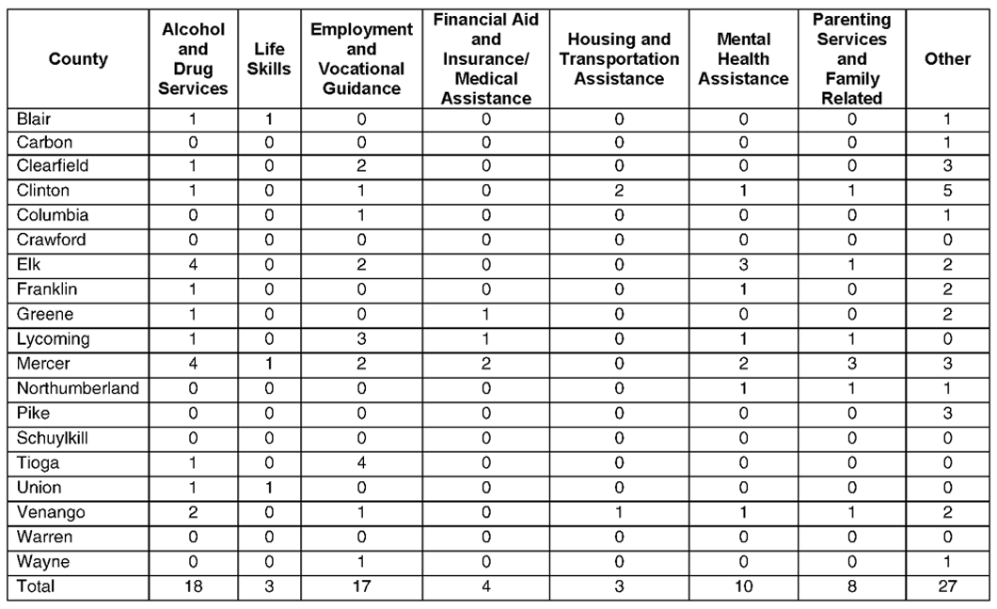
Data source: Survey of county jail wardens.

PBPP, the Reentry Program is ment, Sanctioning, and Community similar to a reentry or drug court, Resource Agents (ASCRA) initia-where selected parolees who have tive that is geared toward more
a history of substance use will be direct provision of reentry services enrolled in a 12-18 month program to parolees in both rural and urban involving regular meetings (usu- communities. The initiative involves ally monthly) at the county court- specialized parole agents who do house with a PBPP board member, not maintain a regular list of pa-judge, parole agent, county drug rolees whom they are responsible and alcohol service personnel and for supervising, but instead focus other staff, as needed. These meet- specically on reentry planning and ings help to assess the parolee’s assistance for parolees in the com-compliance and progress with the munity. ASCRAs work to develop individualized plan for supervision, ties with providers and potential substance abuse treatment, and employers in the community to as-other recommended treatment ser- sist parolees with needed services vices developed for him/her prior to and employment leads and serve as release and to administer rewards or referral resources for other parole corrections based on that progress. agents, assisting them in connect-The Reentry Program can be used in ing parolees on their caseloads with any county if there are parolees in needed services.
need of this service in that county. ASCRAs themselves also run The exact nature of the Reentry treatment groups for selected Program can vary from county to parolees focusing on employment, county, and also from one parolee cognitive skills training, substance to another, but the overarching goal use, family education, violence pre-is to provide a structured and sup- vention and life skills (other parole portive reentry process for seriously agents in general do not run treat-
addicted parolees. ment groups, so ASCRA represent a PBPP also developed the Assess- new direction in the direct provision

12
of treatment services to parolees in the com-munity). At the time of the research, there were only 17 ASCRA agents. According to state parole ofcials interviewed for this study, preliminary research by PBPP seems to nd recidivism reduc -tions associated with
the ASCRA initiative, although no report was available.
The researchers also explored the reentry pro-grams offered by the 43 rural county jails. Table 4 presents a summary
of the types of reentry programs that the county
wardens reported operating. It should be noted that this table does not include those counties that sim-ply did not respond to the survey, nor those counties that responded but did not answer the specic ques -tion. Therefore, the table represents only those county jails that provided some sort of direct answer to that question. Also, as Juniata County closed its jail midway through
this study, its responses were not included in the table.
The researchers grouped the responses into eight program cat-egories, as shown in Table 4. These categories correspond as closely as possible with the other categories of reentry programs discussed in the next section. Note that some coun-ties may offer more than one pro-gram within a given category. The “other” category includes a wide variety of miscellaneous services, such as veterans’ programs and gender specic services.
Drug and alcohol programs are the most common type of reentry program reported by the jails. Em-ployment and vocational guidance

The Center for Rural Pennsylvania

Table 5 – Community-Based Programs in Pennsylvania Rural Counties

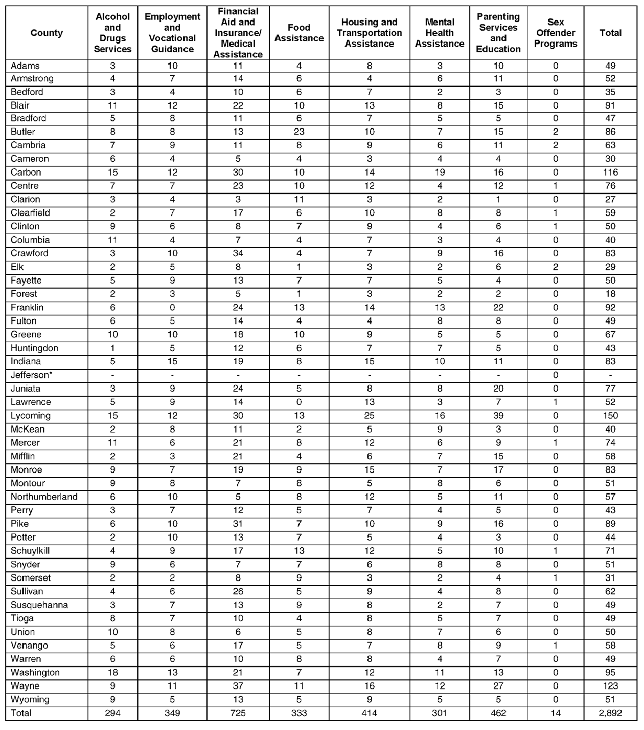
Data source: PADOC and PBPP, supplemented by searches of county websites. *Data were not available for most program categories for this county.

are almost as common. The other program categories are much less in evidence, most notably housing and nancial assistance. The researchers had no informa -tion available about the quality of these programs, or their effects on recidivism. As part of the wardens’ survey, the county jails were also asked about any new reentry initiatives they might be developing. Only six jails indicated that they had any new reentry initiatives

An Examination of Rural Prisoner Reentry Challenges
underway. These initiatives focused on creating drug courts (Carbon, Columbia), parenting programs (Car-bon, Lycoming), housing assistance (Franklin), expand-ing jobs assistance efforts (Lycoming, Pike) and efforts to study what they are currently doing with entry to inform future planning (Clinton).
The data collected through this survey suggest a rela-tive dearth of reentry programs being offered by rural

13

county jails. As noted earlier, and in Zajac and Kow- tion of the social service menu available to ex-offenders alski (2012), county jails often lack the resources and in rural Pennsylvania.
staff capacity to offer extensive programming, which is Also, these community programs are, for the most exacerbated when dealing with very small jails. Clearly, part, available to anyone in the community. Therefore, there is much greater capacity within the state prison ex-offenders must share access to these services with system to provide formal, structured reentry services. non-offenders. Again, this study was not able to collect As a corollary to that, there may be a greater need for information on the client mix that is served by each such services for state inmates, as they typically have program. It is also important to note that these com-been incarcerated for longer periods than county jail munity programs are not necessarily geared specically inmates (Zajac and Kowalski, 2012). towards addressing the core criminogenic needs of
ex-offenders, such as anti-social attitudes and associa-Community-Based Programs in Rural Counties tion with criminal peers. While the researchers could
Following is a discussion of the number and types of not conduct an actual evaluation of each program, they programs available in each county. It was beyond the did review the brief program descriptions (if provided). resources available
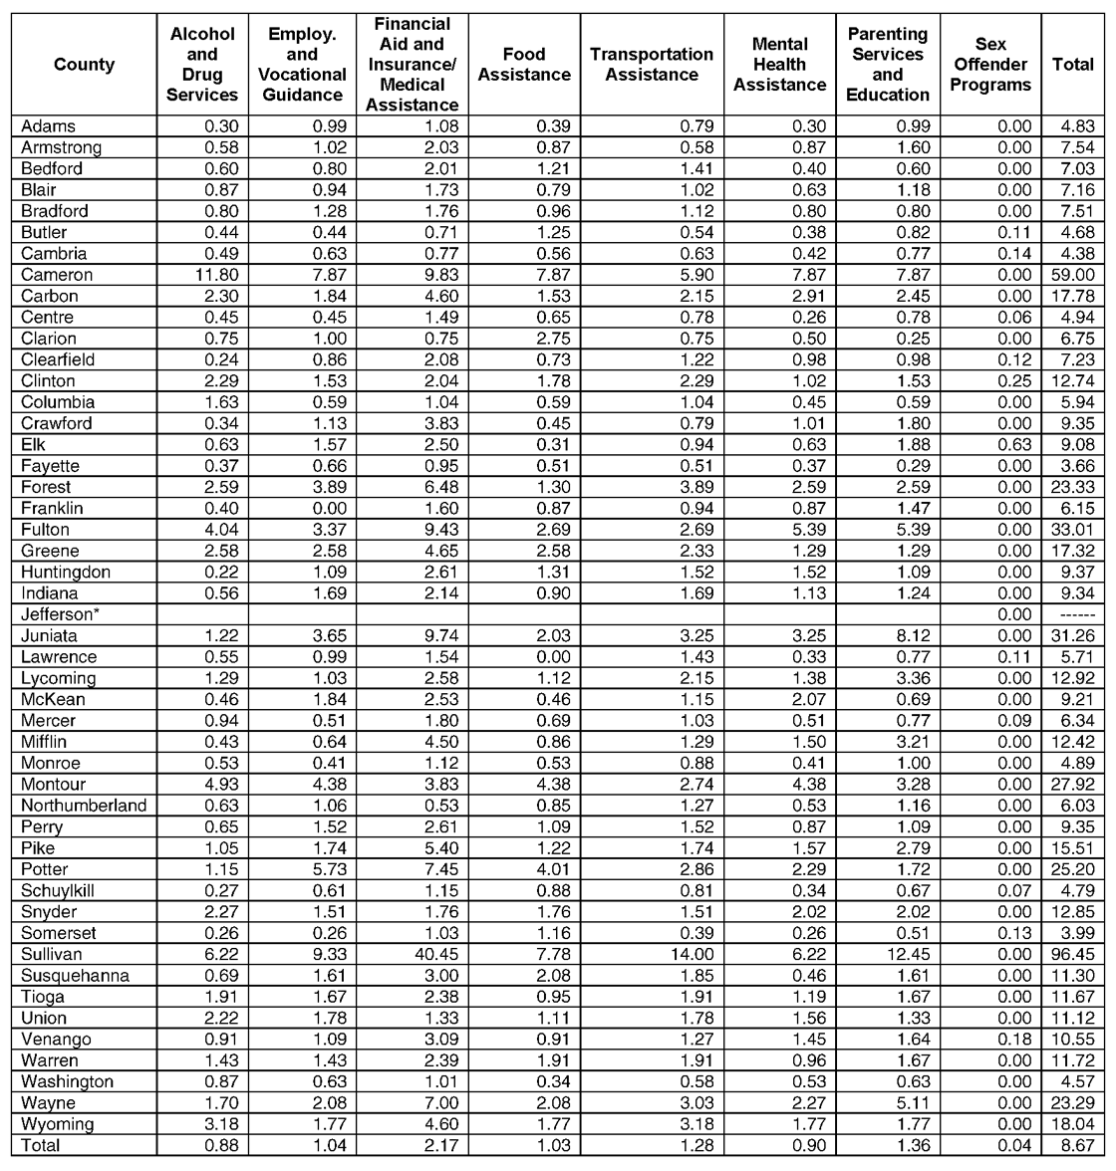
to this research to Table 6 – Community-Based Programs Per Capita (rate per 10,000) assess the quality in Pennsylvania Rural Counties
or capacity of these programs, given that there are nearly 2,900 programs
listed for rural coun-ties. While Table 5 (Page 13) may show that one county has more programs than another, the numbers say nothing about the relative quality of the programs. On a related point, it was not always clear from the program description whether a given program provider is public, private, or non-
prot, what sort of fees may be charged for services, or
how these disparate programs coordinate their services. These are important issues, but would have required a compre-hensive survey of all programs. Still, the following analysis
offers some indica- Data source: PADOC and PBPP, supplemented by searches of county websites. *Data were not available for most pro-gram categories for this county.

14 The Center for Rural Pennsylvania

No evidence was found that any of these Table 7 - Programs Per Capita (rate per 10,000) programs was delivering offender specic in Rural and Urban Counties
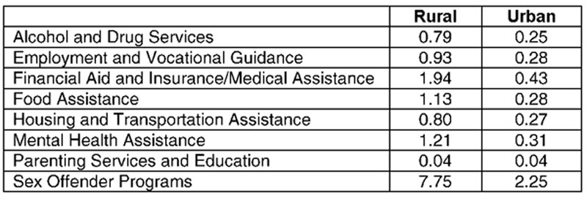
services, as would be found in a prison set-ting. The one exception was the sex offender programs offered in 11 counties, which by denition are oriented towards those who have committed sex crimes. However, there are very few such programs and they are tar-geted specically to sex offenders. The lack of
community programs that specically addresse Data source: PADOC and PBPP, supplemented by searches of county websites. during the interviews and surveys with state
key criminogenic needs was noted as an issu
corrections ofcials and county wardens. collected data on the number of inmates released to Finally, it is unclear how often released inmates take each rural county for each of the past 5 years, the re-
advantage of the community services that are, in theory, searchers did not have any data on the total number of available to them. Some programs charge fees that released inmates living in each county at any one time released inmates may not be able to afford. Transpor- (including inmates who were released prior to the time tation to programs in rural areas was also noted as an period covered by this study).
issue. Table 6 shows the per capita rate for programs for all The researchers learned during interviews with rural counties.
PADOC that it makes the community resource direc- While this study did not intend to examine program tories available in prison libraries for inmates to use, capacity in urban counties, the researchers had the and inmates may request a copy. The PADOC Bureau same community program data for urban counties as
of Treatment Services also provides copies to family for rural, thus allowing them to test the assertion made members of inmates upon request, and these directo- by the state corrections ofcials during the interviews ries are on PADOC’s website. During interviews with that rural counties have less program capacity than ur-PBPP staff, it was noted that the specialized ASCRA ban. Table 7 shows that, across the board, rural counties also work with parolees to direct them towards appro- seem to have equal or even greater program capacity priate community programs. And, as discussed below, than urban counties. Thus, the data seem to contradict several of the responding rural county jails provided the impression that rural counties overall are more some information about specic community programs challenged in their ability to offer services to returning to which they refer their inmates. Therefore, while the offenders. However, it should be noted that the data state and local corrections agencies in Pennsylvania are presented in Tables 5 through 7 do not account for pro-taking care to make released inmates aware of avail- gram quality or the actual ability of returning offenders able programs in the community, it is unclear how these to take advantage of these programs. Thus, the state resources are being used by the released inmates. corrections ofcials may have been reporting on more
Table 5 provides a simple count of the number of nuanced aspects of service capacity within these coun-community-based programs in each rural county that ties than are indicated by the data in these two tables. could be accessed by released inmates, grouped into Table 8 on Page 16 presents a summary of the com-eight categories. munity services the county wardens reported refer-
The number of programs per capita (rate per 10,000) ring to their inmates. It should be noted that this table was calculated for the programs in each rural county to does not include the counties that did not respond to provide a better representation of the density of services the survey or the question. The table also excludes the available in each county, according to how the program response from Juniata County, as its jail was closed base within each county is spread across the population. midway through this study.
For this analysis, the researchers used the rate for the According to the survey results, drug and alcohol entire population of the county, rather than the popu- programs are the most common type of services to lation of released inmates, because these community which the jails are referring released inmates. Alcohol programs are available to everyone in the community, and drug services were also the most common type of not just released inmates. Moreover, while this study reentry program reported to be delivered within the
jails. Other common referral targets include employ-

An Examination of Rural Prisoner Reentry Challenges 15

Table 8 - Community Services to Which County Jails Refer Released Inmates

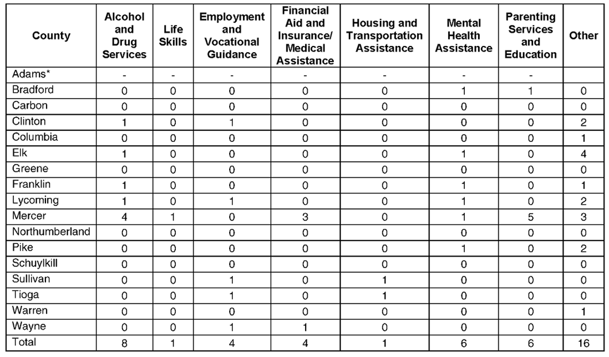
Data source: Survey of county jail wardens. *Note: Adams County attached an extensive directory of programs available in the multi-county area surrounding Adams County.

ment services, parenting, and men-tal health. What seems to stand out from the data is that county jails are making relatively few referrals to reentry services in the community. The counties that responded to this question reported a mean of only three community programs to which they make referrals. It may be that the relatively short-term nature
of most county jail stays, and the challenge of rigorously classifying inmates under these conditions, lim-its the perceived need or capacity of the jails to make community service referrals in many cases (Zajac and Kowalski, 2012).

Gap Analysis of Reentry Services
Gaps in Service Capacity Table 9 shows the number of
combined state prison and county jail inmates released to each rural county in 2011 to the number of programs available in each service category from Table 5, as well as the total number of programs per
capita in each county for 2011 (the most current release data at the time of the research). The researchers chose to examine the most recent year as a snapshot as opposed to us-ing the cumulative releases over the 5-year period of release data avail-able since it is not known how many inmates released in earlier years might still be living in each county. In addition, the program availabil-ity data were current to 2011, thus there was a logical match with the 2011 release data.
Table 9 specically relates pro -gram availability to the number of released inmates, allowing for some conclusions about potential gaps in services for rural released inmates.

Gaps in Types of Services Needed To examine the relationship
between available programs in each county and the specic needs of released inmates, the research-ers used data from PADOC on the needs of released state inmates in three service categories: education,
mental health and alcohol and drug addiction. No detailed informa-tion about specic needs of county inmates was available.
Table 10 shows the number of released inmates in 2011 in each category of service need per the available programs in each cat-egory, by county. It should be noted that this analysis draws inferences about possible needs for services in each of the three categories based on known diagnostic information supplied by PADOC. But, recom-mendations for ongoing service
are individualized to each client. Therefore, the analysis presented here represents a best estimate of the relationship between specic services needed and services avail-able in each county.
Rural counties varied in the number of released state inmates for each available community program. As a general rule, effective cor-rectional programs maintain a ratio of no more than 10 participants for each program/group (Latessa, 2005;

16 The Center for Rural Pennsylvania

Table 9 - Program Availability per 1,000 State and County Inmates Released into Rural Counties in 2011

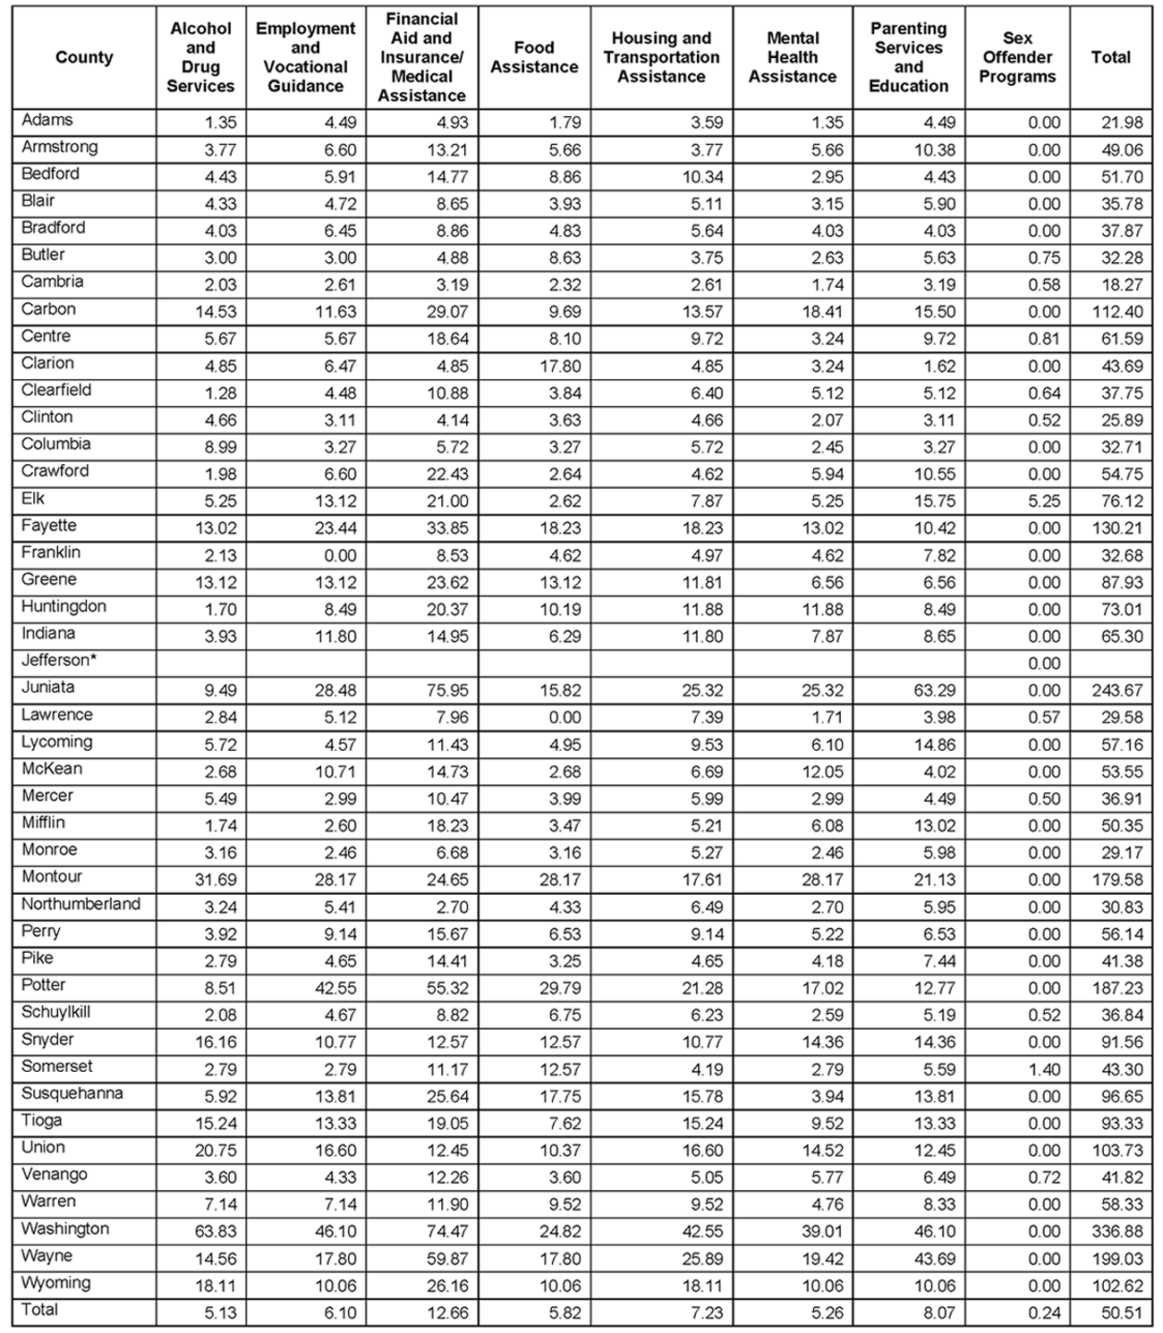
Data source: PADOC and PBPP; and county jail data compiled by Zajac and Kowalski (2012). *Data were not available for most program categories for this county.

Van Voorhis, et al., 2009). With larger participant ratios, it becomes more difcult to maintain the integrity of program implementation and client service delivery. With this in mind, the mean ratio across all rural coun-ties for education/vocational programs was 9, which is ideal. For mental health programs, the mean ratio was

An Examination of Rural Prisoner Reentry Challenges
13, which is close to the ideal of 10 or less. The ratio for alcohol and drug treatment programs was 22, which is considerably higher than the ideal.
The important caveats to this discussion are (1) that these gures do not account for the needs of returning county jail inmates (for which no data were available),

17

Table 10 – Density of Programs for State Prison Inmates Released in 2011 Needing Specic Services in Rural Counties

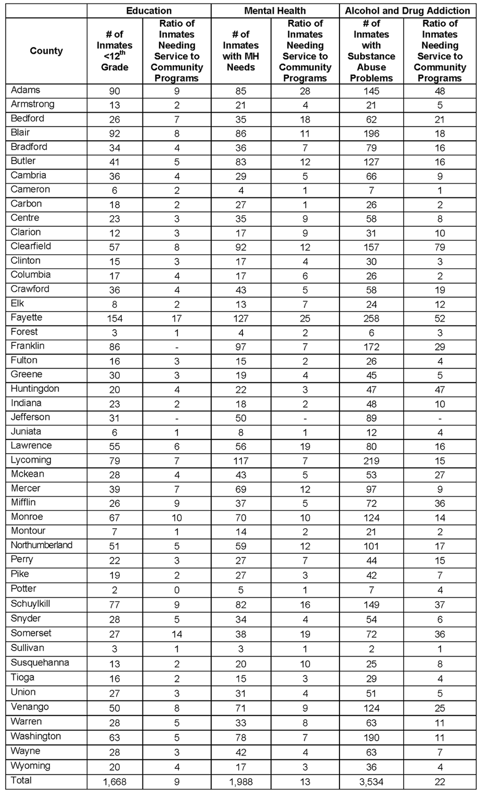
Data source: PADOC.

18 The Center for Rural Pennsylvania

and (2) non-offenders in these communities are also presumably competing with released inmates for these services. Thus, the “true” ratios of returning inmates needing specic services to programs available in rural counties may likely be higher than those reported in Table 10.

Conclusions According to the study ndings, rural reentry will
continue to be an important issue in Pennsylvania, as projections indicated a slight increase over time in the number of inmates returning to rural areas, especially inmates released from state prisons.
Employment, housing, and transportation emerged from this study as key challenges facing inmates return-ing to rural areas. The stigma of the released inmate being an “ex-con” also contributes to difculties in the areas of employment and housing, as identied by the state corrections ofcials interviewed. There are several restrictions for those with criminal records when trying to obtain employment and housing. For employment, offenders are restricted from working with children, as well as prohibited to work as aircraft/airport employees, nursing home workers, private detectives, bank employ-ees, and more. As for housing, the U.S. Department of Housing and Urban Development has specic protocol for those with criminal records or suspected of con-ducting criminal activity in the household that restricts offenders from obtaining housing, including guidelines for when sex offenders should be prohibited from be-ing given housing. Transportation in rural areas is an important issue considering the lack or even complete absence of public transit to aid released inmates in get-ting to work, treatment appointments and meetings with their parole agents.
This study found that social services for released in-mates are unevenly distributed between rural counties, with some counties being in a much better position than others to offer a variety of human and social services to released inmates. Moreover, this study found that social services may be more readily available in rural coun-ties as opposed to urban areas, although the evidence on this question is mixed. But, released offenders must compete with non-offenders for community social services that are available. And, much more needs to
be learned about the actual capacity and quality of the programs that are available in rural Pennsylvania.
While there appears to be a reasonably large number of programs in rural Pennsylvania targeting needs, such as substance abuse, there are very few, if any, cognitive-behavioral programs that address key criminogenic needs, such as anti-social attitudes and poor decision making skills, that are common to many offenders. There are also very few specialized community reentry programs for returning sex offenders.

Policy Considerations Based on the data collected for this study, the re-
searchers offer the following policy considerations that may inform efforts to enhance reentry for state and county inmates being released to rural Pennsylvania.

Enhance Efforts to Address Transportation Challenges
One of the most prominent themes to emerge from this study is how important transportation is to the reen-try experience of rural inmates. While there was some disagreement between state level corrections ofcials and county jail wardens over the challenges posed by transportation, it appears that limited transportation (especially public transit) presents a signicant obstacle to inmates returning to rural areas, compared to urban areas.
While PADOC indicates that it has been making ef-forts to provide more transportation for paroled inmates while they live in Community Corrections Centers/ Facilities, the efforts do not help released inmates once they leave the CCC/Fs, nor does this provide any help to inmates who have maxed out on their sentences and are under no supervision. It is also unclear whether ei-ther PADOC or PBPP have the resources to serve as the “one stop shop” for the transportation needs of released inmates.
Transportation challenges faced by released inmates are of course embedded within the larger problem of transportation infrastructure for all citizens living in rural areas. A recent report by the American Society of Civil Engineers found that 45 percent of Americans have no access to public transit of any sort, and that
millions more have only limited access11. This report of-fers no clear answers to the broader transportation chal-lenges facing rural areas. Clearly, though, any efforts made to enhance general mass transit systems within rural areas will benet released inmates. Short of that,

11. See: “Engineering group gives nation a “D+” on infrastructure.” Post-Gazette.com March 19, 2013. http://www.post-gazette.com/stories/news/us/engi-neering-group-gives-nation-a-d-on-infrastructure-679915/.

An Examination of Rural Prisoner Reentry Challenges 19

funding options may be made available to PADOC and PBPP to enhance their existing efforts to assist released inmates with transportation.

Expand Capacity for

Community Mental Health Services Interviews with state and local corrections ofcials
also suggest that there is a lack of mental health ser-vices for returning inmates in rural areas. Most notably, interviewees noted a lack of psychiatrists in these areas, requiring returning inmates with serious mental illness to travel great distances for intensive mental health ser-vices. In addition, aftercare programs for sex offenders, and support services for family members of returning inmates were also noted as lacking. Therefore, efforts to expand the capacity for community mental health services, sex offender programs, and family support programs, such as counseling programs to assist fami-lies in meeting the needs of their returning loved ones, would promote successful reentry within these rural communities.

Expand Programs that Address Offenders’ Criminogenic Needs
This study documented the almost complete absence of community programs that directly and rigorously ad-dress the key criminogenic needs of offenders, such as antisocial attitudes and peer associates, decision making and problem solving skills and coping skills. Attention to these needs is critical to the rehabilitation of offend-ers and to the reduction of recidivism. Evidence-based program models attending to such needs clearly exist, and such programs are commonly operated in many prison systems, including PADOC (MacKenzie, 2006). While such programs are offered in some of the CCC/ Fs operated by PADOC, the CCC/Fs are widely dis-persed within rural communities and do not serve all released offenders. PBPP’s ASCRA initiative may be one mechanism for delivering these services, at least to released offenders under parole supervision. While the ASCRA initiative had not yet been rigorously evaluated at the time of the research, expansion of the ASCRA initiative may be a policy consideration worth exploring to meet the important crimingenic needs of ex-offend-ers and to build upon these services delivered while in prison. PADOC’s revamped system of contracted CCFs may also become a vehicle for enhancing the provision of evidence-based services targeting these criminogenic needs. It seems likely that any effort to expand such services in the community will require the involvement

20
of PADOC and PBBP, as well as county jails and pro-bation departments, since these services, by their very nature, are of use only to offender populations.

Expand Reentry Resources for Sex Offenders This study found that there are almost no community-
based sex offender programs in rural counties. Only 11 of the 48 rural counties were found to have any sort of sex offender program, and in most of those counties
it was only a single program. Moreover, most of these “programs” seemed to be simply individual counselors (often psychologists or social workers) who were listed as providing some sort of service to sex offenders. Thus, there are few offense-specic reentry services available to sex offenders returning to rural Pennsyl-vania. One option for expanding reentry resources for sex offenders is the growing Circles of Support and Accountability (COSA) model (Hannem and Petrunik, 2007). The COSA approach is based on restorative justice principles and employs a network composed primarily of volunteers guided by a professional counselor that provides support services to returning sex offenders and establishes behavioral contracts with these offenders to enforce accountability to agreed-upon standards of behavior. While COSA has been used more extensively in the United Kingdom and Canada,
it is relatively new to the United States. There is some preliminary research suggesting that COSA does reduce recidivism rates, but it must be cautioned that while this approach is promising, it is not yet fully proven (Elliott and Beech, 2012; Wilson, et al., 2009). But, it may be worth exploring as an option for sex offenders returning to rural Pennsylvania.

Support Efforts to Enhance Reentry Programming
This study provides evidence that rural county jails currently offer relatively few reentry services prior to release. These jails should be supported in their efforts to enhance their capacity to deliver reentry program-ming to soon-to-be-released inmates. Such program-ming can and should include interventions addressing basic rehabilitative decits, such as job readiness and life skills, but must not ignore the underlying thinking errors and poor decision making and problem solving skills that are so strongly related to reentry outcomes (Bucklen and Zajac, 2009; MacKenzie, 2006). It is important that new jail reentry programs do not simply replicate approaches that have been found to be inef-

The Center for Rural Pennsylvania

fective. Moreover, the newer reentry initiatives within PADOC, and any new programs that may be fostered within county jails, should undergo thorough program evaluation to determine their effectiveness in promoting reintegration and reducing recidivism. Program devel-opment is not a once and done process, and rigorous program evaluation is key to sustaining successful reentry services.

Undertake Population Projections
One of the more notable ndings of this study is
that no rural county jail reported undertaking any sort of population projections estimations. The county jail population projections presented in this report represent a basic start to estimating changes in the population of these jails. Population projections are extremely com-plex and technical activities. It is reasonable to suggest that the development of a rigorous projections system is likely to be beyond the resources of any individual small jail. These jails are not likely to have the in-house staff capacity, or the funds, to create such a system on their own. The development of a county jail popula-tion projections “dashboard” (serving both rural and urban counties) may be more feasibly supported by a statewide criminal justice planning agency, such as the Pennsylvania Commission on Crime and Delinquency. Such a dashboard could show up-to-date projections for admissions, instant population and releases for each county jail, out to whatever period is desired (e.g. 1 year, 5 years, 10 years) and including projected inmate demographics. Such an undertaking can be informed and guided by the efforts made by PADOC over the past several years in the renement of its own projec -tions system12. Another option may be for rural county jails to collaborate collectively, or at least regionally, on the development of the overall methodology and archi-
tecture for such a projections system, which can then be tailored to individual jails. It should be noted that such systems come at some cost, with PADOC having spent more than $60,000 on the ongoing development of its own system13. But, population projections are a valu-able component of any modern correctional system, given the importance of timely estimates of population changes for jail and prison policymaking, planning and budgeting.
Development of PA 2-1-1 System

While PADOC and PBPP, and to a lesser extent the county jails, currently make directories of community based services available to returning inmates and their families, this approach may be less efcient than the evolving PA 2-1-1. PA 2-1-1 is a simple telephone service that connects all callers to information regard-ing health and human services available in their com-munity. In Pennsylvania, the 2-1-1 program has been activated in six out of seven regions in the state, with the northwest region being the only region without a live 2-1-1 call center14. PA 2-1-1 is administered by a statewide board of directors, which has the authority to award “call center” status to units throughout the state.
A cost-benet analysis regarding 2-1-1 was con -ducted by the University of Texas Ray Marshall Center for the Study of Human Resources in December 2011. It found that when an individual is looking for informa-tion or referral services, the individual tends to have little or no prior knowledge or experience; therefore, dialing 2-1-1 is much easier compared to other options, such as a handbook. It also found that general informa-tion systems, like 4-1-1, disseminate information that is too general and can have a fee. A national service, such as 2-1-1, is predicted to provide $1.1 billion in net value nationally over the next 10 years (United Way and AIRS 2-1-1, 2012).
PA 2-1-1 then affords to released inmates (or anyone in the community) a one-stop-shop for information about and referral to a wide variety of community ser-vices and programs. It may be easier to instruct in-mates to take advantage of PA 2-1-1 than to have them self-navigate a complex paper directory of community programs, which by its very nature is of limited value to released inmates with low literacy levels. Thus, an investment by the state in the full development and use of PA 2-1-1 may be an important advancement in the reentry process.

Additional Considerations
While the current study explored rural reentry from a variety of angles, much more research is needed on this topic. For example, future research could gather data directly from released and soon-to-be released inmates to learn what they see as key challenges and concerns about their reentry. Data collection from offenders,

12. See the following link to the DOC Key Indicators Dashboard as an example of how a dashboard could be structured: http://www.cor.state.pa.us/portal/ server.pt/community/major_initiatives/21262.
13. Communication with Bret Bucklen, Director of the Bureau of Planning, Research and Statistics, Pennsylvania Department of Corrections, March 7, 2013. 14. For a map of the seven call center regions statewide, see http://www.pa211central.org/locations.html.

An Examination of Rural Prisoner Reentry Challenges 21

especially those in the community, is more difcult, ex -pensive and time consuming than the work undertaken in this study. But, such offender-focused research holds the potential to contribute greatly to an understanding of rural reentry in Pennsylvania.
Also, several interviewees noted that some rural counties are much more “rural” than others, and thus pose their own set of challenges. Future research should take into account the variation not only between rural and urban counties, but also between rural coun-ties themselves.
Another recurrent theme in the interviews and sur-veys with corrections ofcials was the obstacle that stigma may play in rural reentry. The reentry experi-ence is jeopardized when released inmates are simply not accepted by others within their communities, or are viewed as second class citizens. It is difcult to legis -late changes in prevailing attitudes. This report cannot
offer clear guidance on how to overcome the stigma-tization of released inmates. However, efforts may be made to better prepare soon-to-be-released inmates on how to respond to challenges and suspicions by mem-bers of the communities to which they return, much as some job readiness programs teach them how to answer prospective employers’ questions about their crimi-
nal records by offering candid disclosure of their past mistakes and emphasizing the contributions that they can make as employees and citizens. Public education campaigns can also be developed to better inform com-munity members of the contributions they can make to help released inmates succeed and thus to reduce the risk of future crimes. Offender reentry is a community effort. The benets of successful reentry are enjoyed by the entire community, and conversely the costs of failed reentry are borne by that same community.

References
Andrews, D., and Bonta, J. (2003). The Psychology of Criminal Conduct 3rd Ed. Cincinnati: Anderson Publishing. Bucklen, K. B., and Zajac, G. (2009). But Some of Them Don’t Come Back (to prison!): Resource Deprivation
and Thinking Errors as Determinants of Parole Success and Failure. The Prison Journal, 89(3), 239-264. Center for Housing Policy. (1996). The Housing Needs of Ex-Prisoners. York University.
Center for Policy Research. (2006). Incarceration, Reentry and Child Support Issues: National and State Research Overview. Washington D.C.: U.S. Department of Health and Human Services, Administration for Children and Families.
Dillman, D.A., Smyth, J.D. and Christian, L.M. (2009). Internet, Mail and Mixed-Mode Surveys: The Tailored Design Method. Hoboken, NJ: John Wiley and Sons.
Drug and Alcohol Services Information System. (2002). Distance to Substance Abuse Treatment Facilities Among Those with Alcohol Dependence or Abuse. Retrieved from http://www.sa mhsa.gov/data/2k2/distance/distance. htm.
Elliott, I. A. and Beech, A.R. (2012). A U.K. Cost-Benet Analysis of Circles of Support and Account -ability Interventions. Sexual Abuse: A Journal of Research and Treatment, [Online ahead of print]. Doi:10.1177/1079063212443385
Hannem, S. and Petrunik, M.G. (2007). Circles of Support and Accountability: A Community Justice Initiative for the Reintegration of High Risk Sex Offenders. Contemporary Justice Review, 10(2), 153-171.
Latessa, E.J. (2005). Correctional Program Checklist. Cincinnati, OH: University of Cincinnati.
Latessa, E. J., Cullen, F. T., and Gendreau, P. (2002). Beyond Correctional Quackery: Professionalism and the Possibility of Effective Treatment. Federal Probation, 66 (2), 43-49.
Latessa, E. J., and Lowenkamp, C. T. (2006). What Works in Reducing Recidivism? University of St. Thomas Law Journal, 3(3), 521-535.
Latessa, E. J., Lowenkamp, C. T., and Bechtel, K. (2009). Community Corrections Centers, Parolees, and Recidi-vism: An Investigation into the Characteristics of Effective Reentry Programs in Pennsylvania. Harrisburg, PA: Pennsylvania Commission on Crime and Delinquency.
LaVigne, N., Davies, E., Palmer, T., and Halberstadt, R. (2008). Release Planning for Successful Reentry: A Guide for Corrections, Service Providers, and Community Groups. Washington D.C.: Urban Institute Press.
Lowenkamp, C. T., Latessa, E.J. and Smith, P. (2006). Does Correctional Program Quality Really Matter? The Impact of Adhering to the Principles of Effective Intervention. Criminology and Public Policy, 5, 575-594.

22 The Center for Rural Pennsylvania

MacKenzie, D. (2006). What Works in Corrections. New York, NY: Cambridge University Press.

MacKenzie, D.L. and Zajac, G. (2013). What Works in Corrections: The Impact of Correctional Interventions on Recidivism. Report to The National Academies of Science, Committee on the Causes and Consequences of High Incarceration Rates.
Pennsylvania Department of Corrections. (2013). Recidivism Report 2013. Pennsylvania Department of Corrections. (2012a). 2012-2013 Budget Overview. Pennsylvania Department of Corrections. (2012b). Annual Statistical Report.
Pennsylvania 2-1-1 Central Region. (2012). Pennsylvania 2-1-1. Retrieved on December 7, 2012 from http:// www.pa211central.org
Petersilia, J. (2003). When Prisoners Come Home: Parole and Prisoner Reentry. New York: Oxford University Press.
Pew Center on the States. (2010). Prison Count 2010: State Population Declines for the First Time in 38 Years. Issue Brief. Washington D.C.: The PEW Charitable Trusts.
Ruddell, R., and Mays, L. G. (2006). Expand or Expire: Jails in Rural America. Corrections Compendium, 31, 1-5, 20-21, 27.
Smith, L. G., and Suttle, D. R. (2008). An Outcome Evaluation of the Pennsylvania Department of Corrections Community Orientation and Reintegration Program. Columbus, OH: International Association of Reentry.
Van Voorhis, P., Braswell, M., and Lester, D. (2009). Correctional Counseling and Rehabilitation (7th ed.). Cin-cinnati, OH: Anderson Publishing.
Welsh, W.N. and Harris, P.W. (2012). Criminal Justice Policy and Planning (4th ed.). Waltham, MA: Anderson Publishing.
Wilson, J. A., and Davis, R. C. (2006). Good Intentions Meet Hard Realities: An Evaluation of the Project Green-light Reentry Program. Criminology and Public Policy, 5(2), 303-338.
Wilson, R.J., Cortoni, F. and McWhinnie, A.J. (2009). Circles of Support and Accountability: A Canadian Nation-al Replication of Outcome Findings. Sexual Abuse: A Journal of Research and Treatment, 21, 412-429.
Wodahl, E. (2006). The Challenges of Prisoner Reentry from a Rural Perspective. Western Criminology Review, 7, 32-47.
Zajac, G., and Kowalski, L. (2012, December). An Examination of Pennsylvania Rural County Jails. University Park, PA: The Justice Center for Research at the Pennsylvania State University.

The Center for Rural Pennsylvania Board of Directors

Chairman Senator Gene Yaw

Vice Chairman Senator John Wozniak

Treasurer Representative Garth D. Everett

Secretary Dr. Nancy Falvo
Clarion University

Representative Rick Mirabito

Dr. Livingston Alexander University of Pittsburgh

Dr. Theodore R. Alter Pennsylvania State University

Stephen M. Brame Governor’s Representative

Taylor A. Doebler III Governor’s Representative

Dr. Stephan J. Goetz Northeast Regional Center for Rural Development

Dr. Karen M. Whitney Clarion University

The Center for Rural Pennsylvania 625 Forster St., Room 902 Harrisburg, PA 17120 Phone: (717) 787-9555 Fax: (717) 772-3587 www.rural.palegislature.us 1P0314 – 400

